KEY DRIVERS OF INDUSTRIALIZATION IN PAKISTAN



Syndicate Group 15
Final Report
4 March 2020

Syndicate Advisor: | Zara Salman
Faculty Member: | Syed Shabbir Akbar Zaidi
In-Charge Coordination Syndicate Activity: Syed Shabbir Akbar Zaidi

47TH COMMON TRAINING PROGRAMME
CIVIL SERVICES ACADEMY, WALTON, LAHORE

SYNDICATE GROUP NO. 15 MEMBERS

S # | NAME OF PROBATIONARY OFFICER | CSID# | POSITION
1 | Nabeel Ahmed Memon | 4708247 | Chairperson
2 | Shahnawaz Khan | 4702115 | Secretary
3 | Iqra Khan | 4706276 | Member
4 | Kashmala Tahseen | 4709078 | Member
5 | Khadija Awan | 4706023 | Member
6 | Muhammad Siddiq Mahr | 4706202 | Member
7 | Syed Kazim Raza Bhatti | 4704137 | Member
PLAGIARISM UNDERTAKING

A paper submitted to the Faculty of the Civil Services Academy, Walton, Lahore, in fulfilment of the requirements of the 47th Common Training Programme.

We solemnly declare that research work presented in the report titled “Key Drivers of Industrialization in Pakistan” is solely our research work. Small contribution / help, wherever taken, has been duly acknowledged and referenced and the complete report has been written by us.

We understand the zero tolerance policy of the Civil Services Academy, Lahore, towards plagiarism and its implications. Therefore, we, as authors of the report, declare that no portion of our report has been plagiarized and any material used as reference is properly referred / cited. The paper reflects our own views and is not necessarily endorsed by the Academy.

Syndicate Chairperson Signature: _________________
Syndicate Secretary Signature: _________________

Dated: _________________

CERTIFICATE OF APPROVAL

This is to certify that the research work presented in this report, entitled “Key Drivers of Industrialization in Pakistan” was conducted by Syndicate Group No. 15, under our supervision.

Signature: _________________
Name of Syndicate Advisor: _________________
Dated: _________________

Signature: _________________
Name of Faculty Member: _________________
Dated: _________________

ACKNOWLEDGMENTS

We would first like to acknowledge Syed Shabbir Akbar Zaidi, whose weekly check-ins have made this report as punctual and true to requirements as possible.

We would also like to thank our key informant intervieweesfor being generous with their time; their views helped put a human face to the reality of the many theoretical notions of industrialization we found in the literature.

In being assigned to an external organization, we had a syndicate advisor who also filled in as our research coordinator. Wethank Ms. Zara Salman at CDPRfor her guidance, and equally for her patience with earlier drafts.

Our group began this project unfamiliar with macroeconomics, but we believe Ms. Zara’s direction has—at the least—left us with a sense of the enormity of Pakistan’s challenge in revitalizing its economy and trade, and what we may do in our careers to assist this endeavor.

VERSION 2.0
Dated 4 March 2020

This version is dated Wednesday, March 4, 2020, and incorporates all the changes directed by our external review panelist, Dr. Umar Sandhu, as well as other suggestions from the review panel, after our Syndicate presentation dated Friday, February 28, 2020.

Our revisions include:
- The addition of the “Industrial Revolution”—both in history, and Pakistan in comparison to the developed world—in Section 1 (Introduction),
- Comparisons with Turkey to support other comparisons in Section 2 (Literature Review),
- Further analyses to the ‘Ease of Doing Business’ subsection in Section 4.1,
- The addition of consequences post-nationalization in the 1970s, in Section 4.3,
- The addition of “pulp” and other value-added exports, as well as the need for cold storage, in Section 5.2 (Recommendations).

We thank the review panel for their valuable and insightful feedback.

EXECUTIVE SUMMARY

Pakistan’s industrial growth has sustained a downturn in the last decade. Manufacturing has dipped in GDP contribution relative to other sectors (falling 5 percentage points to 12% in 2018), and in a regional comparison: Bangladesh, India, Vietnam, and other South Asian countries have surpassed Pakistan on several indicators that point to a dim investment climate, stagnating capital accumulation, and low overall growth.

Industrialization is vital as a direct contributor to a country’s standard of living; economic theory in the literature presents evidence that a growth in manufacturing brings wider advantageous spillover effects than in services or agriculture. Since countries reach the limit of a domestic market that is their own population, trade becomes a necessity to grow and bring in inputs—economies grow as they move from producing and trading more sophisticated, value-added and capital goods.

Pakistan’s present administration must reckon with a serious twin deficit and international commitments with the IMF to reduce spending, ramp up revenue, and increase its competitiveness in global trade. Manufacturing, and industrialization, therefore, must be a key priority. This paper describes seven key areas of industrial policy where Pakistan faces challenges—overcoming these will help achieve export competitiveness, improve the investment climate, and return the country on a path towards healthy industrialization.

These areas of policy—drivers of industrialization—present the following challenges:
- Institutional:Despite impressive climbs on Doing Business sub-indices, Pakistan contends with poor public-private dialogue; firm-level surveys point to predatory policy implementation that calcifies mistrust with the government and encourages businesses to stay informal. Firms remain burdened by complex and opaque regulations.
- Macroeconomy: Pakistan’s overdue emphasis on import substitution has come at the expense of export-oriented strategies, which combine with distortionary and discriminatory fiscal policies—dominated by capture by an industrial elite in certain sectors seeking undeserved protectionism—as well as a complex, poorly administered tax regime, to keep revenue generation low and policies short-sighted.
- Access to Finance: SME firms constitute 90% of Pakistan’s economic enterprise but find it difficult to acquire loans because private banks prioritize safe and guaranteed lending to government, and do not recognize flexible forms of collateral for small firms. High government borrowing in Pakistan (growing 26% in the past year, compared to 3.5% for the private sector) limits credit available for SMEs. Similarly, VC and private equity firms are held back by regulations that do not facilitate them, e.g. on repatriating profits.
- Market Access:Pakistan has made various inroads to reach markets within the region, particularly with China (CPEC and FTA) as well as with Afghanistan and the United States, but recent political turmoil in Kashmir has halted the limited trade with India. Market access also relies on non-tariff barriers; on this front Pakistan is challenged by rising technical barriers to trade, especially on foodstuff. Finally, the investment climate is dampened by poor infrastructure, especially outside the riverine Punjab region.
- Political Economy: Two major issues at the overlap of political and economic decision-making that affect industrialization is the prevalence of moral hazards—corrupt and perverse incentives for public officials to defraud the system at the expense of legitimate businesses, as well as the recurring dependence on the IMF and World Bank, which adds to a “geostrategic curse” where governments continue to accept aid.
- Human Capital and Technology:One barrier to adequate adoption and transfer of technology is the state of the economy itself—price-competitive exports leave firms with little profits to invest back into their equipment and machinery. Government has failed to subsidize and encourage specific technology acquisition, and where it has—e.g. automobiles—it may be short-sighted and overly optimistic. R&D and upgradation of technology remains a low priority, and human capital is severely underutilized.
- Energy:SME firms remain especially at the mercy of power producers—who, following the 1994 Power Policy, have dominated the industrial energy supply landscape. A vicious debt cycle has emerged for government towards IPPs; combined with a fuel mix overdependent on expensive fossil fuel, line and transmission losses in a worn and torn grid, and poor planning, the government has to make difficult choices regularly between prioritizing businesses and end consumers.

In closing, the paper makes policy recommendations on all seven fronts. What is common across the board is an urgent need to make public-private dialogue transparent and candid, to ensure that Pakistan has a unified industrial strategy that is inclusive, impartial, and directed by market realities in place of elite interest; where possible, the government must also make regulations for—and interactions with—businesses simple and easy to grasp, to nurture an environment of trust, where small businesses are incentivized to formalize as well.
TABLE OF CONTENTS

1 Introduction 10
2 Literature Review 12
2.1 Industrialization as an Engine of Growth 12
2.2 Pakistan, Asia, and the World 13
2.3 Pakistan’s Economic Performance 19
3 Methodology 22
3.1 Research Questions 22
3.2 Selection of Drivers 22
3.3 Data Collection and Analysis 22
4 Findings 24
4.1 Institutional Factors 24
4.2 Macroeconomic Policy 30
4.3 Access to Finance 33
4.4 Market Access 37
4.5 Political Economy 41
4.6 Human Capital and Technology 43
4.7 Energy 46
5 Discussion 49
5.1 Implications for Pakistan 49
5.2 Policy Recommendations 49
6 Conclusion 54
6.1 Future Work 54
7 Bibliography 55
8 Appendices 59
8.1 Interviewees 59
8.2 Interview Guide 60

LIST OF FIGURES

Figure 2.1 Manufacturing as % of GDP, Pakistan vs. South Asia, 1960-2018 14
Figure 2.2 Services as % of GDP, Pakistan vs. South Asia, 1960-2018 14
Figure 2.3 Value added by the manufacturing sector (% of GDP), Pakistan vs South Asian countries, 2009-2017 15
Figure 2.4 FDI as % of GDP, Pakistan vs South Asian countries, 2004-2017 16
Figure 2.5 Bank credit to government and public enterprises, Pakistan vs. South Asian countries, 2004-2017 16
Figure 2.6 Domestic credit to the private sector (% of GDP), Pakistan vs. South Asian countries, 2004-2017 17
Figure 2.7 Share of World Exports, Pakistan vs. Bangladesh and Vietnam, 1990-2017 18
Figure 2.8 Share of World Imports, Pakistan vs. Bangladesh and Vietnam, 1990-2017 19
Figure 2.9 Economic growth rate (%), Pakistan vs. the World, 1960-2018 20
Figure 2.10 Sectoral Share as % of GDP, 2011-2019 20
Figure 2.11 Sector-wise Growth Rates (%), 2004-2019 21
Figure 4.1 Government Borrowing (Flows), 2014-2018 33
Figure 4.2 Pakistan vs Others, Global Innovation Index, 2013 44

Introduction
For the last several years, industrial growth has stagnated in Pakistan. In fact, the share of the manufacturing sector in GDP shrank from 17.5% in 2005 to 12.1% in 2018. Pakistan contributes a paltry 0.12% of total global exports in 2019, down by one-fourth from 2003—and in stark contrast to neighbors Bangladesh and Vietnam, whose share of global exports grew double and seven-fold respectively (Pakistan Business Council, 2018).

In the subcontinent alone, Pakistan comes last—its manufacturing grew 6.2% in comparison to India (11.8%) and Bangladesh (11%), and its investment-to-GDP ratio, at 16.4, is half of Bangladesh and India (31). Sri Lanka in the south is at 37 (Pakistan Business Council, 2018).

While deindustrialization has several overlapping definitions in the literature, it is safe to say that Pakistan qualifies on them all: dropping manufacturing output and employment shares, the continued dominance of agriculture coupled with a shift to services, the inability to secure an export surplus through manufacturing, and a lasting balance of trade deficit. By one definition, the “Industrial Revolution”—following the historical trends that began in 18th century England, and soon spread across Europe and America at large, is in its 4th stage in the developed world, with the advent of the knowledge economy, and the integration of human-led and mechanized work—but Pakistan is still situated in what is considered the 2nd phase, i.e. the production of specialized good using electricity. The advent of IT and automation has still yet to reach a critical mass for Pakistan to be considered in the 3rd stage.

Industrialization directly brings economic growth, and by extension, improves citizens’ standard of living. The manufacturing sector surpasses agriculture and services in providing rapid economies of scale, bringing in new technology and capital for firms, spreading disembodied benefits across industrial sectors, and as a consequence, improving both agriculture and services. As countries industrialize, theydiversify and produce goods at scale for export purposes, grow richer, and are able to raise the quality of life for citizens.

Not only is industrialization beneficial for economic growth, it is inevitable as economies grow. As further described in Section 2.1, a country’s internal population is a limited market, and inevitably countries must diversify from agriculture to import inputs, which requires the establishing of foreign exchange to purchase these imports—thereby motivating industry to produce exports. This, and the forward march of technological progress and rise in efficiency and productivity, explains industrialization as the historical transition a country makes from being dominated by agriculture towards manufacturing goods of progressive sophistication and benefit (toward value-added goods), replacing manual unskilled and skilled labor through mechanization and assembly lines.

The incumbent ruling party Pakistan Tehreek-e-Insaf (PTI), which formed the government following the 2018 national elections, has inherited a debilitating trade deficit. Industrialization is, and ought to remain, a chief priority of this government: it is vital to improve export competitiveness to bring revenue up to par with our import costs. Balancing the trade deficit will in turn reduce our current account deficit, and consequently help us redirect larger portions of the annual budget from debt servicing toward long-neglected sectors: education, health, and provincial awards, especially for impoverished regions.

Our present-day crisis has roots in a plethora of factors across the public policy space; while any categorization is arbitrary, we organize these challenges into seven major areas: institutional strength (or lack thereof), macroeconomic policies (monetary and fiscal), access to finance for industries, market access and trade policy, political economy factors, human capital and technology, and—distinctly for relevance to Pakistan—energy.

In this study, we focus on the immediate matter and emergent corollaries of one broad question: given today’s competitive global environment, what are the key drivers of industrialization Pakistan ought to focus on to remain competitive? Here, we imply the two-fold need to solidify our competitiveness in established sectors—such as textile—and to diversify our channels of growth by making inroads in new sectors.

The remainder of this paper is structured as follows. Section 2 sums up our study of existing literature on Pakistan’s industrialization, by way of suitable cross-country comparison, and qualified by relevant industrial theory. Section 3 presents our methodology, describing how our survey instruments inform our analysis. Section 4 is the majority of our work, and is divided into seven categories that drive industrialization—for each we analyze past policy, shortcomings, and future prospects for Pakistan. Section 5 presents implications on Pakistan’s economy at large, and provides policy recommendations for government and private businesses. Section 6 concludes with a note on possible direction for future work.

Literature Review

Industrialization asan Engine of Growth
The evidence is overwhelming that industrialization is inescapable for economic growth. In 1967, Nicholas Kaldor’s three growth laws postulated that, first, the rate of GDP growth is tied to manufacturing growth outpacing GDP growth; second, that productivity in the manufacturing sector brings both static benefits, like reducing average costs, and dynamic ones, with greater capital acquisition and technological improvement; and third: that this improves productivity outside manufacturing (Kaldor, 1967).

To this, Thirlwall (2003) points a corollary: while nascent industrialization anywhere is driven by agricultural growth, a country’s domestic market eventually introduces a natural limit to domestic demand, and thus further industrialization will require bringing inputs from abroad, which motivates international trade.

In the aftermath of World War II, the entry of newly-decolonized nations into an increasingly globalized market brought manufacturing full-fledged to developing countries.Szirmai (2009) summarizes why manufacturing, and thereby industrialization, is considered an “engine of growth”—particularly when juxtaposed with agriculture and services—because it raises per capita income, helps to drive accumulation of capital, enables economies of scale, promotes technical advancements, and has potent “linkage and spillover effects”, i.e. positive externalities carried over between sectors (Szirmai, 2009).

To model the post-war rise of Asian economies, led by Japan, Kaname Akamatsu put forth the Flying Geese paradigm (FGP)—where Japan is the lead geese in a multi-tiered formation of East Asian countries—which makes the prediction that countries will substitute capital-intensive goods (e.g. electronics) for labor-intensive manufacturing (e.g. garments), transferring the latter down the formation to second- and third-tier countries in East Asia. Here, Akamatsu develops a theory that involves numerous ‘drivers of industrialization’ as well: labor costs, regulations, production structure, international trade, investment, and technology transfer (Akamatsu, 1962).The FGP model is rooted in 1960s trends, but has since seen recurrent engagement in literature; Terutomo Ozawa (2005), introduced the significance of political economy in driving industrialization: in Japan’s case, this is post-war United States hegemony (Ozawa, 2005).

Apropos of our upcoming assessment of Pakistan’s position relative to its neighbors, Szirmai (2012) posits that “all the Asian success stories are stories of industrialization.” Excepting the recent rise of a software services sector in India, he concludes that “neither tourism, nor primary exports, nor services have played a similar role” (Szirmai, 2012).

Pakistan, Asia, and the World
Naturally, how industrialization plays out in a country is contingent both on its original endowment at its founding moment, and when this moment took place relative to the global race for economic growth (Pollard, 1990). A bleak picture emerges on comparing Pakistan with its neighbors, and developing countries worldwide—the majority in South Asia having gained independence from colonialism in the mid-twentieth century.

On identifying successful industrializers that emerged in two periods—1970 through 1990 and 1991 through 2014, Haraguchi et al. (2019) found evidence for several factors that were responsible: “a country’s initial economic conditions, factor endowments, and … demography and geography.” Less immutable factors include the kind of investments a country promotes, its stance on education, how it manages capital openness, and—relevant to Pakistan—"macroeconomic and institutional stability”.

The list developed by Haraguchiet al. (2019) is largely Asian countries—in the first period, this includes Korea and Malaysia, both of which enabled “structural transformation”. In the second period, China, Vietnam, India, and Bangladesh, all obvious cases, are joined by Cambodia, Laos, and Myanmar because of gains made by regional proximity.

A comparison of Pakistan with South Asia, and the world at large, can help set the tone for the rest of this document. Several indicators relating to industrial shifts and global trade indicate that Pakistan’s industrialization has stagnated; several others illustrate the strides that countries such as Vietnam and Bangladesh have made past Pakistan.

As one fundamental example illustrated in Figure 2.2, Pakistan overtook the regional average for share of the services sector in GDP in 1965 and has tracked it since then with a difference of 2-3% (Figure 2.2), but for the equivalent share of manufacturing in GDP, it operates at a wide gap—the regional average is ~26% while Pakistan trails at 18% (Figure 2.1).

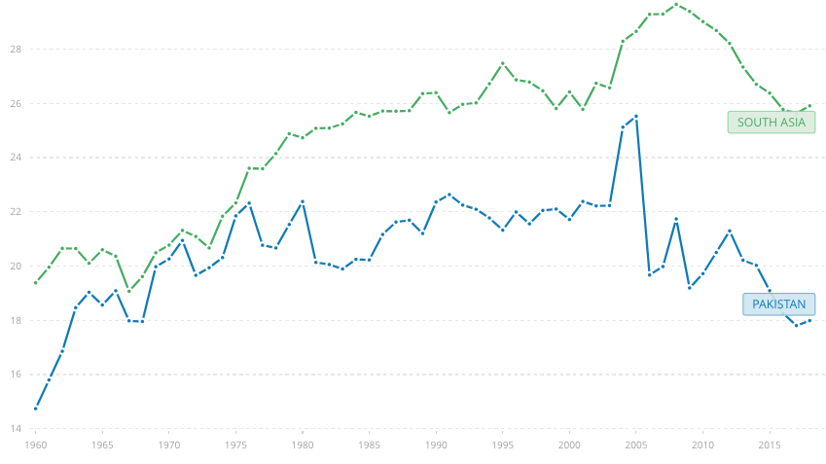
Figure 2.1 Manufacturing as % of GDP, Pakistan vs. South Asia, 1960-2018
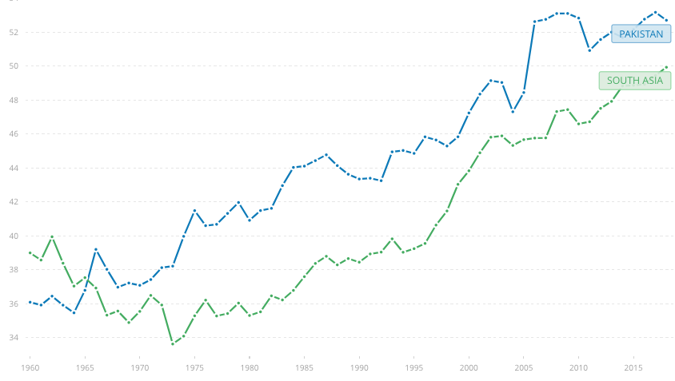
Figure 2.2 Services as % of GDP, Pakistan vs. South Asia, 1960-2018

For Pakistan, this may point to a premature shift towards a services economy, at the expense of potential gains in industrialization. The next section (Section 2.3) will expand on the historic trend in which while agriculture has seen a steady, slow decline in terms of GDP contribution—if not workforce employment—it has transferred these numbers disproportionately over to the services sector, at the cost of industrialization, which is otherwise seen as a necessary intermediate stage if one studies the trajectories of developed countries.

Pakistan vs South Asia
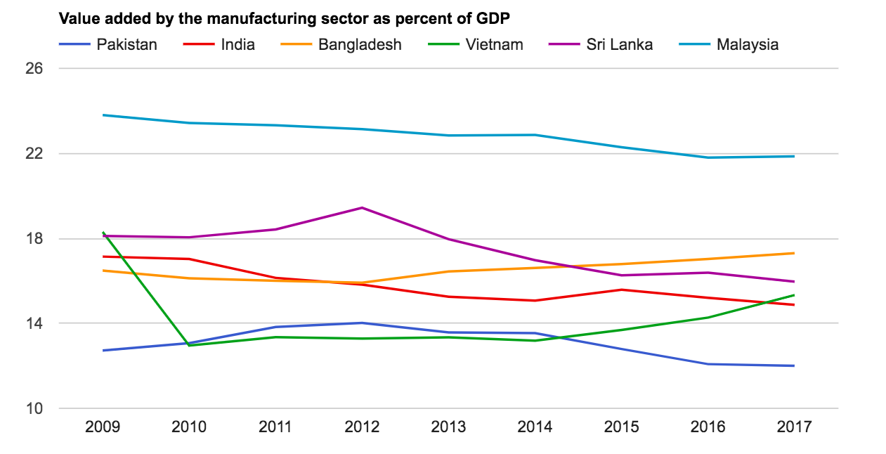
Figure 2.3 Value added by the manufacturing sector (% of GDP), Pakistan vs South Asian countries, 2009-2017
Figure 2.3, sets a foundation for the argument that Pakistan has consistently lagged behind the region in extracting value from its manufacturing industry. Delving deeper into further comparisons can help provide the intuition for the drivers we are about to examine.
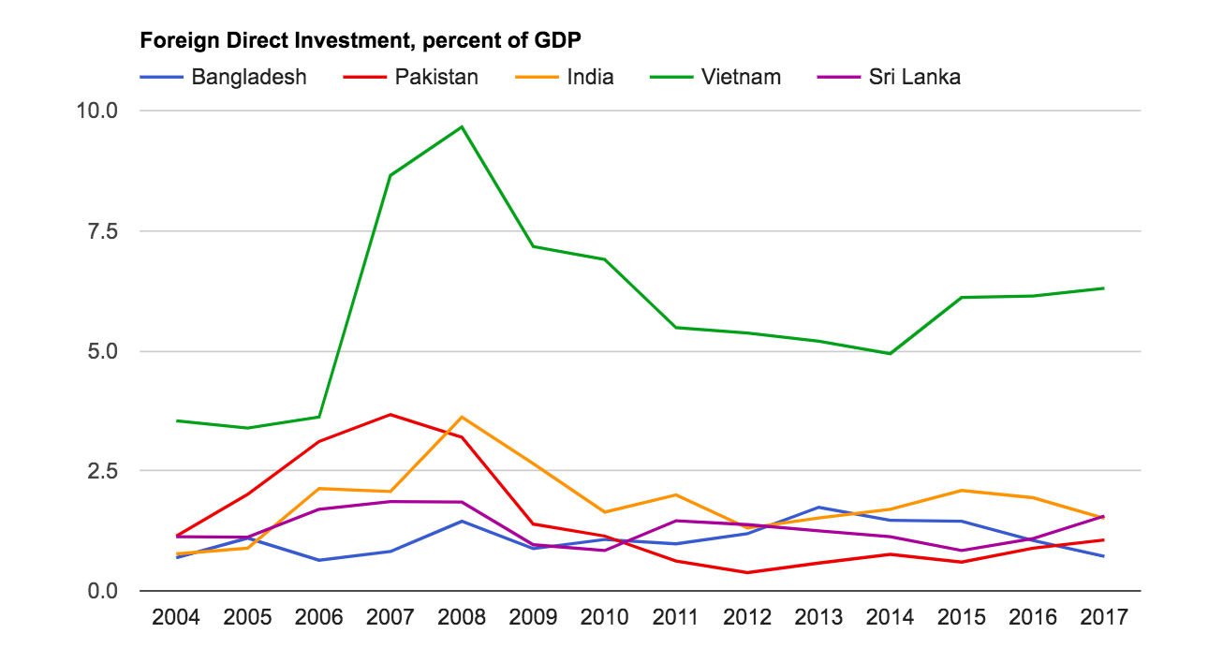
Figure 2.4 FDI as % of GDP, Pakistan vs South Asian countries, 2004-2017

As a first example, Figure 2.4 illustrates that the contribution of FDI to Pakistan’s GDP, floating at slightly above 1% in 2004, increased more than three-fold in 2007, only to dip down to the same level—in comparison to Vietnam, which saw a dramatic injection of foreign investment in the mid-2000s, of which it continues to maintain a significant level.

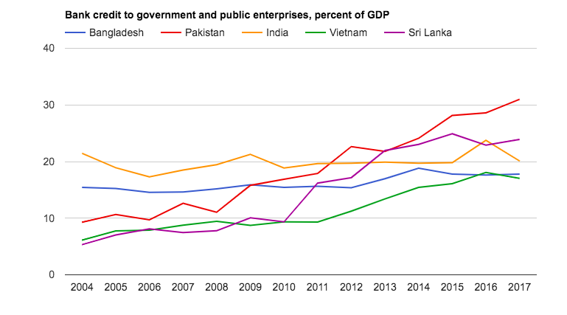
Figure 2.5 Bank credit to government and public enterprises, Pakistan vs. South Asian countries, 2004-2017

Another useful indicator is the propensity of banks to lend to government entities, which can eat into the credit available for private firms. This is a telling statistic for Pakistan—unlike other South Asian countries in Figure 2.5, Pakistan’s banks have increased this availability of credit from 10% of GDP to above 30%, which fits well with the position (in Section 2.3) that poor access to finance, in particular bank loans, is a significant barrier to SME growth—further substantiated by Figure 2.6, where Pakistan is far behind its neighbors in terms of domestic credit to the private sector.

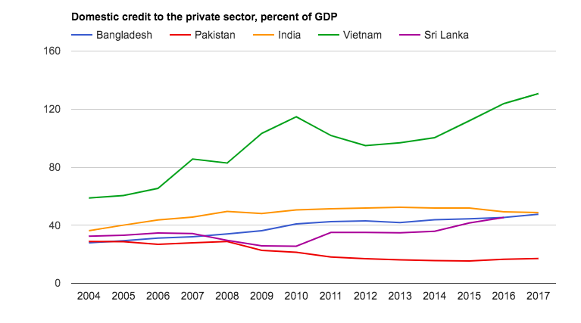
Figure 2.6 Domestic credit to the private sector (% of GDP), Pakistan vs. South Asian countries, 2004-2017
In the entirety of Section 4, wherever opportune, we make similar comparisons between Pakistan and other South Asian countries on various drivers, to drive home the takeaway that only multi-faceted progress on several policy areas will help improve Pakistan’s industrial growth, to significantly catch up to the region.

Figure 2.7 Share of World Exports, Pakistan vs. Bangladesh and Vietnam, 1990-2017

To conclude this section on comparisons: Figure 2.7 shows the dramatic inroads Vietnam has made into becoming a world-class exporter of goods, while Bangladesh has begun from the bottom to capture 0.2% of the market—in the same duration that Pakistan regressed to 0.12% in 2017. However, in comparing this with the same countries’ share of imports for the time period (Figure 2.8), Pakistan tracks Bangladesh’s share of world imports, bringing into sharp relief the country’s grave imbalance of trade.

Figure 2.8 Share of World Imports, Pakistan vs. Bangladesh and Vietnam, 1990-2017

Pakistan’s Economic Performance

A Brief Economic History
Despite a fragile beginning, as of 2020, Pakistan has the 24th largest economy of the world in terms of nominal GDP. Over these 70-odd years, the country’s economy has grown at a higher average rate than the world as a whole—despite a plethora of political, economic, and military challenges.

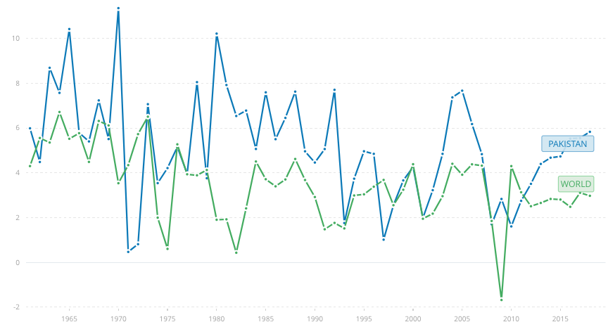
Figure 2.9 Economic growth rate (%), Pakistan vs. the World, 1960-2018
However, a deep dive into the changing constitution of Pakistan’s economy indicates a deviance from the traditional stage of development that countries follow: from agrarian, to industry-heavy, to an economy dominated by services. According to the latest Economic Survey of Pakistan, between 2012 and 2020, the services sector has gained 4 percentage points in its contribution to Pakistan’s GDP (Figure 2.10), while agriculture fell by 3 points, and manufacturing stayed close to 13%.

Figure 2.10 Sectoral Share as % of GDP, 2011-2019
The literature and official statistics are therefore clear on this position: that Pakistan’s industrial growth rate has declined, and particularly at the expense of any gains transferring to the services sector directly. In conclusion, Figure 2.11 best exposits this: between 2004 and 2019, manufacturing was the only sector in Pakistan which dipped to negative growth, and in comparison even to agriculture, remains the slowest growing element of the economy.

Figure 2.11 Sector-wise Growth Rates (%), 2004-2019

Methodology

Research Questions
We aim to answer a three-part question about raising Pakistan’s ability to compete in this globalized environment:
- First, in the aforementioned globalized environment, what are the key areas of industrial policy (drivers of industrialization) that Pakistan must target to remain competitive?
- In theseareas, what challenges and issues does Pakistan face?
- What particular policy recommendations can we make to help the government and private businesses to overcome these challenges and gain competitiveness?

Selection of Drivers
Drivers were selected in the sense that they help organize specific challenges to industrialization (and policies to address them) under ways of looking at government control, e.g. by the institutional model, which looks at interaction between government authorities and firms, or by what firms need to be competitive, such as license to trade or a physical road to a market (market access and connectivity), and loans or credit (access to finance), to quite literally energy, a long-standing issue in Pakistan.

We used these drivers to develop our interview guide, and while our discussion would be semi-structured, it would assist us in organizing this paper into several fronts for policy recommendations.

The literature supports the selection of these drivers: Haraguchi (2019) points to several contributions, such as Hausmann et al. (2005) that find investment, exchange rate depreciation (macroeconomic factors), and political regime changes to correlate with growth; Sala-I-Martin et al (2004) examine 67 variables and find 18 significant in explaining long-term growth—concluding that “price of investment, primary school enrollment, and the initial level of real GDP per capita” are important.

Data Collection and Analysis

Semi-Structured Interviews
For primary research, we conducted semi-structured interviews with 5 experts well-versed in Pakistan’s economic landscape, either as academics, practitioners, policymakers, or seasoned entrepreneurs. Once we identified seven umbrella “driver” categories, we prepared an interview guide (Section 8.2) with a largely inductive aim: to guide our attention to specific policy challenges, and to extract policy recommendations for each category. In this sense, our interviews informed our secondary research, by helping us focus on Pakistan-centric challenges in each driver.

Secondary Research
For secondary research, we surveyeda breadth of literature: specific to Pakistan, or the South Asian region, or similar developing countries with high external validity, alongside cross-country comparisons. We also perused longstanding theoretical frameworks on industrialization and economic growth to guide our understanding of the causal relationships between factors. Beyond academic work, we also surveyed working papers, surveys, journalism, and grey literature surrounding our aims.

Numerical Data
Where provided in the literature, we cite numerical data to support trends, with citations in-text, and where necessary, we update it to recent figures.

Findings
Each of the following seven subsections is a “driver” of industrialization—we motivate its significance to industrial growth, outline past and current government policy, describe barriers to action and progress, and suggest directions for future policy.

Institutional Factors

Industrial Activity through Institutions
In policy analysis, an “institutional model” sees public policy as the output of “institutions” which engage in political activity e.g. the Majlis-e-Shoora (the legislature), the Supreme Court (the judiciary), the President and the Civil Service (the executive), and so on.

In a similar vein, industrial activity—or any economic activity in general—is generated by institutions that interact in or with the market: manufacturing and trade associations, courts, unions, consumer protection bureaus, and other government entities that determine and guide these interactions. The government, via institutions, will determine the rules of participating in the market, and enforce these rules: how a seller can enter the market (register a business), acquire factors of production (buying land, hiring labor, acquiring capital), sell goods with defrauding sellers (enforcing contracts), and resolve disputes—procedure in this vein are described in laws, rules, and policies enacted by the government, and enforced by institutions.

The success of many Asian economies in the last several decades stems from policies and institutional patterns that have helped propel rapid industrialization and structural evolution over a relatively short period of time. Stable institutions have been identified as a key prerequisite for economic development, as well as a good business climate for the private sector (Alesina et al., 1996). A stable government can ensure the successful implementation of a long-term plan, which is needed to promote the development of new industries.Ensuring a high ease of doing business and promoting institutional stability is a key area of economic success (Martorano, 2016).

One metric to gauge this is the global “Ease of Doing Business” ranking, maintained by the World Bank, which compares economies with one another; where the distance to frontier score benchmarks the economy with respect to regulatory best practices (Ashutosh, 2019).

Here we study several “sub-drivers”where dysfunctions exist in the working of institutions, in particular Pakistan’s performance on the Ease of Doing Business (the Doing Business ranking) and its ten sub-indices, the role of standards, regulations, custom policies, labor laws, and the implementation of specific rights (such as intellectual property rights) via law, all of which affect the rate of industrialization.

Ease of Doing Business
A government can support industrialization by providing the requisite underlying infrastructure and business environment. One metric to gauge this is the Ease of Doing Business in a country. This ranking, created by World Bank, compares economies with one another, while the distance to frontier score benchmarks the economy with respect to regulatory best practices (Ashutosh, 2019). Where the ranking demonstrates the extent to which the regulatory environment has changed relative to other economy, the distance to frontier score indicates how much the regulatory environment for local entrepreneurs in an economy has changed over a period.

The EDB index is based on ten sub-indices:
- Starting a Business
- Dealing with Construction Permits
- Getting Electricity
- Registering Property
- Getting Credit
- Protecting Minority Investors
- Paying Taxes
- Trading Across Borders
- Enforcing Contracts
- Resolving Insolvency

Attracting higher foreign direct investment has a general positive effect on the EDB ranking: it results in—or has followed from—easier construction permits, protection of minority interest, and contract enforcement, along with government action in the areas of making detailed credit information more transparent, reducing labor costs, reducing the number of procedures to start a business, reducing the cost of electricity, and registration of property (Singh, 2015).

Pakistan made waves in the World Bank’s Doing Business Report 2020 for climbing 28 points in rank from 190 countries—from 136 to 108 (World Bank, 2020). As a disclaimer, a high Doing Business ranking does not necessarily point to a high degree of deregulation, but the promotion of efficient practices of implementing existing laws, and making compliance procedure fast and efficient (Sadhwani, 2015).

Challenges still persist and—unsurprisingly, because “doing business” is a broad metric to measure—these shortcomings bring us challenges from across drivers. For example, in 2020, Pakistan ranks 123rd on getting electricity (where India is 22nd), with an average procurement time of 113 days; it is 161st of 190 countries on ease of paying taxes, and 156th on enforcing contracts—with an average time of 1071 days.

Poor Public-Private Dialogue
Broadly, there remains a “poor interface between government and businesses” which firms find “hostile” and “predatory”.A survey of firms for the Business Environment Reform Facility (BERF) Report for the Punjabfound that many firms wished to be compliant but felt harassed by inappropriate and arbitrary regulation. One example cited was the experience of firms that were asked for bribes by dengue inspection teams. They were told that larvae would be “discovered” if they did not pay, which is an arrestable offense.

On the whole, conditions in Sindh are reportedly graver than Punjab—with entire fictitious departments, complete with employees, continuing to scam firms, to the point that one businessman father was unable to identify to his son who an official was, except that he had been a regular visitor with the firm to collect money. This is distinctly a failure of policy implementation, not policy design, and (as we develop in Section 4.5.1) a persistent moral hazard, where those that are in the position to implement have the perverse incentive to keep the system broken.

Two consequent harms of this continued disenfranchisement of firms in Pakistan is that it perpetuates a large informal and undocumented economy, and that it cripples export competitiveness.

Firms which encounter arbitrary and hostile government regulation carry a wholesale distrust in all other government policy, which encourages new entrant firms to stay informal: a parallel underground economy thrives in Pakistan which need not adhere to minimum wage laws, pay taxes, or provide employee benefits, such as under EOBI. Their better profit margins enable these firms to undercut the formal sector, and maintain a disincentive from formalization.

Customs Policies and Improvements via WeBOC
Amjad et al. (2012), in their firm-level survey, find firms irate over issues with customs clearance, specifically “Physical inspection of goods to determine if it complies with technical or sanitary standards”. Fewer firms report problems in other areas, like Customs Release, specifically vis a vis discharge of cargo from terminal to export, and arrangement of payment for terminal handling charges (Amjad, 2012).

At the least, this indicates that reforms set in motion to streamline and digitalize customs procedures are paying off. Part of this modernization plan included replacing the ancient, inefficient, manual system with a progressive computerized clearance system—WeBOC (Web-Based One Customs), capable of meeting the huge volume of cross-border international trade. The whole operation has notably been brought under a single window, working round the clock. All operations, from the “vessel intimation report” filed by shipping lines, to filing “goods declarations” by importers/exporters or their clearing agents, is now handled by customs officials through the web. In line with government policy, WeBOC places complete trust in traders involved in import and export, and does not interfere in the discharge of importers’ legal liabilities regarding duties and taxes.

The Doing Business Report 2020 cites the improvement in the “Trading Across Borders” metric from WeBOC and the coordination of “joint physical inspections at the port”, which improved conditions both in Karachi and Lahore.

Compliance to Standards and Quality Certification
Quality certification and compliance to health, labor, and environment standards is still problematic for exporters. There is a pressing need for improving awareness regarding these standards, as well as to make the procedures to avail the facilities simpler. While Pakistan has set up basic institutional arrangements for certification, implementation is not widespread because exporters are not aware these standards exist in the first place. The government has increased support for various quality, environmental, and social certifications for manufacturing units when they obtain any of the standards. However, exporters’ low levels of awareness of these systems make such measures practically ineffective. In Amjad et al. (2012), the percentage of firms who were aware of these systems of certification was highest in the case of the ISO 9000 and ISO 14000, which in itself was not a very high number (Amjad, 2012).

Case Study: Lessons from India and the Single Window Mechanism
Available data and performance analyses for the entire Indian industrial sector shows that the enterprises owned by the central government and the governments of various states are systematically less efficient than either mixed or private sector enterprises—with mixed sector enterprises less efficient than those in the private sector. Since state-owned enterprises have a major role in India’s industrial sector, their relatively mediocre efficiency is thus taken to be one of the factors for India’s somewhat unimpressive performance in the industry particularly with reference to its Doing Business ranking. Governments can improve their ranking by designing a coherent policy framework, facilitating procedural simplicity for investors, and by putting in place strong enablers.

One recommendation given by Indian researchers to achieve procedural simplicity is to create association among various government departments via the single window mechanism. This not only creates better coordination and lesser delays but also helps create faith among investors (Ashutosh, 2019).

In Pakistan, the planned formation of recent Special Economic Zones (SEZs) in Pakistan, within and outside CPEC—notably in Haripur, Faisalabad, and Nowshera, with considerations midway for potential sites in Islamabad and Balochistan—have all come attached with a promise to implement a single window operation. Officials have cited the need to improve Pakistan’s performance on the Doing Business ranking (Jabri, 2019).

As of this writing, the Pakistan Single Window Act, 2019, is tabled by the incumbent government: among other things, it invokes Pakistan’s responsibility to the WTO’s Agreement on Trade Facilitation; this commits Pakistan to establishing a “National Single Window” mechanism by 2022 (Federal Board of Revenue, 2019). The Act will designate the Pakistan Customs Service as the lead agency in delivering this implementation.

As another example, the Faisalabad Industrial Estate Development and Management Company (FIEDMC) is a public-private venture which is developing SEZs in Faisalabad and its adjoining regions.Among them is Allama Iqbal Industrial City, a priority SEZ for CPEC, which is on track to work through a “One Window Service Center”.

Going Forward
Pakistan’s climb in the Doing Business rankings came from various small actions: ending the labor department registration fee, streamlining construction permit approvals, launching an online portal for electricity acquisition, reducing corporate income tax. These translated to putting up strong enablers and reducing barriers for business activity as a whole, which is an important principle to take forward to propel Pakistan’s industrial takeoff. In order to support manufacturing industry in Pakistan and to promote higher-end exports, Pakistan needs to build an investment-conducive climate for business expansion.

Macroeconomic Policy
Countries industrialize largely to trade, and in their interaction as buyers and sellers in an increasingly globalized market, macroeconomic factors govern their activity. For example, Rodrik (2006) finds that successful industrializers administer a competitive exchange rate regime, allowing their domestic sectors to become competitive in international trade, and protect domestic manufacturing better than tariffs levied to reduce imports—both India and China have used such a regime to broaden their industrial sectors (Rodrik, 2006). Pakistan’s monetary and fiscal policy remain vital to its competitiveness as an exporter.

Export Promotion vs Import Substitution—a general note
Successive governments have remained shortsighted about learning from other countries, particularly in moving on from Pakistan’s import substitution mindset, set in place since the 1970s, towards export promotion.

Elite large businesses continue to be courted by the government (more on elite capture in the next section), and consequentlypolicies, including taxation and subsidies, are uneven across sectors to the disadvantage of all but the elite (the automobile industry is a prominent example. In particular, there is limited recognition on immutable limits, e.g. the number of people willing to buy a domestically manufactured car, and that heavy import substitution comes at a cost to export promotion strategies, and the overall competitiveness of Pakistan’s goods abroad. As one exhibit, external debt as a percentage of exports grew from 245% in 2013 to 426% in 2019.

Writing in DAWN, Pirzada and Pirzada (2019) find several reasons to believe export promotion will be augmented following the 2019 budget: lower custom duties on raw materials, rationalization of energy costs, and the increase in State Bank of Pakistan’s limit on Long-Term Financing Facility (LTFF) for projects from Rs 1.5 to 2.5 billion. They also explain why resolution of refunds through promissory notes by the FBR will ensure that firms will be less reliant on external financing.

This does not, however, translate to immediate improvement in the dollar value of Pakistan’s exports—the YoY increase for the first half of FY 2018-2019 was 1.9%—because, as other sections demonstrate, Pakistan’s exports continue to remain low value-added, relying on price cuts to increase competitiveness.

Distortionary Protectionist Policy
One factor that effects development and implementation of robust policies governing the manufacturing sector is activation of strong lobbying efforts by businesses—particularly some sectors—to negotiate favorable terms that are distortionary to the overall manufacturing industry.

Everyone would benefit from an even and accommodating industrial policy which protects sectors in need, but in Pakistan, undue exemptions continue to be given to certain businesses. In its 22nd^{th}package of assistance for Pakistan, the IMF pressed for ridding the country of such distortionary exemptions and customs duties.

An example often brought up is the automobile industry, which has been a long-term beneficiary of this distortion. Governments seek to give exemptions to offset risk for pioneer industries in the beginning, which are sensible for a 5-10 year period—but in 30 years, if an industry is unable to achieve profitability, “you have to go”. This has not been the case of the automobile industry in Pakistan , which has been artificially propped up. Not only is the domestic market for automobiles limited, and demand for domestically produced cars low, the industry has not been incentivized to be innovative, having been shielded from international competition for years, through increased import duties on foreign automobiles. Thailand is a suitable counter-example, an ‘Asian Tiger’, which was adamant on protecting the first few years of its export-oriented sectors, but phased this out and allowed the sector to take off and became profitable naturally.

If rates are irregular, there is constant uncertainty and an always-open window of constant negotiation in the favor of one’s own sector, and since the government must meet its revenue targets in some fashion, if one sector has negotiated a hypothetical 5% tax rate, another must pay 25% to meet overall targets.

Exchange Rate Maneuvers
In 1999, Frankel concluded that smaller economies such as Pakistan, with less diversity in exports, and highly volatile terms of trade, would benefit from a pegged exchange rate to reduce transaction costs, guarantee price stability, and increase policy credibility (Frankel, 1999). Following a long-held orientation of import substitution, that has since damaged Pakistan’s competitiveness as an exporter, Pirzada (2019) shows that after the fall in export quantity between 2015-2018, steps to devalue the exchange rate have improved exports. China and India have long followed conservative strategies in comparison to Pakistan for gradual capital account liberalization, to reduce the volatility of their exchange rate.

Access to Finance
External financing is at the heart of enabling and encouraging risk, especially in new initiatives and underdeveloped sectors. In Pakistan, Small and Medium Enterprise (SME) firms make up 90% of all economic enterprise, employ 8 out of 10 non-agriculture workers, and contribute close to 40% of Pakistan’s GDP (SMEDA, 2020). For these SME firms, adequate access to finance is a significant determinant of how much risk they can take to scale operations, take innovative and risky steps, or even whether they might enter a market.

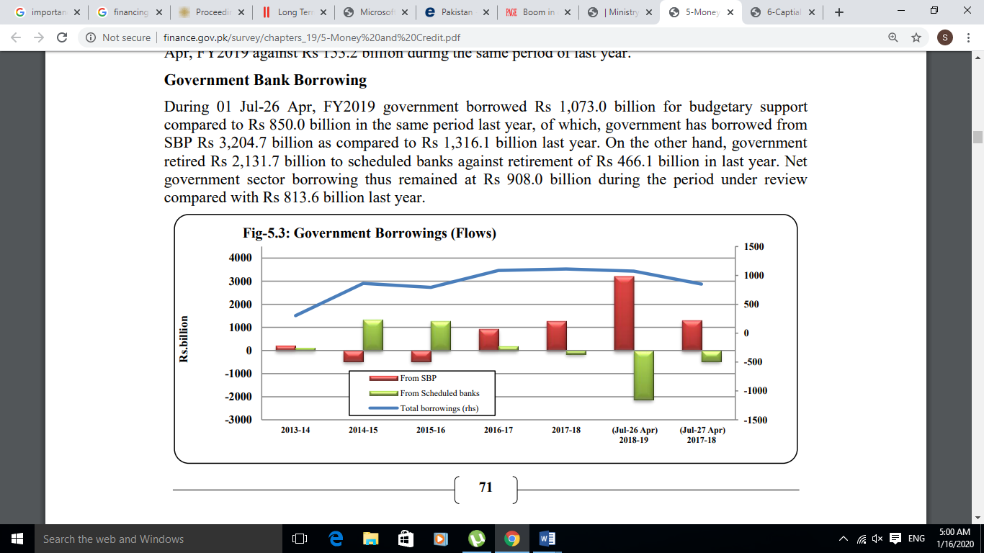
During 2018-2019, total government borrowing stood at Rs 1073 billion, growing 26% from the prior year; private sector borrowing was at Rs 775 billion, having grown a sluggish 3.47%. Banks are more willing to lend to the government, since lending to the private sector is considered a risky move. Combined with the government’s propensity to borrow in full, this impacts the private sector firms, limiting the availability of credit, especially for SMEs (Economic Survey of Pakistan, 2019).
Figure 4.1 Government Borrowing (Flows), 2014-2018

Theability to post profits even during a weak economic environment also incentivizes banks to lend to the government, whenever faced with a choice. However, while a stable avenue for risk-free earnings, investment in government securities is not as productive as lending to businesses.

Types of Financing
Banks in Pakistan broadly provide two types of financing: short-term and long-term, with recoupment under 5 years or between 5 to 10 years, respectively. Manufacturing, and especially major players—textile, engineering, agro-based, and chemical sectors—employ a significant portion of the population and are particularly hurt by the unavailability of accessible long-term financing, from banks’ inability to block capital for longer periods of time.

Loans can either be in the form of ‘running’ finance, to meet short-term funding requirements; cash finance, which can be processed speedily, or term finance with a longer tenor, with a structured repayment schedule and fixed installments (SMEDA, 2020). Loan amounts vary from a minimum of Rs 10,000, up to a maximum ceiling of Rs 75 million, and the processing time for a loan is anywhere between 7 to 45 days, generally increasing with the sum involved.

Poor Financial Inclusion for Small Businesses
There are two elements barring access to finance in Pakistan: the inability of lending banks to be financially inclusive in terms of debt, and the poor availability of flexible equity.

With regard to debt, since banks meet their annual lending and portfolio requirements through lending to government, there is little credit left over for private business. On the demand-side, interest rates under the IMF program are astronomical, which makes it insensible for firms to borrow.

This issue particularly harms SMEs.As of 2019, Pakistan has an estimated 38 million SME firms, of which0.8 million are industrial units, 59% of which are based in rural areas—the remaining are urban (Business Recorder, 2019).

In 1998, the Small and Medium Enterprises Development Authority (SMEDA) was established, and in 2007, SMEDA announced its first SME policy, and soon after an SME bank, which would go on to become privatized. After middling to forgettable results, a revised national SME Policy 2017 was proposed—adjusting from past errors, but leaving room for improvement.

A major reason behind inadequate assistance to the SME sector is the non-provision of loans at affordable interest rates; the rules for obtaining these loans continue to disadvantage SME firms, who find it cumbersome at their small scale to keep machinery, assets, and factories as collateral to finance their operations.

A change in these rules was led by the State Bank of Pakistan’s announcement of separate prudential regulations for SMEs; this afforded firms the ability to procure loans based on a feasibility report, and mortgages were done away with. However, non-compliance to these rules means that banks continue to charge interest rates near 18-20% and continue to demand assets as collateral.

Another drawback for SMEs is that their forms of collateral may not be traditional and therefore are not recognized by banks.This collateral often exists in the form of an existing order from a client. According to our KIIs, banks in Bangladesh are more receptive in comparison to Pakistan, and willing to take up the risk and open a line of credit to firms, particularly in the case of export orders. In a 2011 World Bank report, SMEs that had acquired formal credit from the banking sector was 7% in Pakistan, little over one-fifth of India (33%) and Bangladesh (32%) (McCartney, 2011). From an estimated 4.5 million SMEs in the country, only 163,000 borrowers are registered with financial institutions (banking or non-banking), and SMEs only capture 10% of all available credit. New SMEs with informal setups are unable to meet compliance requirements or post collateral, and the hesitant lending behavior of banks often leaves only informal sources of finance available, such as friends and family (Karandaaz, 2019).

In comparison to Pakistan, Japan has excelled in putting SME firms front and center.Despite a solid industrial base and many internationally renowned firms, Japan has 4.2 million SME industrial units which employ 20.84 million people, over twice the workforce of 10.22 million for large-scale industry in Japan, which only consists of 12,000 unit. This indicates the country’s long-held emphasis on ensuring that smaller businesses can survive and thrive within the state apparatus.

However, one of the KIIs cited the positive example of Karandaaz Pakistan, a non-profit promoting access to finance for SMEs and micro-businesses, which may be willing to lend to vendors working with large companies: for example, Toyota, or Millat Tractors, who will vouch for these vendors. In 2019, Karandaaz Pakistan aimed for Rs 10 billion to finance SMEs (Karandaaz, 2019).

By and large, however, there is a moral hazard in lending to firms, as there is information asymmetry in the absence of proper credit registries (although they are being developed). Banks cannot justify risking higher cost per relation by lending to SME firms, which in turn hesitate to enter the complex, formal environment of banking—full of consequence and recorded debt. Unfortunately, a firm can only maintain a credit history (and a working relationship) by using banks.

Barriers to Private Equity
On the equity market front, the prime obstacle is in the ease of securing partnerships. Traditionally, a startup may look for an investing partner to provide equity; enterprisesgenerally seek a risk-sharing partner before approaching a bank for a loan. With the historic 18th Amendment in April 2010 that devolved the majority of legal subjects to the provincial level, the administration of partnerships was also devolved to provinces, where implementation has been poor.

In a similar vein, venture capital firms are neither bound nor facilitated, by appropriate regulations from the Securities & Exchange Commission of Pakistan (SECP). Banking regulations make it difficult for foreign VCs to repatriate profits back home, and startups of this kind are forced to register abroad, as non-banking financial companies (NBFCs), which means they must navigate other roadblocks in local operations.

Pakistan’s challenge with access to finance is therefore two-fold: inadequate government facilitation of SME firms, and an inability to update legislation to keep up with business, which is a fast-moving space.

Market Access
Conventionally, market access is the ability to reach markets and sell products and services across borders; while this largely entails international trade, it can also refer to domestic trade between provinces, particularly since connectivity and infrastructure issues can prevail anywhere. The typical aim of negotiating market access is to benefit one’s export industry while limiting one’s market to importers. On the whole, free trade benefits consumers through lower prices and high variety of goods, and while nascent industrial sectors may benefit from some protectionist safeguards, in the long run they ultimately gain relatively more through efficient and ubiquitous market access than short-term protection from losses.

Augmenting Market Access
To disburden the Pakistani Rupee and steer the country out of economic crisis, Pakistan has been seen strengthening trade ties and making efforts to get access to developed markets, particularly China, Indonesia, Qatar, and European countries. Abdul Razak Dawood, the Prime Minister’s Adviser for Commerce, Investment, Industries, Production, and Textile, laid explicit emphasis on the necessity of reviving exports for any sustainable economic growth, and the need to understand this at a policymaking level.

With regard to existing trade agreements, the principal subject of most policymaking is now the China-Pak Economic Corridor (CPEC), part of China’s Belt and Road Initiative.The multilateral enterprise aiming to connect Asia to Africa and Europe via land and maritime network is dependent on CPEC in particular, which will provide China access to sea via Pakistan, in return of infrastructure and energy projects all over the country.

The second phase of the China-Pakistan Free Trade Agreement is also now in effect. This is accompanied by an opportunity for the manufacturers and traders in Pakistan to export over 300 new products to Chinese market without any duty costs. However, the textile sector of Pakistani industry is expected to benefit the most. Initially under the first phase of the FTA, Pakistan was enjoying duty free export of more than 700 products to China, whereas, now with an increase in the number of products, it also has a chance to strengthen its other industries such as agriculture, leather and confectionary (Ministry of Commerce, 2020).

Under the new round of the Free Trade Agreement, the incumbent government has expanded its scope—not only with reference to trade in practice, but also with initiatives to strengthen the skill and capacity building of local industrialists. The FPCCI has been directed to establish thinktanks to carry out research in the area, and plans to arrange visits to China to study its industrial sector. The FTA also promises to reduce production costs as the zero tariff imports include machinery and high quality production material, which will aid in manufacturing quality import goods, and enable local investors to ramp up local production.

Since the purview of this agreement includes eliminating poverty and uplifting the country’s socio-economic conditions via industrial development, there are several concerns about the agreement: foremost that it may prove more beneficial to China than Pakistan, since Pakistani industrialists may not be able to compete with Chinese firms. However, in terms of the promise of increasing industrial operations, the opportunity is a vital one.

Pakistan’s other significant trade relationship, with the United States, also saw a recent uptick, hitting two records in 2017 and 2019. The United States is still Pakistan’s largest export market. The US-Pakistan Trade and Investment Framework Agreement (TIFA) remains in play, with ongoing discussions aiming to improve digital trade and strengthening intellectual property rights for Pakistan’s business climate.

Within the region, the 2010 Afghanistan-Pakistan Trade Transit Agreement was signed to enable the Afghan region to serve as a trade bridge to Central Asia. However, the advent of smuggling through Pakistani vehicles has massively harmed domestic industry. Officials report that items purchased from Afghanistan are sold back at exorbitant rates; merchants in Afghanistan have been assisting Pakistani traders in importing goods under the guise of trade, transporting them to Afghanistan, and then pirating them over into Pakistan. This, coupled with political friction between the two countries, has led to numerous border closures and ban on consignments in the past. There is an incumbent need for both countries to sit together to reform the trade agreement to ensure regional stability.

Non-Tariff Barriers
A report published by the Asia-Pacific Trade and Development in 2019 states thatnon-tariff measures affect approximately 58% of regional trade. They are often rendered to weaponize trade policies, to carry out important functions like protecting human health, consumer safety, and ensuring a clean and sustainable environment.

Under Pakistan’s agreement with the World Trade Organization, sanitary and phytosanitary (SPS), and technical barriers to trade (TBT) pose great challenges to Pakistani exportersin terms of quality and standard maintenance. There are many examples when quality issues have had adverse effects on Pakistan’s trade, particularly regarding foodstuff. Pakistan’s mango exports have been banned by Japan, Germany and Australia, and are under risk of ban by the European Union. Similarly, Belgium, Sri Lanka, Philippines, and USA have also reported their concerns related to SPS and TBT, which have been haunting the country since 1995.

WTO members are expected to monitor the proper implementation of these non-tariff barriers. However, Pakistan’s exports have been harmed by stringent health and safety measures wielded unnecessarily, which may be well-intentioned, or an insidious proxy to either protect the interests of domestic producers or to gain maximum comparative advantage in foreign trade.

A study titled “The Impact of TBT and SPS Measures on Japanese and Korean Exports to China” (John Wood, 2019) finds that both Japan and South Korea export medium to high value products to China—whose membership in the WTO has raised its health and food safety standards, increasing its demand for high quality products, and consequently leading to a strict implementation of the TBT and SPS requirements. While for Japan this led to a loss of exports, South Korea made gains, since its exports are largely processed goods which remained protected by NTMs. This serves as a good example for how South Korea has managed to combat the negative impact NTMs tend to have on a country’s trade flows. China’s SPS measures have helped South Korea’s agricultural exports, since the criterion has compelled the quality of its agricultural produce to rise. A growing understanding of health and safety standards is, thus, forcing exports to focus on quality goods; there is room for Pakistan to make similar strides in exporting processed goods, to help shed its repute as an exporter of low quality food items.

Connectivity, Infrastructure, and FDI
Market access is also key for buyers in the form of investors, particularly from outside Pakistan, and connectivity is vital to enabling this access: both in the physical sense of roads and transportation networks, as well as virtual connections through telephone and internet networks. Without this infrastructure, and more crucially, the visibility of this infrastructure, foreign direct investment (FDI) will remain low.

Our interviews brought out the “crisis level” in Sindh in terms of infrastructure: the absence of paved roads and proper sewage, and the poor optics when investors visit a factory. Since investment is a function of trust, they are wary on visiting a food production factory and pass open sewage on the way. On example is of how flower suppliers in interior Sindh boasted that they had some of the best roses in the world, but the numerous forms of uncertainty in transporting these to urban centers (Karachi) would not let the business be profitable. This extends to most perishable goods, including fruit, vegetable, and horticulture goods. Similarly in Swat, alongside perilous roads carved into mountains, there is also a land rights issue originating from recent military operations. In Gilgit-Baltistan, apart from an army-run network service, internet connectivity can be spotty.

Issues of connectivity add up to the perception that Pakistan’s investment climate is poor, and there is little long-term thinking dedicated to improvements on this front.

Political Economy
The intersection of politics and the economy can be vast, and in the interest of covering our scope, we focus on two large intractable issues Pakistan faces in terms of political economy: the principle-agent problem of corrupt officials and short-sighted policymakers, and the political dimensions of Pakistan’s history with external assistance, particularly its reliance on the IMF and an address-book of allied countries.

Moral Hazards in an “Overdeveloped State”
The KIIs highlighted several examples of the principle-agent problem persistent throughout any and all industrial policy in Pakistan: that those in the position to administer (and therefore reform) policies stand to lose the most from a fixed system.

As described in Section 4.1, firms harbor widespread distrust about government actions because their experience with field officials—inspectors, taxmen, auditors, civil servants—is often sub-par, and the latter’s behavior predatory and hostile.

Recent developments discussed elsewhere in this work bring to the forefront the classic work of Dr. Hamza Alavi, whose position that Pakistan is an “underdeveloped country with a developed state” is relevant today. There is also a discrepancy between actual and popular understandings of elite capture: populism targets “middle-class angst” as per Dr.Asad Saeed, in the form of utility prices and school fees, but little attention is paid to land grabs and tax breaks (Saeed, 2019).

A working paper by Dr. Allan Dwyer names an entrenched elite with a political stronghold: the Pakistan military and security services. He notes Stephen Cohen’s proposal of viewing Pakistan’s place in the world—and its decision-making—first on the obvious front as an “indispensable refuge for India’s Muslims”, but also notably as an “unstable nuclear-armed entity with a worrying history of tepid democratic periods interspersed with ‘benign authoritarianism’ at the hands of the military” (Dwyer, 2016).

Geopolitics, Trade, and Aid
Extending the discussion above is TV Paul’s (2014) “geostrategic curse” argument that Pakistan’s centrality on the map of Asia means that governments have found it “advantageous to push economic and social development to the back burner as they have accepted aid from various external courtiers, most notably the United States and Saudi Arabia.” Paul states that “rentier” elites overstate the likelihood of conflict with India to maintain their influence.

For example, the Imran Khan government approached the IMF for Pakistan’s 22nd assistance package, but the Prime Minister’s first priority after his mid-2018 election was to seek out external help from a host of historical allies: Saudi Arabia, the UAE, Malaysia, and China among them. The PTI had first campaigned vocally against the “begging bowl” mentality of prior administrations, but eventually conceded to IMF assistance in the face of a dangerously growing current account deficit.

Human Capital and Technology
As our literature review hinted (Section 2), manufacturing’s prime benefit over the agriculture and services sector is the rapidity of making nonlinear technological progress, and its consequential spillover effects, within and beyond manufacturing itself. The crux of Akamatsu’s Flying Geese Paradigm (Section 2), relies on technological sophistication, without which high-performing ‘geese’ such as Japan, would be unable to take up the production of capital goods, shedding lower-value goods down the formation—which also rely on technology transfer or innovation to continue the process.

In two decades that witnessed a promising diffusion of technology across sectors, Pakistani firms trail behind others, and the country’s exports “remain concentrated in low value-added and low quality product segments” (Mahmood et al, 2005).

Poor Incentivization for Skill Development
Small Pakistani firms traditionally purchase secondhand equipment, often from firms that close down elsewhere, for example, in Europe. Since our export market is price-competitive, firms earn low margins and can invest little in upgrading machinery.

In comparison, Bangladesh and Vietnam have found success with bonded warehouses. High-performing governments, tend to incentivize specific technology acquisitions, which bring spillovers across the economy. For example, this was the original motivation for Toyota’s partnership with DENSO; if Toyota comes to Pakistan, Thal Engineering may then partner with DENSO which will help Pakistan acquire technology, and pair it with skill development training.

However, the absence of skill development also discourages continued investment in the country. Quoting an electric fan manufacturer, one of our interviewees drew the comparison between local labor, which he considered “alif bay wala” not “ABC wala” i.e. skilled in Urdu, but not English. This implied that if laborers cannot even read the manual to operate the machine, the country isseriously lagging behind.

Recent Developments
The adoption of new technology that raises productivity is significant for industrial development, but often the pace at which this occurs can be the make-or-break factor—and is often very slow (Bloom et al. 2013).

A survey studying innovation at a textile firm, that aimed to assess correlation between product innovation and industrial productivity, showed high labor productivity—10%—as a consequence of product innovation. On the other hand, larger firms and export-oriented industries were found more inclined towards technology adoption and innovation; notably, the study also revealed that firms which received national subsidies were less likely to adopt innovation techniques (Wadho& Chaudhry, 2018).

Figure 4.1 highlights that Pakistan lags behind other developing economies in terms of technological advancements—because technological upgradation is often less incentivized, the resource pool for R&D remains meager and kept at a low priority, and the link between academia and their contribution to industry is under-developed. According to Mangla& Din (2015), Pakistan’s low industrial output is the reason of constraint to achieve global competitiveness; due to less than ideal industrial and trade policies which do not drive firms towards productivity improvements, underutilize human capital, and maintain an unfavorable business environment.

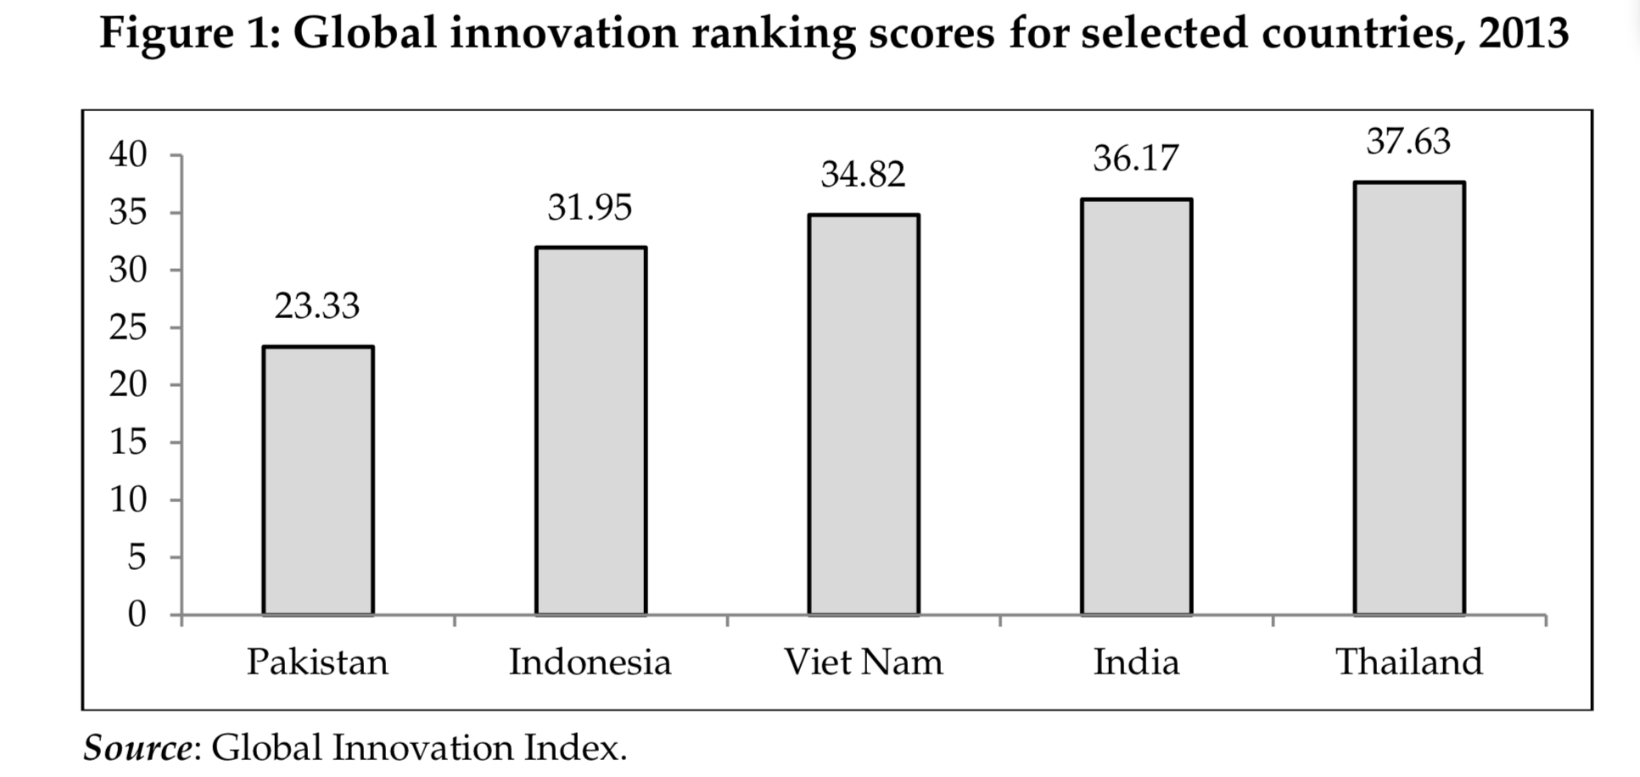
Figure 4.2 Pakistan vs Others, Global Innovation Index, 2013

Another major impediment is the lack of skilled human labor; in the IT sector, the retention rate of highly skilled technical labor remains low, and brain drain possibilities high (Hassan, 2014). The unavailability of skilled workforce hampers the formation of high-tech firms and leaves less room for improvement for existing industries. Limited numbers of experts are present in professional as well as academic and research fields. (Rahman et al., 2005).

The adoption of technology and increasing innovation can be source of job creation. A survey-based study was performed by the textile and apparel sector of Pakistan that demonstrates the fact that technology advancement is instrumental in employment creation.

The critical role of robust public policy in enhancing entrepreneurship and fostering conducive environment for innovation and technology is well establishedto ensure economic growth and industrial up gradation.The linkages between science and technology and industry have to be developed. A multi-pronged industrial strategy is required to strengthen industrial success on premise of technological innovative improvement. The developed strategies should take into consideration the important aspects human resource development boasting market competitiveness, and providing incentives to modernize.

Energy
Pakistan’s industrial sector, especially SME firms, have long been at the mercy of the energy sector. Frequent load-shedding and power failures have driven firms to adapt: according to a 2012 firm-level survey, 23% used an uninterrupted power supply device (UPS) and 38% used generators to meet their electricity requirements (Amjad et al, 2012).

Energy over the years
A negligible industrial base in 1947 meant that Pakistan’s nascent industrial performance was less tied to energy provision. The Pakistan Industrial Development Corporation (PIDC) was set up in 1952 to create such an industrial base. In the 1970s, the country pursued a state-led industrialization approached based on heavy industry. War with India, the separation of East Pakistan as Bangladesh, combined with oil shocks and public deficits to land a major blow to manufacturing, and growth fell from 7.8% in the 1960s to 3% in the next decade. However, with total consumption at 7700 GWH and generation capacity at 11000 GWH, energy was not a contributor (Economic Survey of Pakistan, 2010).

Reversing nationalization in the 1980s, Pakistan transitioned to an import substitution approach; the industrial sector moved to 23.2% of GDP, marginally above 22.7% in the 1970s. The need to increase generational capacity in the mid-1980s led to the Integrated Planning and Policy Formulation (IEP) but it quickly fizzled in favor of Independent Power Producers (IPPs) with the presumption that the market will sort out any gaps in capacity.

However, under the International Monetary Fund’s directives in the 1990s, the air thick with free-market policies, deregulation and liberalization sped up a shift towards a services-based economy. Industries made a value addition of 24% to GDP in the 1990s, compared to nearly 50% by services. The government’s 1994 Power Policy guaranteed to IPPs a 15 to 18% rate of return in US dollars, without much regard to progress by WAPDA or KESC—setting the stage for exponential circular debt once the rupee would fall (Yasmin and Qamar, 2013).

Learning from others
The developed world is on the path of restructuring the industrial sector since the 1970s. This phenomenon has been attributed to the higher productivity growth of the industrial sector, North-South trade, and outsourcing of the manufacturing sector.

Globalization has some impact on de-industrialization in OECD countries, and it can be concluded that the fall in manufacturing employment in the developed world has resulted from the outflow of investment from North-South trade—in which energy played a pivotal role. China’s case underscores the importance of power capacity, without which it would not transition to capture a majority of global trade.

For developing countries, power generation policy shifts are the major cause of deindustrialization. Recent lobbying efforts and global agreements for environmental sustainability have led governments to adopt eco-friendly energy. Nigeria is a predominant example of how energy can transform industrial outlook: with 60-70% of the Nigerian population deprived of reliable access to energy, and a general crisis in place for three decades, industrial growth is at a halt, and productivity in shambles.

Current challenges
In the 2000s, consumers of electricity shot up from 8 million (1992) to nearly 20 million (2008), but shortfall was at 37% of demand. Although Pakistan has a hydropower advantage, its fuel mix with thermal remains less than thoughtful—from 60:40 in 1980 to 30:70 in 2000, raising electricity cost nine-fold between WAPDA and IPPs.(Munir and Khalid, 2012).

The National Power Policy 2013 aimed to meet manufacturing demands, encourage energy conservation, minimize line losses, and increase distribution efficiency. However, the government must accompany this with several radical changes. Foremost to go must be Pakistan’s unhealthy dependence on furnace oil, which was ramped up in the wake of the 1994 Power Policy, as 60% of energy is generated through thermal stations. IPPs operating in the absence of international bidding procedures, the untargeted timing of plants commissioning and their sites, and the haphazard location of IPPs away from load centers and the Northern Areas—laying a service strain on the state’s physical infrastructure—are all prevalent issues.

Within the business of electricity generation in the status quo, there is massive room for improving efficiency. One estimate reports that 70% of thermal installations work inefficiently, and consume on average 0.22-0.35 kg of fuel to produce one unit of electricity, which increases generation costs notified by the government, leaving a gap recovered through subsidy.

A second source of inefficiency is high transmission and distribution losses, with record highs of 63.6% and 56.9% being reported in Bannu II (Khyber-Pakhtunkhwa) and northern Sindh, respectively (“Distribution firms suffer…”, DAWN, 2019).

Discussion

Implications for Pakistan
General themes that emerge from specific weaknesses across these 7 areas include poor public-private dialogue, poor implementation of otherwise well-intentioned regulation, a difficult uphill battle for reform in the face of perverse incentives to keep the system broken, and massive room for catch-up on several fronts, especially energy, connectivity, and access to finance.Compared to earlier times, Pakistan has dropped the ball on competing with the region in near-permanent fashion—losing potential gains from trade and industrialization to neighbors, most prominently Vietnam, Bangladesh, and India.

The gaps in implementation identified across Section 4 are naturally those that will offer the most immediate gains in industrialization if remedied, and they cannot come at a more pivotal moment: there is significant doubt that on its own, the 13th IMF bailout deal worth $6 billion will bring much long-term benefit to Pakistan’s growth. Kaisar Bengali, former government economic advisor, believes the IMF package, while relieving the balance-of-payments gap, will not fulfil Pakistan’s requirements (“IMF Bailout Package”, 2019). The PTI-led government was also criticized for aggravating the fragile position of the country by holding back on the IMF structural adjustment program until it was too late (“Pakistan Seeks IMF Bailout”, 2019). As of this writing, with inflation at 8% and a deficit of $12 billion, the country was only good for two months of imports when it made the deal. Moeed Yusuf, then a Pakistan expert at USIP, and now an advisor to Prime Minister Imran Khan, has predicted that “the next two years are going to be very difficult” (“Imran Khan Swallows Pride…”, 2019).

For Pakistan to recover from this position, structural reform is necessary, and concerted efforts along these seven drivers can help take the first step towards it regaining competitiveness in the international market, and playing to its strengths.

Policy Recommendations

General Recommendations
From the analyses above and our KIIs, we can extract a handful recommendations that are broad-based, in that they require work and deliver benefits across multiple drivers.

First, it is important to ensure transparent and candid public-private dialogue both between government entities and between government and businesses—this will bring efficiency not just to institutional operations and Doing Business sub-indices, but also demand planning for energy, better financing policies for SMEs, and other spillover effects; one can presume there is a raft of small business concerns that can begin to be addressed once this dialogue comes to fruition.

Second, it is essential to steer public policytowards an evidence-driven plan grounded in 21st century market realities—e.g. in deciding where government subsidies, tax cuts, and other favorable policies go, it is important to favor sectors based on their long-term profitability, existing demand, and marginal benefit to the wider economy. This runs contrary to previous state policies which—as discussed above—have, for example, privileged the local automobile manufacturing industry, to no apparent long-term success.

Third, for every physical interface between government and businesses—and particularly where inspections, regulations, and the imposition of fines and punishments are involved—there is a dire need to ensure that officials are incentivized to play an impartial and facilitatative role, free of corruption and manipulation by either side, and held accountable otherwise.

Institutional Remedies
- Above all, the government ought to evaluate the quality of its public-private dialogue and work to establish a channel that communicates clear intent and good faith, and reduces the fear of being hostage to business groups. Such a line of communication must be able to identify serious concerns and must be more inclusive of larger voices through dialogue with sector associations and city based commerce chambers. (Section 4.2 and 4.5).
- Implement a ‘Regulatory Guillotine’ to the framework of regulations, which is a trademarked approach by Jacobs, Cordova & Associates developed in 2004 to scientifically cut down the many fragmented and outdated rules and formalities that accrue in governments over the years. A telling example for Pakistan is how for the local government to make changes to a mansion at Lahore’s Mall Road, it needed a no-objection certificate from the irrigation department—courtesy of canal tributaries that once passed through the area, and an archaic regulation left untouched by civil servants who were uninterested in ceding power.

Macroeconomic Policies
- There is near-universal consensus that the foremost priority must be to widen the tax base, which involves making the tax regime simple to grasp, removing complex, multi-tiered tax criteria, and reduce reliance on short-sighted amnesty schemes.
- There is a need to strike a balance where our exchange rate is stabilized but responsive to market realities—the focus must be on an all-hands-on-deck commitment to reorient Pakistan toward export promotion, over artificial adjustments to the exchange rate.
- Above all, the government must gather the political will necessary to bring impartial and equitable tax and subsidy strategies that end the present-day distortionary effects which only provide advantage to certain sectors—textile, automobiles, sugar, for example—and open up opportunities for new and emerging sectors—IT, value-added garments, chemicals—and the growth of smaller sectors, such as sports and surgical goods.

Improving Access to Finance
- Encourage and provide guarantees to flexible forms of collateral for SMEs, such as export orders, or OEM guarantees.
- Encourage the entry of venture capital firms, and amend SECP regulations to make repatriation of profits smooth and straightforward. New firms find it difficult to enter contractual relationships with nothing to show of repute, and VCs can help shore up this initial risk, once they assess the promise of an innovative idea.
- The government must reconsider high withholding tax on bank withdrawals, to encourage bank deposits and savings.
- Following from our recommendation to widen the tax base in Section 5.2.2, such an improvement will also reduce government borrowing from private banks, increasing the credit available for SME firms.
- Leverage rising smartphone penetration and Pakistan’s competitive cellular provider industry to improve access to digital banking that is user-friendly, ubiquitous, and free of astronomical processing fees. Above all, the State Bank must match banking regulations in countries such as China, and now India, where digital payment/wallet services have seen remarkable penetration, as an alternative to traditional banks.
- Empower Pakistan Stock Exchange members to act as primary dealers to develop the bond market.
- Make information about government lending and credit schemes widely available so that there is clarity of available financing options to firms emerging in underprivileged areas, and the creation of small industrial units is not held back. As a corollary, run media campaigns about schemes such as KamyaabJawan.

Market Access
- Provide a single channel for official communication on the progress of CPEC, including a dashboard for project completion, especially as it affects industrial areas. The perceived opaqueness of the $46 billion project is its own enemy.
- Focus on shoring up regional trade opportunities with Iran, Afghanistan, and Central Asia, to reduce dependence on China, and to compensate for recent trade losses with India, following political isolation over Kashmir in August 2019.
- In the long-term, trade with India is crucial. Pakistan’s political leaders should make trade with India agnostic of regional politics, since conflict at the border has cost us billions, especially in the last two decades.
- Identify weak infrastructure in and around industrial estates, especially outside Punjab and riverine areas, and invest in physical infrastructure, telephony, internet connectivity, and sewage.
- In addition, it is important to target markets with excessive regional unmet need and a window of opportunity, such as in fruit pulp and similar value-added goods. These will require a concerted effort to invest in cold chain and storage facilities, to ensure that perishable goods can be preserved and delivered based on demand.

Political Economy
- There is no outright solution to reform low-level corruption in field officials, but moral hazards can be reduced by ensuring accountability for audit and inspection teams.
  - Make it easy for firms to identify misconduct by preparing, updating, and notifying firms of regulations and procedures well ahead of time.
  - Make it easy for firms to report any misconduct through a single-window mechanism, akin to an online portal.
- In the long-run, parallel to a ‘regulatory guillotine’, it is essential to reduce the likely politicization of government officials, and the bureaucracy as a whole. Policy research on making public procurement honest and efficient, rewarding civil servants with preferred postings and performance bonuses, and other efforts in this regard must continue to be piloted and implemented en masse.

Human Capital and Technology
- Commit to partnerships where we invest in developing the skill of labor if a foreign investor can help us acquire the technology—subsidies on this front brings huge spillovers.
- With the 18th amendment, the federal government can no longer legislate on education, but it can help encourage and subsidize technical education and vocational training, and provide grants-in-aid for provinces to set and reach minimum standards for skill development.
- To make any inroads in technology acquisition, it is important to recognize upcoming pioneer sectors and provide them with adequate, time-bound protections and subsidies to ensure they can reach profitability.
- India has an exceptionally strong software services sector since the early 2000s. An investment in local software houses and computer science education will help Pakistan catch up and pay dividends in the long-term as firms in developed countries continue to offload software solutions services to the developing world.

Energy
- Reconsider the current unhealthy fuel mix that has left Pakistan dependent on furnace oil and fossil fuels in general.
  - Promote the use of solar energy and bio-gas for commercial use to conserve gas for industrial units, wherever possible.
  - Recoup gas relieved from the cement industry and inefficient thermal stations for reuse.
  - Renegotiate the price of LNG with Qatar which stands at $20/MMBtu.
- A significant portion of CPEC energy projects are thermal-based; where possible, renegotiate to transition these toward renewable energy.
- Where limited to thermal stations, invest in upgrading machinery to provide clean and efficient conversion to energy. The economic benefits of Prime Minister Imran Khan’s proposal to reduce import duties for scrubbers—in a bid to reduce smog in Punjab, particularly Lahore—can be extended to any and all machinery that increases environmental sustainability in industrial practices.
- Develop a web-based procurement system to import oil and gas.

Conclusion
This paper sheds light on some weaknesses in Pakistan’s present-day implementation on drivers that should promote industrialization and competitiveness. Among other things, we have identified the broad themes that are symptomatic of Pakistan’s policy challenges: the lack of transparent communication in good faith between government and the private sector, which leads to information asymmetry and enables corrupt and predatory practices by public officials, an informal economy that develops from this distrust of government, which weakens revenue generation, increases government borrowing at the cost of financing for SMEs, decreases investment in infrastructure, connectivity, energy, human capital or technology, and sours the country’s investment climate.

Future Work
From an academic standpoint, our work is a collection of—and in some places provides an update to—policy considerations that are essential for promoting industrialization, rather than the contribution of new and original research to the study of industrial growth.

Future work will do well to study, in greater depth, the historic elite capture of policymaking. In general, our work would benefit most from research dedicated to economic history, since early cross-country analyses of Pakistan’s economic policy juxtaposed with other Asian and/or developing countries is minimal. Looking for inflection points in history, particularly to identify what may have poisoned our prior industrial policies, may be a useful point of departure.

Bibliography
Abbas, S. &Waheed. A (2017). Trade competitiveness in Pakistan: Evidence from the revealed comparative advantage approach. Competitiveness Review, 27 (5), 462-475. doi:10.1108/CR-12-2015-0092
Akamatsu, K. (1962). A HISTORICAL PATTERN OF ECONOMIC GROWTH IN DEVELOPING COUNTRIES. The Developing Economies, 1: 3-25. doi:10.1111/j.1746-1049.1962.tb01020.x. Retrieved from https://www.ide.go.jp/library/English/Publish/Periodicals/De/pdf/62_01_02.pdf

Alesina et al. (1992). Political Instability and Economic Growth. J Econ Growth 1, p. 189–211 (1996). https://doi.org/10.1007/BF00138862

Amjad, R. et al. (2012). Export Barriers in Pakistan: Results of a Firm-Level Survey. Lahore Journal of Economics, Department of Economics, The Lahore School of Economics, vol. 17(Special E), pages 103-134, September.

Arifeen, M. (2018, April). Pakistan Economist. Retrieved from http://www.pakistaneconomist.com/2018/04/30/proposed-subsidies-2018-19-hope-meet-goals/

Ashutosh D. G. (2019). Ease of Doing Business in India: Challenges & Road Ahead. International Journal of Management Studies, VI: 1, p. 114-119. Retrieved from http://researchersworld.com/ijms/vol6/issue1_1/Paper_15.pdf

Broadening access to financial services. State bank of Pakistan annual report FY17. State Bank of Pakistan. http://www.sbp.org.pk/reports/annual/arFY17/Vol-1/Chapter-4.pdf

Conference report – Financing to support make-in-Pakistan. Pakistan Business Council. https://www.pbc.org.pk/proceedings-of-the-financing-to-make-in-pakistan/

Federal Board of Revenue (2019). The Pakistan Single Window Act, 2019. First Draft. Retrieved from http://download1.fbr.gov.pk/Docs/2019721571628176FirstDraftPSWAct-2ndJuly,2019(1).pdf

Gul, I. (2017, March). Global Village Space. https://www.globalvillagespace.com/pak-afghan-border-reopened-alternatives-for-pakistan/

Haraguchi, N. et al. (2019). What factors drive successful industrialization? Evidence and implications for developing countries. Structural Change and Economic Dynamics, 49, p. 266-276, https://doi.org/10.1016/j.strueco.2018.11.002. Retrieved from http://www.sciencedirect.com/science/article/pii/S0954349X17302400

Hausmann, R et al. (2005). Growth Accelerations. J Econ Growth 10, p. 303–329. https://doi.org/10.1007/s10887-005-4712-0

Human rights due diligence in Pakistan. Ethical Trading Initiative. https://www.ethicaltrade.org/sites/default/files/shared_resources/human_rights_due_diligence_in_pakistan.pdf

Hussein, M. A. Industrial finance in Pakistan. Punjab University. http://pu.edu.pk/images/journal/pesr/PDF-FILES/5%20HUSSEIN%20Industrial%20Finance%20in%20Pakistan-1955.pdf

Industrialization in Pakistan (2002, January), Dawn News. https://www.dawn.com/news/13697/industrialization-in-pakistan

Industry specific opportunities and threats. State Bank of Pakistan.http://www.sbp.org.pk/publications/pak-india-trade/Chap_4.pdf

Jabri, P. (2019, February 25). Special Economic Zone to establish on priority: BOI. Business Recorder. Retrieved from https://www.brecorder.com/2019/02/25/476936/special-economic-zone-to-establish-on-priority-boi/

Kaldor, N. (1967). Strategic Factors in Economic Development. New York: Ithaca.

Karandaaz. (2019). The unbanked: A hundred-million question. (2019, March). Karandaaz. https://karandaaz.com.pk/blog/unbanked-hundred-million-question/

Khan, I. (2019, September). Dawn News. Retrieved from https://www.thenews.com.pk/print/525152-financial-inclusion-in-pakistan

Lankes, H. P. (2002). Market access for developing countries. Finance and Development, 39 (3).

Malik, M. S. (2019, April). Xinhua. http://www.xinhuanet.com/english/2019-04/30/c_138025459.htm

Martorano, B. et al. (2016). Catching Up, Structural Transformation, and Inequality: Lessons from Asia. Asian Development Bank Economics Working Paper Series No. 488. Retrieved from SSRN: https://ssrn.com/abstract=2811540

McCartney, A. (2011). Best Practices and Policy Insights. Developing a Sustainable SME Banking Franchise in Pakistan, 2011- IFC, World Bank Group.

Munir, K. A. and S. Khalid (2012). ‗Pakistan‘s Power Crisis: How Did We Get Here‘. LahoreJournal of Economics. 17(3). pp. 73-82

Mustafa, A. & Noor-e-Hera. (2017, October). Dawn News. https://www.dawn.com/news/1367105

National finance inclusion strategy. Government of Pakistan: Ministry of Finance http://www.finance.gov.pk/

National power policy 2013. Government of Pakistan: Private Power and Infrastructure Board. http://www.ppib.gov.pk/National%20Power%20Policy%202013.pdf

Nisar, A. (2017, August). Pakistan Economist. http://www.pakistaneconomist.com/2017/08/14/7076/

Non-tariff barriers hurting trade in Asia-Pacific. (2019, October). Dawn News. https://www.dawn.com/news/1510583

Ozawa, T. (2005). Institutions, Industrial Upgrading, and Economic Performance in Japan. Edward Elgar Publishing, number 3541.

Pakistan Business Council. (2018). Contours of a New Industrial Policy. Retrieved from https://www.pbc.org.pk/wp-content/uploads/Contours-of-a-New-Industrial-Policy.pdf

Pirzada, A., & Pirzada, J. (2019). After the budget: what’s missing in Pakistan’s export promotion policy? DAWN. Retrieved from https://www.dawn.com/news/1488182.

Pollard, S. (1990). Typology of Industrialization Processes in the Nineteenth Century.

Qurban, Z. (2019, October). Pakistan House. https://pakistanhouse.net/afghanistan-pakistan-transit-trade-agreement-implications-and-failures/

Rodrik, D. (2006). What’s so special about China’s exports? China & World Economy, Institute of World Economics and Politics, Chinese Academy of Social Sciences 14, 5 (2006) 1-19.

Sadhwani, K.R. (2015). Ease of doing business and its influence on foreign direct investment in India. Gujarati Technological University, 40-45.

Sajid, I. (2019, February). Anadolu Agency. https://www.aa.com.tr/en/asia-pacific/2nd-phase-of-china-pakistan-free-trade-deal-in-effect/1661413

Sala-I-Martin, X, et al. (2004). Determinants of Long-Term Growth: A Bayesian Averaging of Classical Estimates (BACE) Approach.American Economic Review, 94 (4): 813-835.

Siddiqui, S. (2019, August). Express Tribune. https://tribune.com.pk/story/2040817/2-pakistan-fast-gaining-access-markets-developed-nations/

Singh, C. P. (2015). Ease Of Doing Business An Efficiency Analysis: Government Vs Private Sector. Ease Of Doing Business: Contemporary Issues, Challeges& Future Scope (Pp. 89-98). Ahmedabad: Gujarat Technological University.

SMEDA. (2020). Credit guarantee scheme for small and rural enterprises. SMEDA. https://smeda.org/index.php?option=com_content&view=article&id=496&Itemid=972

State Bank of Pakistan. SBP’s Priority Areas. sbp.pk.org. Retrieved from http://www.sbp.org.pk/70/sup-14.asp

Szirmai, A. (2009). Industrialisation as an engine of growth in developing countries. UNU-MERIT.

Szirmai, A. (2012). Industrialisation as an engine of growth in developing countries, 1950–2005. Structural Change and Economic Dynamics, 23, issue 4, p. 406-420, https://EconPapers.repec.org/RePEc:eee:streco:v:23:y:2012:i:4:p:406-420.
Thirlwall, A. (2003). Growth and Development: With Special Reference to Developing Economies (7th ed.). Palgrave. pp. 121–122. ISBN 978-0-333-98089-7.

US-Pakistan trade and investment framework agreement aims to create jobs and growth. (2019, May). US Embassy & Consulates in Pakistan. https://pk.usembassy.gov/u-s-pakistan-trade-and-investment-framework-agreement-aims-to-create-jobs-and-growth/

Wood, J., Wu, J., Li, Y. & Kim, J (2019). The impact of tbt and sps measures on Japanese and Korean exports to China. Sustainability, 11 (21), 6141. doi: 10.3390/su11216141

World Bank. (2020). Doing Business Report 2020, Economy Profile: Pakistan.

ZaraiTaraqiati Bank Limited.(2017). Long term industrial finance in Pakistan: Current scenario and history of industrial growth. ZaraiTaraqiati Bank Limited. https://www.ztbl.com.pk/wp-content/uploads/Documents/Publications/Research-Studies/LongtermIndustrFinPK.pdf

Appendices

Interviewees

No. | Name | Designation | Date | Interviewers
1 | Dr Shujaat Ali | Dean, National Management College, National School of Public Policy | 12 Dec 2019 | Khadija Awan,  Nabeel Ahmed
2 | Ahmad Khan | CEO, cheetay.com | 12 Dec 2019 | Syed Kazim,  Siddiq Mahr
3 | NazishAfraz | Teaching Fellow, Lahore University of Management Sciences (LUMS) | 19 Dec 2019 | Nabeel Ahmed
4 | Nadia Jahangir | Director Policy, Small and Medium Enterprises Development Authority (SMEDA) | 19 Dec 2019 | Shahnawaz Khan, Kashmala Tahseen,  Iqra Khan
5 | Sajid Saleem Minhas | CEO, Delta Garments Limited | 19 Dec 2019 | Syed Kazim,  Khadija Awan,

Interview Guide

Our interview guide, finalized on 11 December 2019, is reproduced below in full:

General (Part I)

- In your view, what are the key factors Pakistan must focus on to achieve industrialization?
  - Which of these carry the highest ratio of investment-to-returns?
- What sectors in Pakistan do you think are:
  - Established?
  - Upcoming – with the potential to grow into established?
  - Underdeveloped – where we should invest and grow?

- *The Ease of Doing Business index depends on 10 sub-indices. How do you think Pakistan does (and how can it improve) on each of these fronts?
  - Starting a business
  - Construction permits
  - Getting electricity
  - Registering property
  - Getting credit
  - Protecting investors
  - Paying taxes
  - Trading across borders
  - Enforcing contracts
  - Resolving insolvency

Institutional Drivers

- How effective has Pakistan’s customs and border policy been in driving industrialization?
- How effective has Pakistan’s trade policy been in promoting business-friendly measures?
- What can the government do to improve the quality of regulations to promote private investment?
- What are the challenges to Pakistan’s exporters in complying with global standards and regulations?
- What is the role of labor laws in industrialization, and how has Pakistan adjusted to global requirements?
- Does Pakistan have any hurdles in implementing IP law to encourage entrepreneurship and innovation? How can this improve?
- Are there any standards or regulations that Pakistan must introduce or update to stay competitive in the world market?

Market Access

- What are the main challenges with regards to market access for Pakistani exporters?
- How can the imposition of heavy duties on imports affect the economy?
- With reference to the Free Trade Agreement between Pakistan and China, how do you see Pakistan’s local industries competing in the Chinese market?
- How can the government improve access to information of global trends and techniques to help Pakistani exporters remain up to date?

Financial Access

- In general, how well does Pakistan do on providing access to finance to small and medium businesses looking to manufacture here?
- How well do our banks’ credit policies fare and can they be improved?
- Is the government’s decision to end subsidies for zero-rated industry good or bad for industrial progress?
- What role can schemes such as the PM’s KamyaabJawaan Entrepreneur scheme play in industrial development?

Human Capital and Technology

- Is Pakistan’s industrial sector receptive to adopting and using new technology? Which sectors do well and which can improve on this front?
- We need high-level skill development to ensure the adoption of new technology in industry. What is your view on how we can overcome this barrier?
- Technology adoption can reduce production and labor costs but may cause mass unemployment. How do we address this trade-off?
- Pakistan ranks poorly on labor and technology fronts (130 of 144 on labor market efficiency, 51 in capacity of innovation, 85 in firm-level technology absorption, 96 in wastefulness of government spending, 91 in government procurement of advanced technology products, and 108 in ethical behavior of firms). What would be your suggestions for improvement?

Political Economy

- To what extent have our industrial policies been shaped by political pressure?
  - Such as appealing or catering to a vote bank?
  - By interest groups?
  - By politicians’ own private interests and ownership?
- *Historically, have any stakeholders’ input been excluded in Pakistan’s industrial policies?
- *Historically, which policies were successful in driving Pakistan’s industrial sector?
  - How did they manage to garner consensus from stakeholders?
- What is your view on Pakistan’s reliance on the IMF and the World Bank?
  - Do you believe there have ever been alternatives to asking these organizations for assistance?
  - Is there reason to believe the IMF can help us reduce our long-term dependence on its assistance?
- How do IMF/World Bank-led policies affect our industrial sector year-on-year?

Macroeconomy

- A government’s fiscal policy includes its tax rates and spending levels and patterns. What fiscal policy can the government adopt to drive industrialization?
- A government’s monetary policy is the central bank’s (SBP) control over the quantity of PKR in our economy, by managing money supply, interest rates, and foreign exchange rates. What can Pakistan improve on this front to drive industry?
  - Will a free-floating Pakistani rupee help improve Pakistan’s export competitiveness?

Energy

- What are Pakistan’s largest challenges in providing energy (electricity in particular) to businesses — and how can these be resolved?
- How can the government provide a stable and profitable environment for independent power producers (IPPs)?
  - How can the government ensure the prompt payment of energy?
- What can private industries do to improve their efficient consumption of energy?

General (Part II — concluding)

- What are policy recommendations you would make to:
  - Government policymakers?
  - Private sector businesses?

All comparison data from World Integrated Trade Solution (World Bank)
Source: WITS (see footnote 10)
Source (Figures 2.3 to 2.6): Trading Economics, which uses each country’s annually published statistics. For Pakistan, this includes the Economic Survey of Pakistan and other PBS material.
Source (Figure 2.7 to 2.8): Trading Economics
Source: World Bank DataBank (https://data.worldbank.org/indicator/NY.GDP.MKTP.KD.ZG)
Economic Surveys of Pakistan 2019 and 2011
Based on an interview with Dr. Shujaat Ali (NSPP), whose entire interview centered on examples of why government-business dialogue remains opaque and self-interested.
Based on an interview with Ms. NazishAfraz (LUMS).
Based on an interview with Ms. NazishAfraz (LUMS), from the section on customs policies.
Based on a lecture by Mian Kashif Ashfaq, CEO at FIEDMC, at the Civil Services Academy (February 2020).
Based on an interview with Ms. NazishAfraz (LUMS).
We briefly describe elite capture in a political economy sense in Section 4.5.
Based on an interview with Ms. NazishAfraz (LUMS).
Based on an interview with Ms. Nadia Jahangir, who is Director Policy at SMEDA.
Karandaaz was independently cited in an interview with Ms. NazishAfraz (LUMS)
Based on an interview with Ms. NazishAfraz (LUMS) in recounting her prior work, as well as substantiation in an interview with Mr Sajid Saleem Minhas (Delta Garments).
Based on an interview with Ahmed Khan (Cheetay.com).
Based on an interview with Ms. NazishAfraz (LUMS).
Based on an interview with Mr. Sajid Saleem Minhas (Delta Garments Ltd.); his remarks provided an inside look at upcoming sectors and those historically held back by poor policy.
Based on a lecture Dr. Manzoor Ahmad, Former Ambassador for Pakistan to WTO, at the Civil Services Academy, Lahore (January 2020).

