06 Sep 2013
6 Negative Impacts of Slums
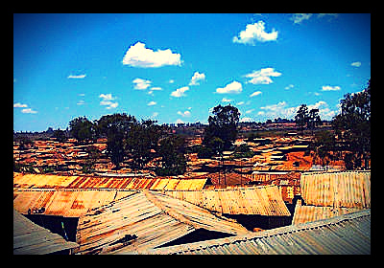
Slums are heavily populated urban areas characterized by substandard housing, inadequate access to clean water and sanitation, and a constantly changing residential population. As of 2012, 863 million people called a slum their home. But, the negative impacts that result from slums are alarming. They affect everything about a community, from education to natural disasters. This article discusses the key 6 negative impacts of slums and their significance.

Top 6 Negative Impacts of Slums

- Women and Girls: Women and girls are not afforded time for education, as they are burdened with carrying water long distances and caring for sick family members. And, in slums with poor (or nonexistent) sanitation facilities, going to the toilet at night increases their risk of sexual assault.
- Health and Child Mortality: Illness and disease spread like wildfire in slums; in the Kibera slum in Kenya, HIV infection is twice the national average, and diarrhea is the leading killer of children under five.
- Education: Social and cultural barriers deny children from slums the opportunity to receive an education. Many children never receive any formal education and few complete a primary education.
- Finance: Banks often refuse residents of slums because they are considered ‘unbankable.’ Without the support of a financial institution, slum dwellers must incur interest charges from loan sharks, which serve to further impoverish them.
- Political and Social Exclusion: Governments often ignore slum dwellers; they are excluded from voting, city development plans, and full protection under the law. Without the rights and voice that other citizens have, people living in slums constantly face political and social exclusion.
- Disasters: Many slum dwellers in developing countries live in danger of a rise in sea level. Storms, earthquakes, and other disasters affect city slums more seriously than other areas, as substandard houses crumble or poor drainage systems promote prolonged flooding.

