

Role of e-Governance in Effective Administration in Pakistan

  - SYNDICATE # 8

Syndicate Advisor: Mr. Hassan Yousaf Shah
Research Coordinator: Ms. Fozia Hadi
Faculty Member: Capt. (Rtd.) Arsam Aftab
In-Charge Coordination Syndicate Activity: Syed Shabbir Akbar Zaidi

47th COMMON TRAINING PROGRAMME
CIVIL SERVICES ACADEMY, WALTON, LAHORE

List of Syndicate Members

1 | CSID: 4708183 |  | Fizza Arshad |  | Chairperson
2 | CSID: 4708176 |  | Aneek Anwar |  | Secretary
3 | CSID: 4710095 |  | Sadia Pirzada |  | Member
4 | CSID: 4704139 |  | Muhammad Minhaj Mahdi Memon |  | Member
5 | CSID: 4701007 |  | Aitizaz Khan |  | Member
6 | CSID: 4704103 |  | Syed Qamber Ali |  | Member
7 | CSID: 4711203 |  | Zeeshan Ali |  | Member
8 | CSID: 4706051 |  | Yahya Tariq Cheema |  | Member

PLAGIARISM UNDERTAKING
A paper submitted to the Faculty of the Civil Services Academy, Walton, Lahore, in fulfillment of the requirements of the 47th Common Training Programme.
We solemnly declare that the research work presented in the report titled “Role of e-Governance in Effective Administration in Pakistan” is solely our research work. Small contribution / help, wherever, taken has been duly acknowledged and referenced and the complete report has been written by us.
We understand the zero-tolerance policy of the Civil Services Academy, Lahore towards plagiarism and its implications. Therefore, we, as Authors of the report, declare that no portion of our report has been plagiarized and any material used as reference is properly referred / cited. The paper reflects our own views and is not necessarily endorsed by the Academy.

Syndicate Chairperson Signature:

Syndicate Secretary Signature:

Dated:

CERTIFICATE OF APPROVAL
This is to certify that the research work presented in this report titled “Role of e-Governance in Effective Administration in Pakistan” was conducted by Syndicate Group No. 08, under our supervision.

Signature:
Name of Syndicate Advisor:
Dated:

Signature:
Name of Research Coordinator:
Dated:

Signature: ________________
Name of Faculty Member: _________________
Dated: _________________

ACKNOWLEDGEMENTS
We would like to extend our heartiest gratitude to all those who helped us in making this research possible, and guiding us in the finalization of this report. First and foremost, we would like to extend our special thanks to Director CTP, Mr. Zulfiqar Younas, for arranging interviews for us with the administrators of various departments. This research would have been incomplete without his valuable contribution. Mr. Hassan Yousaf Shah, our syndicate advisor, was of immense help to us throughout research. He took over the reins midway through our research, and guided us to the completion. We thank him wholeheartedly for taking the time, and guiding us even outside the office hours. We must also thank our ex-advisor – Mr. Amir Munir – who was instrumental in the initial stages of our research, and unfortunately, could not continue with us due to his official commitments. Madam Dr. Fozia Hadi Ali was also extremely helpful throughout our research, and she guided us in structuring the report, and kept us abreast of the technicalities of doing research. We are extremely thankful to her. We must also thank our faculty in charge Capt. Arsam Aftab who was helpful through his inconspicuous guidance, and was accessible to us at all times. Finally, we would like to thank all of our interviewees, who took time out of their busy schedule to give us insightful answers to our questions, and provided us with valuable suggestions in our research.

EXECUTIVE SUMMARY
The research report on “Role of e-Governance for Effective Administration in Pakistan” is an effort towards investigating the role e-Governance has played so far in improving governance in Pakistan, and the way forward in absorbing the e-Governance in all spheres of administration in the country.
E-Governance is the use of ICTs in the realm of public administration, especially public service delivery. It enables easier information access, more participatory decision-making, and lead towards open, transparent, and accountable governments. The launch of “Digital Pakistan Vision” by the current federal government in 2019, and the approval of Pakistan’s first ever “Digital Pakistan Policy” in 2018 signifies the importance recent governments have placed on the use of ICTs in ensuring effective administration. Pakistan has been focusing towards introducing more and more e-Governance practices in the country, and developing new ICT infrastructure in the country. It is a consensus among the administrators that e-Governance invariably lead towards more effective administration in the country. It does so by minimizing the human element in service delivery, streamlining the administrative processes, reducing corrupt practices of the officials, enhancing efficiency of the personnel, and shortening the timelines for public service delivery. Punjab Land Revenue Authority, Punjab Safe City Authority, Pakistan Customs’ WeBOC and NSW, Inland Revenue Service’s IRIS, and Police’s e-FIR, CRMS, PSRMS are just a few examples that have transformed the public service in their respective departments. However, Pakistan still ranks only 148 out of 193 countries in UN E-Governance Development Index (EGDI), which highlights significant room for improvement.
In modern countries, public service delivery is now in fact electronic service delivery as all major government services are available online. Pakistan is slowly moving towards the same model, but it faces significant challenges in the way. Lack of trained IT personnel, existing digital divide in the general population and unawareness about existing e-Governance services, resistance of government staff to new technology based initiatives, non-integrated ICTsystems, high cost of procurement of state-of-the-art automation systems, and security of citizen’s data are some of the challenges being faced by the government in transitioning towards a modern e-Governance based administrative setup. Moreover, public adaptation and usage of the existing online services is quite low, indicating a need for a governmental campaign to sensitize the public to the advantages of the e-Governance. Nevertheless, these challenges are not insurmountable.Building capacity by training public officials, developing an integrated ICT infrastructure, bridging the existing digital divide in the general population, sensitizing them about the existing online services and their efficacy, harnessing fast evolving technologies, formulating a comprehensive e-Governance roadmap, and dedicating ample fiscal resources would surely lead towards a better administrative system, rooted in the ideals of e-Governance, and geared towards providing the best services to the general public.

Table of Contents
List of Syndicate Members i
EXECUTIVE SUMMARY v
List of Figures ix
List of Acronyms x
Introduction 11
1.1 E-Governance and e-Governments 11
1.2 Models of e-Governance 12
1.2.1 Stakeholders based Models 12
1.2.2 Quirk’s Four Stage Maturity Model 12
1.2.3 World Bank’s Three Stage Model 13
1.3 E-Governance for Effective Administration in Pakistan 13
Literature Review 15
2.1 Review of Existing Research 15
2.2 International Best Practices in e-Governance 24
2.3 Research Gaps and Significance 25
2.4 Research Questions 25
Research Methodology 26
3.1 Research Approach 26
3.2 Methods for Data Collection 26
3.3 Data Analysis 27
3.4 Ethical Considerations 27
Data Analysis and Findings 28
4.1 Background 28
4.2 How e-governance has influenced effective administration in Pakistan? 28
4.2.1 Digitization of Land Revenue Records in Punjab 30
4.2.2 e-Governance and e-Policing 31
4.2.3 e-Governance and e-Health 33
4.2.4 Electronic Filing of Taxes and Federal Board of Revenue 34
4.2.5 Jhang Model – Punjab Model for Proactive Governance 35
4.3 What are some of the failures of e-Governance in Pakistan? 36
4.4 Which global best practices in e-Governance are most suited for Pakistan? 37
4.5 What are the challenges and impediments to implementation of e-Governance practices in Pakistan? 37
4.6 What resources are required to overcome these impediments? 39
4.7 The Other Side of the Story – Analysis of Public Survey on e-Governance 40
4.7.1 Sample Demographics 41
4.7.2 Public Awareness regarding e-Governance 41
4.7.3 Public Stance on e-Governance and Effective Administration 44
4.7.4 Public Usage of Major e-Governance Initiatives – Citizens Portal, e-FIR and IRIS 49
Conclusion and Recommendations 51
5.1 Discussion in light of Literature Review 51
5.2 Answers to Research Questions 51
5.3 Contribution to Theory and Practice 52
5.4 Limitations of the Research Study 52
5.5 Recommendations 53
5.5.1 Recommendations for improving e-Governance in Pakistan 53
5.5.2 Global Best Practices in e-Governance – Some recommendations for Pakistan 56
References 58
Appendices 61

List of Figures

Figure 1 Modes of Internet Access 41
Figure 2 Awareness regarding provision of online services 42
Figure 3 Awareness regarding government websites 42
Figure 4 Percentage of people checking government websites 43
Figure 5 Online services vs. manual services 43
Figure 6 Trust of Public in Online Services 44
Figure 7 Availability of Online Services 44
Figure 8 Online Services and Reduction in Corruption 45
Figure 9 e-Governance and Physical Visits to Offices 45
Figure 10 e-Governance and Effective Administration 46
Figure 11 e-Governance and Cost of Public Service Delivery 46
Figure 12 e-Governance and Citizen Empowerment 47
Figure 13 Is e-Governance costly? 47
Figure 14 e-Governance and the poor 48
Figure 15 e-Governance and the rich 48
Figure 16 e-Governance and the rural-urban divide 49
Figure 17 Public Knowledge of major online services 49
Figure 18 Public Usage of Major Online Services 50
Figure 19 Most useful Online Service 50

List of Acronyms

ICT |  | Information and Communication Technologies
UN |  | United Nations
UNDESA |  | United Nations Department of Economic and Social Affairs
UNESCAP |  | United Nations Economic and Social Commission for Asia Pacific
EGDI |  | E-Government Development Index
SDG |  | Sustainable Development Goals
HCI |  | Human Capital Index
OSI |  | Online Service Index
TII |  | Telecommunication Infrastructure Index
G2G |  | Government to Government
G2B |  | Government to Businesses
G2C |  | Government to Citizens
PSCA |  | Punjab Safe City Authority
MIIT |  | Ministry of Information Technology & Telecom
PITB |  | Punjab Information Technology Board
WeBOC |  | Web Based One Customs
AI |  | Artificial Intelligence
NSW |  | National Single Window
ESD |  | Electronic Service Delivery
NADRA |  | National Database & Registration Authority
CPLC |  | Citizen Police Liaison Committee
LRMIS |  | Land Record Management and Information System
PSRMS |  | Police Station Record Management System
RTS |  | Result Transmission System

Introduction

E-Governance and e-Governments
The world is in the midst of a new revolution. The rise of new digital technologies and their rapid expansion has transformed the whole world. Nearly 40% of the world population has access to the Internet, and amongst the poorest 20% of the world population, 7 out of 10 have access to the mobile phones (World Bank, 2016). This is truly remarkable, and governments must use this high digital availability to improve their governance and administer effectively. This is where e-governance comes into play. The term E-governance is defined as the use of Information and Communication Technologies (ICTs) in the public sector for enabling easier information access, efficient public service delivery, participatory decision-making, and more accountable and transparent governments. Using e-governance, taxes can be filed electronically, driving licenses and land deeds can be obtained online, votes can be cast using secure network links, and administrative meetings can be held via video links. The list of applications of e-Governance is simply non-exhaustive.E-governance is not tangential to conventional forms of government; rather, it acts as a complement to conventional governance and aims to fill the gaps left by conventional governance. In that way, e-governance helps the governments achieve the objectives of good governance, and ensure effective administration of the country.
In literature, the terms “e-Governance” and “e-Government” are often used interchangeably, even though there is a difference between them. The term e-Government is generally used when talking about the systems of the government, whereas the term e-Governance is employed when talking about the functionality and structures of the government. E-Government is a broader term and it refers to the use of Information and Communication Technologies (ICTs) in the operations of the government. E-Government encompasses four concepts:
- E-Administration – The process of using ICTs in the general administration and management of the government by moving towards paperless environment
- E-Services – The provision of most, or all, government services electronically to the citizens and businesses
- E-Democracy – The use of ICTs for enhancing participatory role of citizens in decision making
- E-Governance – The development and deployment of policies, laws, regulations and frameworks for supporting the usage of e-Government systems
Hence, e-Governance, in essence, is a subdomain of e-Government. Nevertheless, due to overlapping definitions of both terms, they are often used synonymously in the literature. We have followed the same convention, and for the purpose of this report, the terms e-Governance and e-Government mean the same thing – using ICTs for improving public service delivery.

Models of e-Governance
Different models of e-Governance have been proposed so far, based on various aspects and dimensions of e-Governance.Some of them are:

Stakeholders based Models
- Government to Government (G2G) Model: G2G model involves data and information exchange between governmental agencies via Information Technology (IT) infrastructure.
- Government to Citizens (G2C) Model: G2C model involves facilitating citizens by providing them online services, access to information via websites, and single window operations (Alpana, 2012).
- Government to Businesses (G2B) Model: In G2B model, the focus of government is on facilitating businesses via online services like online tax filing, granting of permissions and licenses, online registration of new businesses, and optimizing of cost for the businesses (Monga, 2008).
- Government to Employees (G2E) Model:G2E model focuses on improving the efficiency of government employees through integrated ICT systems like biometric attendance (Alvydas, 2012).

Quirk’s Four Stage Maturity Model
- E-Management: Government agencies start using ICTs for management purposes.
- E-Service: Government public delivery services start coming online.
- E-Commerce: Businesses shift to online services, and one-stopportals.
- E-Democracy:ICTs take a pivotal role in governmental decision-making.

World Bank’s Three Stage Model
- Publishing: Government information is available to citizens via government websites.
- Interaction: Citizens can give feedback to governments via emails and forms.
- Complete Transactions: Citizens can use governmental online services for end-to-end transactions like securing licenses, filing taxes etc.

E-Governance for Effective Administration in Pakistan
Effective administration is a quintessential part of good governance. The eight elements of good governance purported by the United Nations (UNESCAP, 2010) – participatory, transparent, accountable, consensus-oriented, responsive, effective and efficient, equitable, and law abiding – are all easier to ascertain when e-Governance is employed in conjunction with the conventional forms of government. The launch of “Digital Pakistan Vision” by the current federal government in 2019, and the approval of Pakistan’s first ever “Digital Pakistan Policy” (MITT, 2018) in 2018 signifies the importance modern governments place on the use of ICTs in ensuring effective administration. The Digital Pakistan Vision outlines the broader vision of digitizing Pakistan by enhancing connectivity, improving the digital infrastructure, investing in digital literacy, and promoting innovation and entrepreneurship. The Digital Pakistan Policy specifically lists twelve objectives for accelerated digitization of the country to expand knowledge-based economy, and one of the key objectives in that policy is “E-Governance”. Hence, in coming years, public administration is going to be revolutionized by the use of e-Governance, and it is imperative to study its impact and efficacy in Pakistan, identify the present and future impediments, and discuss the possible solutions.
The rationale behind this case study is to explore the role of e-governance in the effective administration of Pakistan. The research aims to look into the usage of ICTs in the domains of public sector administration and public service delivery in Pakistan, and their efficacy, from the perspective of administrators or service providers. It intends to identify whether e-Governance is a handy tool for public administrators; what challenges, if any, are faced by the administrators while transitioning towards e-Governance; and how can these challenges and impediments be overcome using the existing resources. The research also aims to identify some global best practices in the domain of e-Governance, and validate their applicability in the context of administration in Pakistan.

Literature Review

Review of Existing Research
In the midst of the prevalent wave of Information Age, characterized by rapid technological innovations, the usage of Information and Communication Technologies (ICTs) has seeped into the deep recesses of our society thereby transforming the lives of individuals in every possible sphere. This utilization of ICT has also cast its impact in the realm of governance to the effect that it has become a prerequisite of good governance. This entire phenomenon of using ICT in the realm of governance to ensure effective administration has given rise to a new terminology known as E-Governance.
The sound implementation of e-governance in Pakistan is wrought with a plethora of different problems. In order to harness the complete power and full potential of e-governance in Pakistan, it is imperative to be cognizant of the various mechanisms that can be employed in order to ensure the ironing out of these issues. The resources needed in order to ensure sound implementation of e-governance models are not just financial; they cover a broad spectrum. The underlying ethos behind ushering in an era of e-governance in Pakistan rests with the need to enhance citizen participation, which continues to remain cocooned in its infancy right now. Poor access to healthcare, lack of infrastructure, illiteracy, poverty, corruption, lack of political etc. continue to act as impediments. The question then remains as to what resources need to be harnessed in order to mitigate these impediments.
The UN E-government survey 2018 (UNDESA, 2018), and UN E-government survey 2016 (UNDESA, 2016) are comprehensive surveys on the global trends of e-government, and enlists the ways in which e-governance can be used to build resilient and sustainable societies in light of the Sustainable Development Goals (SDGs) and Agenda 2030 (United Nations, 2015). The surveys link the achievement of SDGs with the use of ICTs and e-governance, and propose that the realization of SDGs will not be possible without the evolution of e-governments. They highlight the opportunities present for using e-government and point out the necessary conditions for the deployment of such technologies. They measure the performance of all 193 states using the E-Government Development Index (EGDI), which is the arithmetic average of the three dimensions of e-governments – Online Service Index (OSI), Telecommunication Infrastructure Index (TII), and Human Capital Index (HCI). In 2018, Pakistan ranked 148 out of 193 states in the E-government survey, which indicates an ample room for improvement in the domain of e-governance.
World Bank report on the gains of digital technologies, named “Digital Dividends”, (World Bank, 2016) sheds light on the disparity between the expansion of digital technologies and the benefits that could be reaped by their proper adoption. The report suggests that the first step towards the success of e-governance is to bring the offline global population (nearly 60%) into the digital circle by making Internet affordable and universally accessible. This should be coupled by investments in the sectors of education to develop human capital, capable of taking advantage of this digital revolution. Finally, it suggests that strong regulations should be put in place to avoid any undue exploitation of the public by both the governments and the corporations.
The adoption of e-governance is not rapid and sudden, rather it follows a phased approach. Alhomod and Shafi (2012) lists four stages for e-governments: presence on the web, digital interaction between the government and the citizens, complete transactions over the web, and the final stage is the complete digital integration of all government services. This phased adoption of digital technologies is called “maturity model”. Fath-Allah and Cheikhi (2014) further expand on this idea of maturity models, and categorize them into the governmental models, holistic approach models, and the evolutionary models. They espouse that the best practice is to adapt evolutionary models to make a transition from immature to mature e-governments to improve service delivery and ensure quality assurance.
Piaggesi (2011) in his book “Global Strategy and Practice of E-Governance: Examples from Around the World” presents several examples of successful digital policies and their implementations around the world, and cites them as reference for future endeavors. He quotes successful strategies and best practices at local, national, and even at regional level. The Soveria.it Project: A Best Practice of E-Government in Southern Italy is an example of using e-governance at local level in which direct channels of communication were established between the citizens and town government by providing town-wide free wireless Internet access. At national level, two notable examples are of Denmark and Turkey. Danish e-Government Success Factors: Strategies and Good Practice Examples lists the success factors for Danish e-governance initiatives like defining a proper interoperability framework, focusing on collaborative governance, and the promotion of the usage of ICTs in the public sector. Evaluation of Turkish Public E-Procurement Systems: An Analysis of Critical Success Factors discusses the electronic procurement system of Turkey and the advantages reaped from the adoption of this system.
Davies (2008) in his presentation to World Bank on e-Government Best Practices discusses the challenges faced by governments today – effective, efficient and rapid public service delivery, building trust of the public on the governments’ ability to deliver, and gauge what the public wants most to prioritize public spending. He proposes that e-governance is the best way to adapt to changing circumstances and move towards citizen-centric governments. He also presents the case study of India’s “National e-Governance Plan” which established a massive digital infrastructure to provide facilities and services to both public and businesses through integrated service centers, Kiosks and cyber cafes.
Kazmi (2010) highlights some key challenges in the successful implementation of e-Governance in Pakistan. The key factors identified in the study were poor quality of web portals, weak technological infrastructure, non-existent digital policy, and lack of skilled and educated human capital. Sheikh and Shah (2016) lists the disparities between manual and electronic public service delivery systems in Pakistan in the context of good governance and socio-economic development, and presents the justification for the use of e-governance in Pakistan. It also identifies the policy options available for the Government of Pakistan in incorporating digital technologies in public service delivery, and presents some recommendations like institutional and cultural reforms, implementation of ICTs, trust building between citizens and government, financial impact considerations, and introduction of new cyber laws.
Hina Sarfaraz (2007) in her article briefly gives an overview of the extent and policy measures taken to transition towards e-government in Pakistan and analyzes the impact and potential this new form of process for handling and delivering government services may have. She is of the opinion that e-governance is the “new Good Governance” (p.15) and states that Pakistan should work on transforming its governance model to e-government. E-governance, she writes, would “build trust” between the public and the government, where the citizens will be able to participate more frequently; “ensure accountability” as a “‘connected citizen’” can monitor and evaluate the government’s performance immediately instead of waiting around for the “electoral process” to give his or her feedback; and will also be helpful in “minimis[ing] [sic.] divide” between the urban and rural population as both would be equipped with the same standardized devices and operations (p. 14).
Ali and Mujahid (2015) look at the process of e-governance through the lens of good governance in their paper in Pakistan. They state that the objectives of the two concepts have significant overlapping as they both focus on increasing transparency and accountability, and aim to make the system “responsive, effective and efficient” ((Electronic government re-inventing governance: a case study of Pakistan, p. 4). They identify the various areas in which e-governance can aid in effective administration. It can help in elimination of corruption, provide social welfare services more effectively and efficiently through electric service delivery (ESD) as digitalization of data would allow better identification of target groups and “reduce the scope of duplication” by same individuals and misuse by other organizations or people (Ali & Mujahid, p. 4). It can empower the citizens by strengthening trust in policies and improving relationship with the government through accountability and transparency (Ali & Mujahid, p. 4).
While specifically focusing on the role of e-governance in Pakistan, Ali and Mujahid (2015) point out both the benefits and potential and the barriers faced while implementing it. They highlight “pivotal role” Ministry of Information and Technology, which was established in 2002, is playing (p. 5). “Important institutions like National Database and Registration Authority (NADRA) and CPLC (Citizen Police Liaison Committee) have been established” where both of these institutions are digitalizing their data and services (p. 5). Amongst barriers in e-governance, they have pointed out a number of challenges both on the consumer as well as on operational side. These include, limited skills and aptitude amongst senior officials, lack of collaboration between the departments, ICT infrastructural deficiencies, resistance to accept electronic documents officially and legally, lack of awareness of e-governance amongst the masses, and scarce usage of technology by people amongst other (p. 6). They also give policy recommendations to overcome these barriers which include, awareness and education of e-governance, involve civil society to promote e-governance, government should adopt information society tools to be responsive to the needs of the citizens etc. (pp 6-7). They believe if these structural difficulties are overcome, then e-governance will not only lead to informed decisions making process but also increase economic benefits of the society (p. 7).

In their article “Public service delivery and e-governance: the case of Pakistan”, the authors Shaikh, Shah, and Wijekuruppu (2016) have compared manual and electronic Public Service Delivery (PSD) and demonstrated that if Pakistan fully transitions towards e-government paradigm, it can root out corruption, improve transparency, move towards decentralization and remove other malpractices and inefficiencies related to bureaucratic paradigm such as red tapism etc. They state that it is because of the absence of ICT structure that there is lack of “symmetrical information” without which the public cannot participate and hold the government accountable. Without computerization of “national identity cards, voting cards, community score cards, social audit and community participation and grievance redress mechanisms that enhance fairness of the process” many of the developing countries face problem in effectively and fairly delivering public services (Shaikh, Shah, & Wijekuruppu, p. 1162). “ICT,” they argue, “will prevent these malfunctions” by providing information and “control at every step. Efficient public services and effective management of resources [would] lead to improved quality of decentralization” (p. 1162). They state that in order for the government of Pakistan to improve its service delivery, it needs to shift to e-delivery as it “can provide an accurate system with accountability as well as transparency, thus it has the ability to improve the effectiveness of decentralised government systems” (p. 1165). For this purpose, some policy recommendations are given by them which can lead to an effective PSD. These are: all the government sectors should have proper ICT infrastructure, proper internet bandwidth, and that each ministry should have its web portal updated with complete information regarding its services, should also have Government to Citizen (G2C) and Government to Government (G2G) interaction option available on their websites, and should have proper legal framework to prevent cybercrimes (p. 1169).
Muhammad Ilyas (2016) has scrutinized the maturity model of E-Governance which was initially presented by Gartner, an international e-business research consultancy firm. According to this model, e-governance is not a sudden phenomenon which can be analyzed in isolation; it undergoes four stages of evolution and allows users to review the strategy after each stage to resort to course correction whenever required. The four stages are: Presence, Interaction, Transaction and Transformation. In the first stage of presence, the need for bringing all the stakeholders into the loop and laying the basic infrastructure for telecommunication is met. In the second stage, there is a limited ability to automate government services for the convenience of customers who are provided with user-friendly details. In the third stage, the interactivity increases but there is one-way flow of communication. In the fourth stage, the usage of ICT permeates through all spheres of public service delivery to come up with customer-centric solutions. A state like Pakistan where the foundation for technological initiatives has already been laid, has to go through the transformative stage of e-governance. However, in pursuit of going through this phase, the administration has to meet certain challenges in the wake of implementing e-governance initiatives.
Muhammad Ilyas (2016) has further highlighted four potential challenges to E-governance in Pakistan. These challenges pertain to issues related to privacy of data; network security issues due to loopholes in the software development and operating system controls; meagre funds at the disposal of government for effective management of data; and, the presence of “digital divide”, accentuating unequal access to information and communication technologies by the citizens of Pakistan (Ilyas, 2016).
Arfeen, Iqbal & Mushtaq (2017) endeavored upon a survey study to identify the administrative issues arising as a result of E-government implementation in Pakistan. The study focused on the Government-to-Government (G2G) part of E-Government and the survey was conducted from bureaucrats working at different levels of Federal Government. According to the respondents, the chief factors that act as obstacles in the way of effective implementation of e-government initiatives are: political support, lack of legislation, communication gap, lack of ICT infrastructure and interoperability. Firstly, the political support is the most significant element of effective implementation of e-government initiatives. There are no ICT technocrats in the National Assembly to extend their point of view about introducing various initiatives. Such initiatives need to be aligned with the government’s strategic vision and objectives. Secondly, scarcity of funds and resources on part of the government also acts as a hindrance for the implementation of e-government. There needs to be a fixed percentage of funds from the annual budget earmarked for the development and maintenance of ICT infrastructure. Thirdly, legislation is also an important factor in the success of e-government. Implementation will become relatively easier when the initiatives are backed by legal shield. Lastly, there exists a communication gap among various stakeholders which further obfuscate the process of effective implementation of e-government initiatives (Arfeen, Iqbal, && Mushtaq, 2017).
In a similar fashion, Chandio (2019) has identified the transformation from traditional government to electronic government in the realm of public service delivery. In this perspective, he has highlighted certain political, social and economic challenges to E-Government in Pakistan. In addition to the factors already mentioned above, Chandio added financial issues, organizational issues, technological dilemmas and cultural resistance to the list. According to the author, the prevalent social setting is not tailor-made for the implementation of ICT in letter and spirit. Lack of literacy and awareness are the major issues in the successful implementation of e-government in Pakistan. Furthermore, the existing Information Systems lack effective and efficient internal control mechanisms for data protection coupled with the dearth of knowledge for safety hazards and penalties. Furthermore, in some organizations, people are reluctant to accept such initiatives and are resisting this change owing to the lack of skills and knowledge required for the adaptation of these initiatives (Chandio, 2019).
Zulfiqar Haider, in collaboration with Chen Shuwen and Bux Burdey, also endeavored upon a study of E-government project obstacles in Pakistan. A list of projects along with their associated obstacles have been scrutinized and a general framework of obstacles in terms of six different perspectives (infrastructure, political, economic, social, legal and user-related) have been presented. For example, the project of electronic voting system introduced before the 2013 general elections was marred by poor technical management system, meagre financial resources and untrained human resources. Likewise, initiatives like e-police services and e-health services could not achieve the desired results due to lack of professionalized staff, unfocused behavior of government and lack of awareness among the general public. According to this study, E-Government index of Pakistan is 158 which is only higher than Nepal and Afghanistan and as a consequence, e-participation, online services, human capital and infrastructure are ranked the lowest among the SAARC nations (Haider, Chuwen, & Burdey, E-Government Project Obstacles in Pakistan, 2016).
In addition to all the above-mentioned challenges, Atif Iqbal identified the issue of trust as a hurdle in the way of implementing E-Government initiatives in Pakistan. According to the author, there exists a trust deficit between the government and the general populace which leads to the latter’s resistance in every government initiative. Hence, the government’s credibility and connection with the masses is of paramount significance to attain any policy advocacy.
Sirajul Haque and Pairote Pathrannarakul (2013)undertook a research study of eight public sector organizations where e-government technology was in use, and analyzed its impact in enhancing the transparency and accountability of public organizations. They conducted a survey of 240 sample size in which the respondents were the employees who have been using e-government at different levels of government organizations for the purpose of enhancing good governance. In their article, they tested out two hypotheses in which the instrument used was “Good Governance Evaluation Cards” to conduct the survey of the targeted population. Hypothesis 1 was formulated in the following manner: “Instant information access positively affects in increasing the transparency of the organization. The more access to available information, the higher is level of transparency”. They found that e-government increased transparency by 64% (p. 22). According to the “scale of good governance” in which the range 50%- 64% is seen as fair, they found the result to be fair. Thus, the hypothesis was accepted “that e-government facilitates in enhancing the transparency of the public organizations” (p. 22).
On the other hand, their second hypothesis was framed in the following words: “Empowerment of employees significantly increases accountability of the organization. Thehigher degree of empowerment, the stronger is the level of accountability”. When the results were obtained, it was found out that there was an increase of accountability by 62% (p. 22). According to the scale of good governance 50%-64% is seen as fair, therefore the hypothesis was accepted and it was shown “that e-government technology empowers employees and thus empowerment of employees enhances the accountability of the public organization” (p. 22). The authors of the study concluded that their findings corroborate the fact that ICT helps in improving governance.
Lessons can be gleaned from India, Sri Lanka, Bangladesh as well as Africa primarily because they are countries facing similar socio-economic issues, ergo, their examples remain more pertinent in Pakistan’s context. In Nigeria, the government partnered with NGOs and launched a public-private partnership called Police Diaries (“E-governance and Citizenship Participation in Africa: Challenges and Opportunities”, 2017). Funds from NGOs were used to enhance interaction with the citizens and reduce the trust deficit between citizens and the police with a daily radio show aired on the public radio station. In 2008, Cape Verde introduced an online website called the Citizens’ Centre – a platform that brings together information pertaining to different government departments onto one uniform portal (“E-governance and Citizenship Participation in Africa: Challenges and Opportunities”, 2017). Citizens do not have to visit separate ministries and can directly engage with the government online. Moreover, Cape Verde’s health department holds public consultations with citizens online. Other countries such as Mauritius, Morocco, Bangladesh and India have been focusing on boosting internet access, mobile phone technology and connectivity, broadband usage, technological literacy, donor funding, social media usage etc. in in order to enhance e-governance in their countries (Dadashzadeh, 2010).
The resources that Pakistan needs are similar to the aforementioned countries and require paying attention to the current dearth of human, physical, financial and infrastructural capacity. It is imperative for there to be a boost in literacy amongst citizens. This will enhance the usage of mobile phones, online applications, software and websites. Most of the information on websites is in English or Urdu language and requires a basic understanding of how to operate cell phones or laptops. Basic training on usage of technology and the internet should be provided to students in schools and colleges, and to citizens through vocational training institutes. Awareness about the importance of using computer technology needs to be enhanced, especially amongst women (Jain, 2018). Informercials can be aired ontelevision in order to increase awareness amongst citizens about new initiatives being undertaken with respect to e-governance and ways of accessing it. Sound policies and laws need to be implemented by the government which channel into an integrated, uniform government strategy, rather than a standalone one (Madon, 2014). Linking of e-government strategies with a country’s respective industrialization plan is what has enabled many African countries to develop comparatively robust e-government systems (Papadopoulos & Kanellis, 2014).
It is imperative to enhance access to technology for Pakistani citizens, provide them with phone network signals, cheaper mobile phone technology, wider and cheaper internet access and enhanced online security in order to ensure a smooth transition towards e-governance. The people who develop websites and applications needed for e-governance should be properly trained, so that they develop feedback mechanisms to cater for user complaints, and constantly update the systems. They will also need to develop systems that are secure, in order to curb hacking or electronic fraud. E-governance initiatives should not be solely donor-driven; the government should be an equal participant and ensure access to those in rural areas, the marginalized and women (Jain, 2018). Strong political will, sound policies and laws and a multi-partner vision composed of the civil society, the government and the private sector will create the foundation needed to iron out the impediments that can crop up whilst implementing e-governance. Local governments, especially post 18th amendment, will have to be taken on board as they themselves are a resource which should be utilized in order to ensure the implementation of e-governance. Local leaders can create awareness, ensure the creation of IT kiosks or check-points, listen to feedback, work with developers etc (Dadashzadeh, 2010). The government can also start funding initiatives with international donors such as the World Bank or UNDP, as has been done in Africa, in order to bring in the funds needed to create online portals, enhance social awareness regarding computer technology, boost literacy rates, enhance technological infrastructure, reduce the cost of accessing information technology and reduce the gender gap that exists when it comes to using technology (Waema & Adera, 2014).

International Best Practices in e-Governance
United Nations Department of Economic and Social Affairs (UNDESA) has compiled cases of best and most innovative e-Government practices from all over the world in its five volume “Compendium of Innovative e-Government Practices” (UNDESA, 2013). Some of the global practices, most relevant to the Pakistan’s context are listed here, and their relevance and applicability in the current administrative setup of Pakistan is alsovalidated in the research.
- Singapore’s eGov 2015 e-Governance masterplan focused on collaborative government. It provided 1600 online services, and 300 mobile services. The focus now is on providing more mobile based public services, through the mGov programme which focuses on feature-rich and innovative mobile services.
- Fiscal transparency and fiscal monitoring enhances the trust of citizens on government functionaries. South Korean government uses a real-time digital disclosure of tax usage on public projects.
- South Korea’s “smart governance” initiative uses an mVoting system, in which public policies are shared on the platform, and citizen vote against, or in favor of such policies.
- Hong Kong is a major Asian business hub, and a major chunk of their e-Governance initiatives is geared towards facilitating existing businesses, and attracting new ones. They currently provide 80% of their public services online. The local and foreign businesses can access Hong Kong’s one-stop online portal to register their companies and perform other auxiliary administrative tasks.
- India launched its “Land Registry Digitization” initiative in 2008, aimed at surveying lands, upgrading records and establishing ownership. It was to be completed in 2016 with an allocated budget of $841 million, but in 2016, date was extended to 2021 with a 100% increase in budget. Land Registry Record in Pakistan is also undergoing digitization for quite some time, but the process remains incomplete.
- Bangladesh’s Central Bank started the Digital Financial Services Lab to provide financial support to the poor in the remote pockets of Bangladesh. More than 1900 Digital Centers were established in remote rural areas in order to provide access to Internet and e-Government services. It aims to increase payment digitization, assisted e-commerce and financial literacy among the poor families in the village.

Research Gaps and Significance
The global research on e-Governance, and its impact on administration, is quite significant and thorough, especially by international organizations like United Nations, World Bank and their subsidiaries. However, the research done on the role of e-Governance in effective administration in Pakistan is almost non-existent. This research is specifically interested in exploring the role of e-Governance from the perspective of public administrators and public service providers.

Research Questions
In light of the literature review, identification of the prevalent research gaps, and the significance of e-Governance in modern era for the effective administration of the country, following research questions will be explored:
1. How e-governance has influenced effective administration in Pakistan?
2. Whichglobal best practices in e-Governanceare best suited for Pakistan?
3. What possible impediments are faced while implementing e-Governance practices?
4. What kind of resources are required to overcome these impediments?

Research Methodology

Research Approach
The present study used mixed methods approach to ascertain the impact of e-Governance on effective administration in Pakistan. The study was conductedunder the transformative paradigm, as it seeks to explore how e-Governance would induce desirable and sustainable traits in the working of public sector organizations for the betterment of the society. The bulk of the study is qualitative in nature as it primarily approachesthe topic from the perspective of administrators – those who provide services to the public. However, as there are always two accounts of the same story, and the research would not be considered complete without taking into account some perspective of those who utilize these e-Government services. To that end, the present study used quantitative research to ascertain the extent of the adoption and usage of online services by technology literate population.

Methods for Data Collection
As posited earlier, the primary concern of the study was to acquire the perspective of administrators in using e-Governance as a tool for efficient and responsive administration, and swift delivery of public services. To accomplish that, semi-structured interviews were conducted with the officials of:
- Pakistan Administrative Service
- Police Service of Pakistan
- Punjab Prisons Department
- Inland Revenue Service
- Pakistan Customs Service
- Punjab Food Authority
Furthermore, views were also collected from relevant people who visited Civil Services Academy for lectures and panel discussion, most prominent being the Chairman of Punjab Information Technology Board (PITB).The interview protocol used for these semi-structured interviews is attached in Appendix I. Furthermore, we have also validated some of the global best practices in e-Governance in the context of Pakistan by asking the interviewees about their opinion on these practices, and the extent of their applicability in Pakistan. The interview protocol for that task is attached in Appendix II.
In order to obtain the perspective of service utilizers – the public – a brief survey was conducted that outlines the extent and the number of online services used by the technology literate portion of the society. Due to paucity of time, it was not possible for us to conduct detailed surveys from all strata of the society; hence, the results of this survey cannot be generalized for the whole population.However, they do provide an insight on the adoption of online services by the literate segment of the society. The survey is attached in Appendix III.

Data Analysis
Some interviews were recorded, and later transcribed. Most interviewees were not comfortable with their views being recorded, and so their opinions were recorded in shorthand. Views of public officials on e-Governance were analyzed systematically according to the research questions, and incorporated when presenting an analysis of e-Governance in their respective departments. Public survey was conducted on Google Forms, and analyzed in a separate section.

Ethical Considerations
Since the interviewees were government employees serving at key posts, it was requested that the interviews should not be recordedto allow free and candid discussions. The request was duly acknowledged as the goal was to get an unbiased and honest point of view from the government officials. In the same manner, the public survey was done anonymously so that people could provide honest opinion without any fear.

Data Analysis and Findings

Background
The research wasprimarily focused on the role of e-Governance in effective administration from the perspective of administrators, and the research questions were framed accordingly. The research intended to investigate the role e-Governance is playing in improving administration in Pakistan. It further aimed to inquire the ways in which global best practices of e-Governance could be implemented in Pakistan, the impediments encountered in their implementation, and the resources required in overcoming these impediments.
The data gathered through interviews from different administrators is analyzed on departmental basis. The main stakeholders in our study were administrators from Pakistan Administrative Service, Police Service of Pakistan, Inland Revenue Service, Pakistan Customs Service, and Punjab Information Technology Board. In the following sections, each research question is addressed by quoting examples from various departments or attached departments of the government, and analyzing the views of the officers from the respective departments.For each research question, a brief comparative study is also done comparing the penetration of e-Governance in different departments of the government, and its efficacy concerning public service delivery.

How e-governance has influenced effective administration in Pakistan?
The first research question investigated was the role of e-Governance in improving effective administration in Pakistan. The prime assumption was that e-Governance did lead towards better administration, and in all the data gathered and the interviews conducted, this assumption held true. The administrators, as well as the public, agreed with the perception that e-Governance invariably leads towards a more effective administrative system. Various reasons were quoted for this argument, as discussed below:
- Minimizationof the Human Element:All interviewees agreed that using e-Governance and ICT infrastructure minimizes the human element in the system, which invariably makes the administration easier. Humans are non-predictable, and more prone to error than machines. E-Governance practices aim to minimize the role of humans in simple administrative procedures, and reserve their role in more important or critical tasks.
- Streamlining of Processes:One of the hallmarks of e-Governance is well-defined, simple, streamlined, and automated processes. This makes administration much easier and smoother. If there are well-defined processes, it also reduces the discretionary powers of the administrators, making the administration more fair, just and equitable.
- Increase in Efficiency: Introduction of e-Governance practices and automation of processes always lead towards more efficient and robust administrative system. The task, which was previously done by ten to twenty people, could now be done by one IT trained operator. For instance, according to the IRS official, when taxes are filed electronically, instead of manually, all checking and counter-checking is done by software, eliminating the need for manual auditing. Similarly, e-Transfer system introduced in education department has reduced the transfer time from 8-9 months to just 2 months. Hence, e-Governance systems invariably lead towards more efficient and effective administration.
- Reduction of Corrupt Practices:One of the biggest complaints of public against the public officials and administrators is the corruption. Usage of e-Governance and automation significantly reduces the chance of corruption in the system. Key examples quoted were of land revenue and e-FIR. In both cases, decades old colonial systems were a source of bane for the general public, and perception was high that one could not get land registry or register an FIR without greasing the palms of Patwaris and SHOs. Now, with the digitization of rural land records, and introduction of e-FIR, these steps have become almost hassle free, and corruption in the system has been reduced significantly.
- Shortening of Timelines for Service Delivery:Yet another advantage of e-Governance over conventional governance practices is the shortening of time for public service delivery. Much of it can be attributed to the very nature of ICT services, which process multiple user requests simultaneously, and rapidly. For instance, while manual process of getting land registry was nearly 2 months, after digitization of land records, same process can be done in just 50 minutes.
Various examples of existing e-Governance structures were quoted to support the argument that e-Governance had improved the administration and public service delivery in Pakistan. In the subsequent sections, existing ICT infrastructure in various departments of the government is analyzed to further the argument. These examples support the fact that employing e-Governance has led to an improvement in the different administrative departments of the government.

4.2.1 Digitization of Land Revenue Records in Punjab
Agriculture is considered the backbone of Pakistan’s economy, and it is especially true for the province of Punjab. Agriculture contributes 19% to the GDP of Punjab, and 43% of province’s labor force is associated with agriculture. Keeping track of land records in rural Punjab was an extremely cumbersome process before the completion of LRMIS.Land Record Management and Information System (LRMIS) is a landmark project of the Government of Punjab, which digitized 56 million land records of the rural areas of Punjaband corrected 5 million records in the digitization process. The project was a joint venture of the World Bank and the Government of the Punjab, and it took ten years to complete (2007-2016), with an approximate cost of US $115 million.It replaced the manual system of land records with digital records or “fards”, and removed exploitative Patwaris from the administrative process. Now, over 140 Arazi Record Centers (ARCs) serve over 20 million landowners in all 36 districts of Punjab. The digitization process has dramatically reduced the transaction time of the issuance of fard from 2 months to just 45 minutes. Furthermore, it has increased the value of land, empowered women and poor farmers, reduced corruption significantly, and created a valuable database that could be used for future planning of revenue generation, tax collection, and resource allocation. It has made getting land registry so much easier that in the coming 7 years, 4.11 million new fards would be issued at the projected increase of 7% per annum. LRMIS is one of the landmark success stories of using e-Governance, and World Bank is now trying to replicate the same model in other developing countries like Sri Lanka. Illango Patchamuthu, World Bank Country Director for Pakistan summed up the success of LRMIS as:
“The success of the Punjab LRMIS project is a clear example of how technology, when integrated in an inclusive reform process, can effectively help promote land rights and improve service delivery for citizens.”

4.2.2 e-Governance and e-Policing
Policing in Pakistan has always been a tough task, and due to high population, ratio of policing staff per citizen is extremely low, which makes policing in Pakistan an administration nightmare. Recently, various automation processes and e-Governance practices were adopted by police departments of all provinces, most notable KPK Police and Punjab Police. Officials of Punjab Police were interviewed to get their stance on the role of e-Governance in improving administration. They were of the view that e-Governance definitely aids in effective administration by automating processes, and digitizing records. It also removes human discretion that might benefit some person at the cost of others. The prime examples quoted were of online FIRs, or e-FIRs, Complaint Management System (CMS), Police Station Record Management System (PSRMS), Police Khidmat Marakiz etc. The police in Punjab and KPK is using hybrid models where the existing non-digital processes are still in place along with newer e-Governance practices. For instance, e-FIR is available for those who prefer to use it, but old system of FIRs is also in place. Same is true for criminal record management, where digitization of records is done along with manual bookkeeping. New e-Governance systems have not only improved the administration processes, but some projects like Punjab Safe City Project have been immensely helpful in catching criminals, reducing crimes, and increasing revenue through e-Challans. Overall, police officials were positive that introducing more e-Governance practices would lead to better administration in the department. In the following subsections, some e-Governance projects of KPK police and Punjab Police are analyzed:

4.2.2.1 e-Policing in KPK
KPK Police has started several initiatives of e-Governance. Most significant among them are the online FIR, Identity Verification System, Vehicle Verification System, and Geotagging or Hotspot policing. The Identity Verification System allows for the verification of CNICs and POR (Proof of Identity for Refugees) by personnel deputed at the check posts. In Vehicle Verification System, 400 Vehicle Verification Sims have been issued, and personnel can check the validity of the vehicle by simply sending an SMS. Hotspot policing stores all pictures of crime scenes and its details, tagged with geolocation, in the central database and all details are available through Android application. This helps in analysis of crime trends and crimes-clustering.

4.2.2.2e-Policing in Punjab
Punjab police has also initiated several e-Governance initiatives. In Complaint Management System (CMS), officials of IT branch are placed at Front Desks and Receptions to entertain the complaints of citizens. Complainants are issued e-Tags to keep track of their complaints, and all monitoring is done centrally in Central Police Office. 4.2 million complaints have been entertained so far. Police Station Record Management System (PSRMS) provides online tracking and monitoring of lodged FIR, and it has digitized 2.5 million FIRs so far. Criminal Record Management System (CRMS) is a centralized database of fingerprints, physical appearance and crime history of criminals, and 1.3 million fingerprint records have been digitized so far. It is also integrated with Tenant Registration System and Hotel Eye to identify the criminals staying in hotels or renting the houses. Anti Vehicle Lifting System (AVLS) is a province wide database of stolen vehicles, and an integrated effort of Punjab Police, Excise and Taxation Department, and Punjab Forensic Laboratory (PFL). Police Khidmat Markaz is an effort towards one-stop policing, and it provides 13 services to citizens including character certificate, driving license etc.

4.2.2.2 Punjab Safe City Authority
Punjab Safe City Authority (PSCA) is one of the success stories of e-Governance in policing. It was established under the Punjab Safe Cities Ordinance 2015. It aims to provide policing at modern lines using technology, especially high resolution CCTV cameras. Under PSCA, PPIC3 (Punjab Police Integrated Command, Control and Communication) systems were established for polices of major cities of Punjab, starting from Lahore.6700 CCTV cameras have been installed in phases 1 and 2, and 10000 more cameras will be installed in the coming years at the identified 2000 locations in the province.These cameras provide real time information and intelligence, which facilitate in evidence-based decision making in the process of investigation. According to CCPO Lahore, PSCA cameras have been helpful in several high profile cases including the suicide bombing case in front of Arfa Tower at Ferozepur Road, Lahore. Moreover, PSCA has been used to implement e-Challan system, which has helped in reducing traffic violations in the city of Lahore, and also generate revenue for the department.

4.2.3e-Governance and e-Health
Like in other areas, ICT in health sector can help in transforming it. It can help in providing services to far-flung areas, and in improving accessibility and quality of medical information of patients to doctors, in spreading awareness regarding diseases etc. (Muqeet & Durrani, 2012). E-health, as defined by World Health Organization (WHO), includes a range of “activities that use electronic means to deliver health-related information, resources and services: it is the use of information and communication technologies (ICT) for health”.Authors Izhar Ud Din et al. (2017) state that health is an important indicator of income. Many studies have been conducted which establish a strong relationship of economic growth with health (Well 2007; Lorentzen, McMillan, and Wacziarg 2008). Therefore, for a country such as Pakistan, which spends around 2.75% of its GDP on health sector, it becomes imperative that it starts prioritizing on health.
Health was previously a federal subject, but after the 18th amendment, it has become the responsibility of the provinces. Although this has led to an increased interest and responsibility of the provincial governments, there exists many hurdles and deficiencies such as in the number of health workforce and facilities as compared to population. Moreover, the demand for private health care is greater than public health care, which is not only expensive, but also puts a huge financial burden on the individuals. Private hospitals are taking a lion’s share of providing services throughout the country and are also equipped with latest technology (Izhar Ud Din et al., 2017). In such a situation, it is extremely imperative that the government of Pakistan takes steps which provide free health care access to all so that health does not remain a privilege.
e-Health is a relatively new phenomenon in which the government of Pakistan has taken some initiatives. It has launched a service of personal identification cards, which store health histories and patient data securely. This information allows doctors to have access to patients’ histories so that they can make informed decisions (Digital Pakistan, p. 6). Another initiative called eVaccs is a vaccination project that has been carried out by the Government of Punjab and KPK, in collaboration with the Federal Ministry of Health and WHO (World Health Organization). “The project automates the whole process of immunization, from ensuring on-the-field vaccinator attendance to increasing geographical coverage of vaccination. The program is applauded for its impact, reaching out to 2.6 million children so far and increasing overall coverage for low-income rural areas by approx. 160% in almost two years” (Digital Pakistan, p. 6).Other ICT facilities include MIS for patients, biometric attendance system for doctors and other paramedical staff, online payment system for treatment through bankcard, internet, computer and cell phone based appointment with doctor (Government of Pakistan, 2016).
Moreover, Punjab Information Technology Board (PITB) has started some other initiatives. The most important and beneficial initiative in health sector is Dengue Activity Tracking System, a mobile application developed after 2011 Dengue outbreak. The app provided real-time information on larvae prevention, detection and public hygiene activities. With the help of geo-tagging, effective dengue surveillance was carried out for affected areas and teams were mobilized to cope up with the menace (Punjab Information Technology Board).The system has been operational in more than 25 government departments and across 36 districts as well as the ICT (Islamabad Capital Territory) & CDA (Capital Development Authority) since 2012.
Other initiatives include e-Vaccs, Disease Surveillance System, Biometric Attendance System for Health Facilities, Monitoring System for Polio Campaign, Drug Inspection and Monitoring Evaluation System, Drug Testing Laboratory Automation Programme, Medicine Procurement.

4.2.4Electronic Filing of Taxes and Federal Board of Revenue
As established in the literature review, e–Governance has increased efficiency and transparency. Physical interaction, especially in the case Inland Revenue, has narrowed down, discretionary powers have been curbed to an extent and the overall room for giving favors has decreased. Federal Board of Revenue started automation in 2002, andthe process is still under way as the dream of a 100% automated system is yet to be materialized. Data gathering has now become easier as there is no longer the need to sift through numerous files containing hefty data in which finding some particular information was akin to finding a needle in a haystack.
Currently, FBR has three main branches: Inland Revenue (Income and Sales Tax), Customs and Audit. Every department has its own software. All records are available online. Refund verification is now online. FASTER software is being used for low-to-medium volume online processing. Furthermore, show-cause notices are also sent through software thereby reducing time and ensuring rapid service delivery to the general populace.
In the case of Pakistan Customs Service, the process of automation evolved through stages. Before 2002, it took 7-8 days, on average, for a single container to be custom cleared thereby resulting in delays and losses accruing to the traders. In 2005, the department adopted PAX system which reduced the clearing time from 8 days to 3 days. The containers were identified on the basis of risk profiling and a new green channel was established for containers having low risk profiles. In 2012, WeBOC(Web Based One Customs) system was introduced and this is also the currently operated system via which 98% of consignments are being cleared. The mechanism is such that containers with low risk profile and ready to be cleared are kept in “green channel” with all their information recorded. Once their information is stored, the second time when the container comes for clearance it is cleared after minimum scrutiny. The containers with a high-risk profile are awarded a “yellow label” which means that they will further go through examination. From the Yellow Channel, the container can be sent to either Green Channel or the Red Channel. According to Collector Customs, 63% of containers pass through the Green Channel and 37% are held for further examination. The WeBOC system has been recently upgraded to WeBOC Global in which GD filing could be done from home with minimum interaction from the customs people.Overall, the automation process has improved administration by leaps and bounds and has increased the revenue by Rs.60 billion.

4.2.5Jhang Model – Punjab Model for Proactive Governance
Jhang model was introduced in 2007-08 by then DCO (District Coordination Officer) Jhang – Zubair Khurshid Bhatti – to fight the rampant corruption in the public sector. The World Bank awarded it the Innovation Fund Prize in 2011, and later on, it was introduced in other areas of Punjab, with the title Punjab Model for Proactive Governance. The basic idea was to get the cellphone numbers of citizens, whenever they avail a public service like registration of land or accessing basic health service. The citizens were then called by the DCO office, and asked about their experience of visiting the facility, and whether they had to pay any bribe or not. Initially, the response of citizens was lukewarm, but as action against corrupt and inefficient officials was taken, the system gained traction and citizen became more confident in their responses. As a result, corruption dramatically decreased in the district, and the feedback mechanism became a cheap method for getting the customer (citizens) feedback in a cost-effective manner. The project was later on implemented in 10 more districts of Punjab with the help of World Bank, and is one of the success stories of e-Governance in the country. One problem was the entry of fake or known cellphone numbers by stakeholders like Patwaris, but the problem was sorted out by getting rid of such bogus numbers. The efficacy of the system can be summarized by the following lines, extracted from the letter of World Bank to Punjab Government:
“The creation of a direct feedback loop with citizens can bring big benefits to all areas of public service delivery and we look forward to partnering with the Punjab government and learning from its experience.”

What are some of the failures of e-Governance in Pakistan?
While discussing the success of e-Governance in Pakistan, it is also pertinent to discuss some of the failures. Failure of e-Governance projects not only cast a bad image to e-Governance as a whole, it also further cements the position of the critics of e-Governance. In general, there are infrastructural issues – like NADRA link is down at passport offices or Arazi Record Centers – which can be solved by improving the ICT infrastructure. Then, there are glaring examples of failure, like RTS (Result Transmission System), which put into question the credibility of all e-Governance projects. RTS was supposed to replace existing manual elections result transmission system, and allow speedy transmission of results from polling stations to returning officers to ECP (Election Commission of Pakistan) Headquarters. It was an Android application, developed for presiding officers, and they were supposed to send Form 45 to ECP headquarter via an intermediate server for centralized announcement of results. On the eve of elections, about 15 minutes before midnight on July 25, 2018, the system crashed. The aftermath was an inordinate delay in the announcement of results, which marred the transparency of the whole election process, and led to loud allegations of rigging by the losing candidates. What caused the RTS to crash still remains a mystery, and it is highly unlikely that it would be used in the next election process.
The failure of RTS was a huge setback to introducing e-Governance in the election process. A country like Estonia with a population of mere 1.3 million provides e-Voting services to its citizens for easier management of results and transparency of process. Pakistan, on the other hand, is finding it difficult to even transmit results electronically. There was substantial support by some parties in moving towards electronic balloting in Pakistan to ensure transparency, but failure of RTS has put brakes to the whole process of digitization of elections of Pakistan. The government must learn from its failures, and must ensure that in the future, any critical ICT project is carried out with all due diligence, and after thorough testing, to avoid shattering the image of e-Governance in the eyes of the public.

Which global best practices in e-Governance are most suited for Pakistan?
The second research question investigated various best practices of e-Governance employed in various parts of the world. Being a developing country, it is always beneficial for Pakistan to learn from the experiences of the developed countries, and adapt their successful strategies after tailoring them to its own environment. There was a long list of international best practices in both the UN e-Government Survey of 2018, and the UN Compendium of Innovative e-Government Practices. Some of these best practices, which seemed most pertinent to Pakistan, were shortlisted and the interviewees validated their efficacy in the interview sessions.These best practices are only listed here, and discussed in detail in the recommendations section:
- Real-Time digital disclosure of taxes
- Urban and Rural Land Record Digitization
- Digital Centers in Rural Areas
- One stop shops for businesses
- E-Government Master Plan on the pattern of South Korea e-Government Master Plan 2020, or Singapore mGov Plan

What are the challenges and impediments to implementation of e-Governance practices in Pakistan?
The third research question looked into various challenges and impediments faced when implementing e-Governance practices in the country. Some of the challenges are common for all administrative departments whereas some are more specific in nature, and pertain only to certain departments. Both are discussed below.
- Lack of trained IT Personnel:Most interviewees complained about the non-availability of trained IT people in their departments, which is a major hindrance to the adoption of e-Governance practices. Public sector staff lack the required digital literacy to adopt to modern practices of e-Governance. Even in the course of implementation of the NSW (National Single Window) project, the FBR Chairman is of the view that the biggest hurdle in the process of NSW implementation is to find out capable workforce in the public sector.
- Resistance to new e-Governance Initiatives:Since public sector workers and officials are not well trained in modern IT skills, and the overall digital literacy rate in public sector is quite low, there is significant resistance from the staff to adopt newer practices of e-Governance. Whenever a new e-Governance initiative is proposed, the biggest opposition comes from within the department in which initiative is to be implemented.The staff fear that after the introduction of ICT infrastructure and automation, they would become redundant and jobless. This not only makes the adoption of e-Governance practices very slow, but also tend to make them look inefficient. One interviewee pointed out that staff in his department looked down upon the initiative of digitization of records, and protested that it only added another bureaucratic layer. In the face of such resistance and non-cooperation from the staff, it becomes very difficult to get good results through e-Governance initiatives.
- Digital Divide in general public:There exists a significant digital divide in our society, and most people are not well versed in technology. There are people who have good knowledge of IT, and then there are people who have never used a computer or visited website before. Thus, government departments invariably have to maintain two parallel systems in place – one for those who can use online services, and the second manual service for IT illiterate people. This puts a lot of strain on the public exchequer, and also overloads the working staff of the government departments.
- Lack of Awareness in general public: Even people who are familiar with IT are unaware about the online services provided by the government, and keep on using the older processes. This is also evident from the survey conducted to gauge the public response, and is discussed in much more detail in section 4.6.
- Capacity Issues:For departments where automation had been done, and data is continuously coming, there are now issues of processing of that data due to limited capacity. Data, in raw form, is meaningless. To get information out of it, it needs to be sifted, sorted and presented in the forms of charts and tables. According to Commissioner IRS, there is a lot of data related to the taxpayers that is stored in the centralized database maintained by FBR Inland Revenue. This data is transmitted to various zones located in cities and each zone is further divided into units. Now units have very little capacity to handle the data of even 5000 people. So, there is huge challenge regarding the capacity of staff to handle the data, and issues regarding that data, if all processes are automated and if all services are provided online.
- Non-integrated Systems: Currently, many automated ICT systems are existing in isolation, and there is little integration of different systems of different departments. This makes sharing of information very difficult. Required information is provided on the request of officials of the department, and not shared automatically. For instance, bank officials only provide account information to FBR on special request, NADRA itself processes fingerprint records of suspected criminals on special requests etc. Such systems need to be integrated so that fullbenefits of e-Governance could be reaped.
- High Cost of Modern Automation Systems:Due to limited availability of local software and hardware solutions, like ERP (Enterprise Resource Planning) systems, government either has to procure solutions from abroad at a hefty cost, or put a lot of effort and time for local development of such systems. This acts as a disincentive for the introduction of more automation in the government departments.
- Security of Data and Privacy Issues:One of the hallmarks of e-Governance is collection of large amounts of data for evidence-based decision-making. When large amount of data is collected, its security inevitably becomes an issue. All interviewees agreed over the fact that security of the data is a paramount challenge, and it must be dealt with at early stages of e-Governance. Commissioner IRS was of the view that all automation system must be developed indigenously, so that any undesirable foreign intervention is avoided, and our data is safe in our own hands, and not easily available to foreign agencies.

What resources are required to overcome these impediments?
The fourth research question looked into the resources required for overcoming the impediments faced when implementing e-Governance practices.All interviewees had agreement over the resources required for overcoming the impediments to implementing e-Governance, and they are discussed below:
- Skilled Human Resource:All public officials, who were interviewed, agreed in unison that the biggest need of the hour is the IT skilled human resource. Any e-Governance initiative is useless unless proper training of staff is conducted to enlighten them with the nuances of ICT and automation processes.
- Integrated ICT Infrastructure:ICT infrastructure present in our country exists in the form of islands. Different departments are not well integrated through a single centralized system, which enables easy sharing of information across the departments. Officials were of the view that we need an integrated infrastructure to reap the actual benefits of e-Governance, otherwise isolated ICT systems are only tantamount to adding another bureaucratic layer in the system.
- Comprehensive e-Governance Master Plan:The officials complained about the lack of a coordinated and a comprehensive e-Governance master plan on the pattern of South Korea and Singapore. E-Governance initiatives taken in Pakistan are mostly based on the whims of the officials at the helm of affairs, and proper planning is missing regarding the roadmap towards the transformation of an efficient and effective e-Government. For proper implementation of e-Government, a comprehensive e-Governance master plan is needed.
- Dedicated Fiscal Resources for e-Governance: Interviewees were unanimous in demanding dedicated fiscal resources for introducing e-Governance practices in all relevant government departments. Current projects are mostly initiated and carried out from the developmental budgets, whereas the interviewees were of the view that a dedicated percentage of the budget of each department must be reserved for e-Governance projects. This would not only make the development of new projects easier, but also the maintenance of existing projects hassles free.

The Other Side of the Story – Analysis of Public Survey on e-Governance
As mentioned earlier, the focus of the research were the administrators, and their take on e-Governance. However, it is equally important to have the perspective from the other side – the feedback of the public for whom e-Governance is being introduced. For that end, a quantitative survey was held where people were asked to choose from the given options, and record their views on e-Governance. The survey was designed to gauge the response of public regarding e-governance services provided by the government. The analysis of the survey is given below.

4.7.1 Sample Demographics
73 people filled the survey. Nearly 95% of the sample population belonged to age group 18-30 years, 85% of the sample population was living in urban areas, almost all were highly educated (Graduate or above), majority (54%) were government servants and earning Rs.20k to Rs.50k per month.

4.7.2 Public Awarenessregarding e-Governance
Majority of population accessed Internet through mobile phone or laptop.
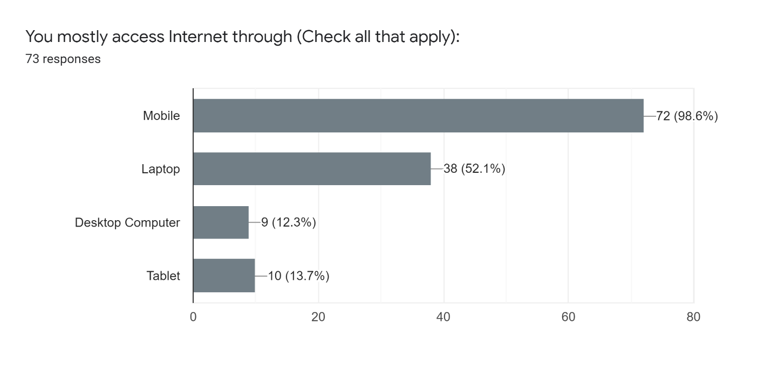
Figure 1 Modes of Internet Access
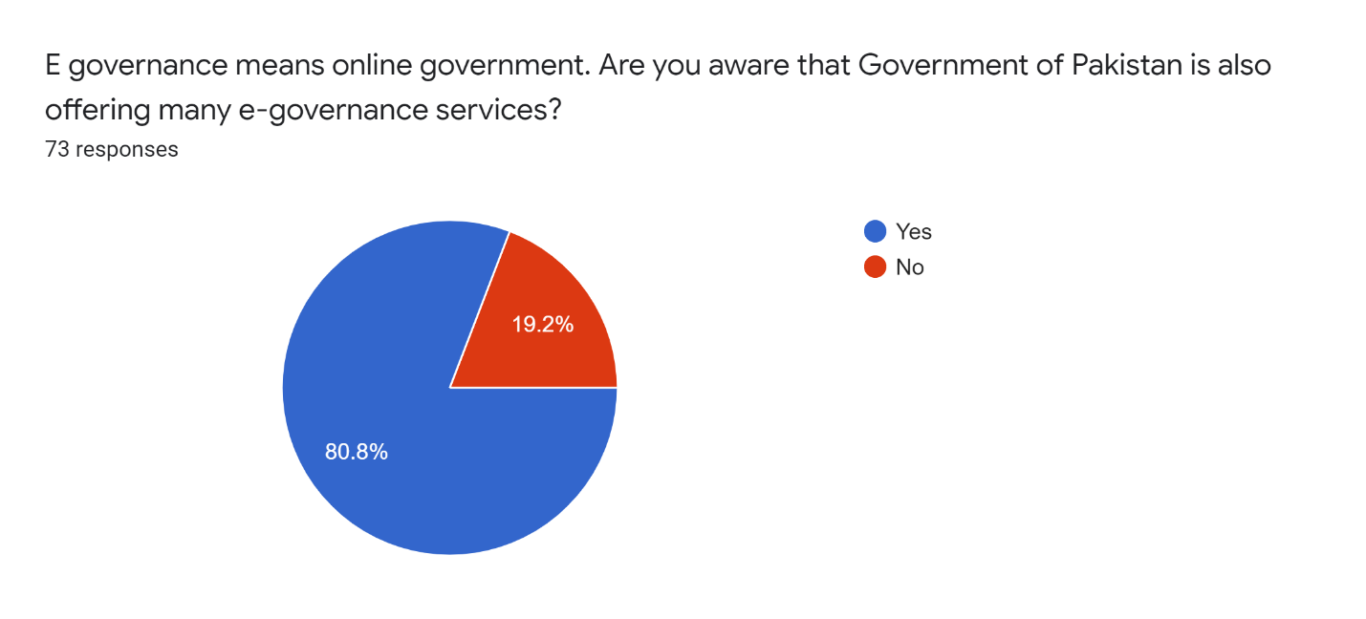
Figure 2 Awareness regarding provision of online services

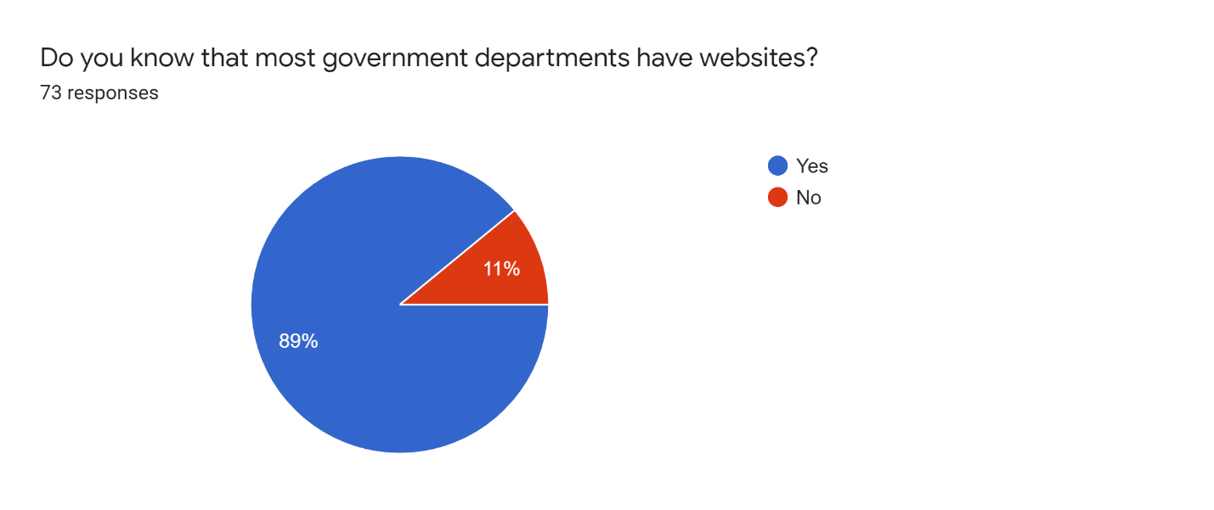
Figure 3Awareness regarding government websites

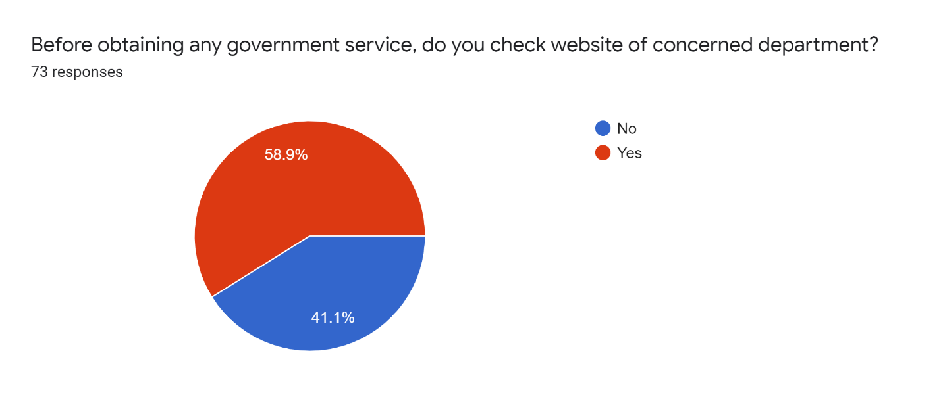
Figure 4 Percentage of people checking government websites
The above three charts depict that most people were aware that Government of Pakistan is offering several e-Governance services, and almost all government departments have websites, but only half of the sample population checked these government websites before physically visiting the offices.
A bulk of sample population (87%) preferred online services to manual services, and 60% of the sample population has complete trust on online services but majority said (almost 60%) that they seldom or never find their needed public service online.
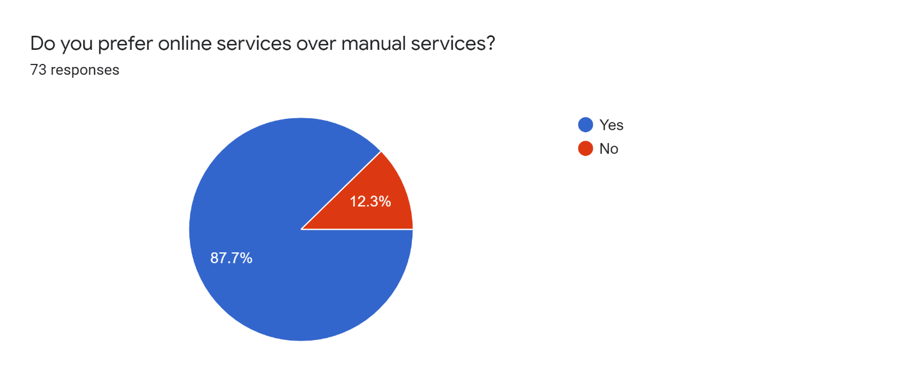
Figure 5 Online services vs. manual services

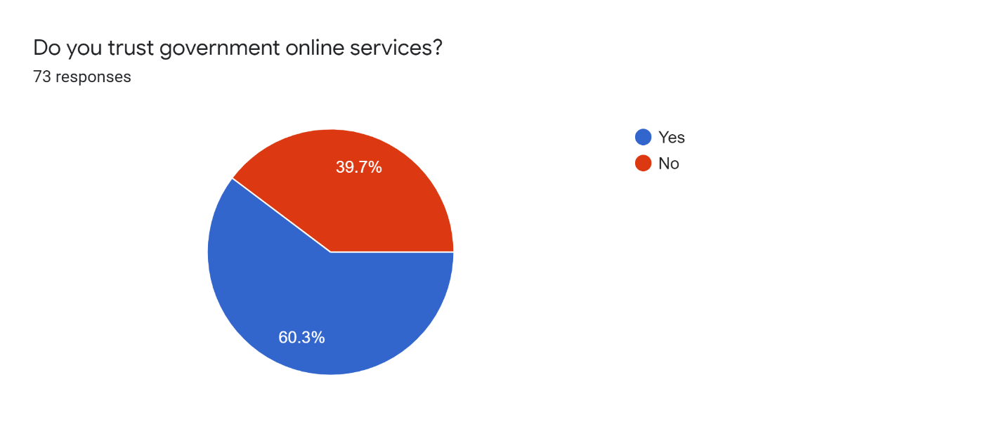
Figure 6 Trust of Public in Online Services

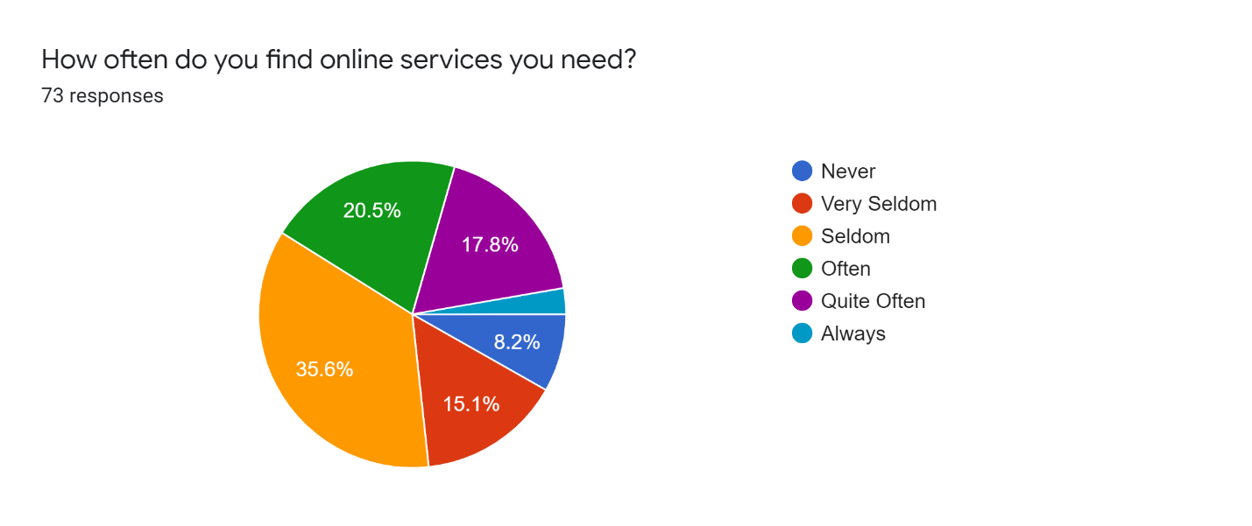
Figure 7 Availability of Online Services

4.7.3 Public Stance on e-Governance and Effective Administration
A bulk of the sample population agreed that e-Governance reduces corrupt practices and saves unnecessary visits to government offices.
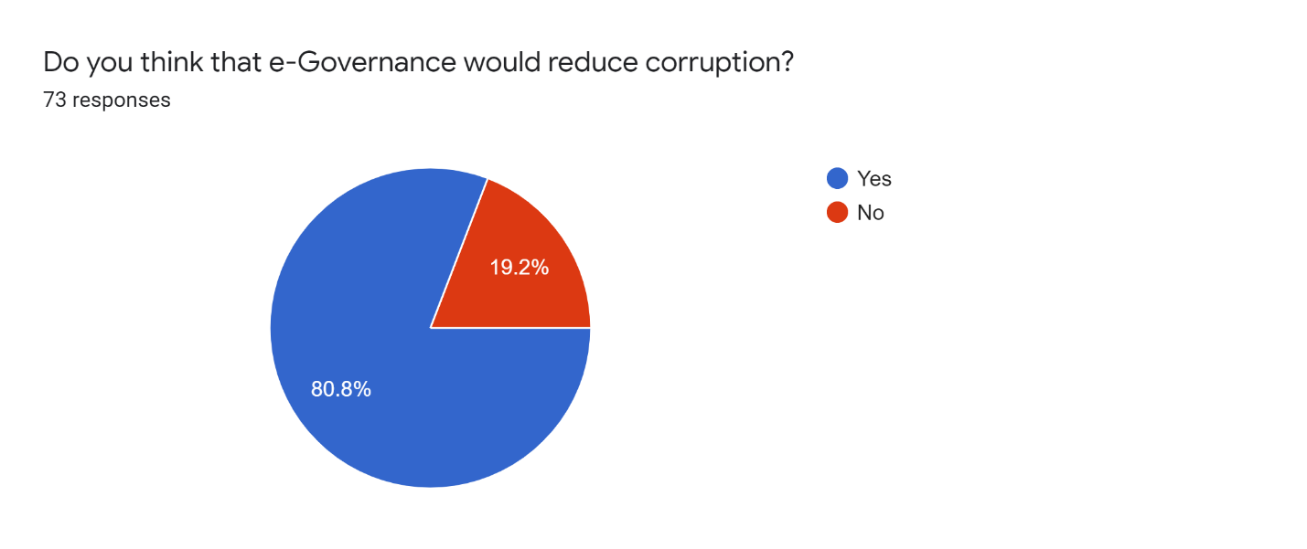
Figure 8 Online Services and Reduction in Corruption
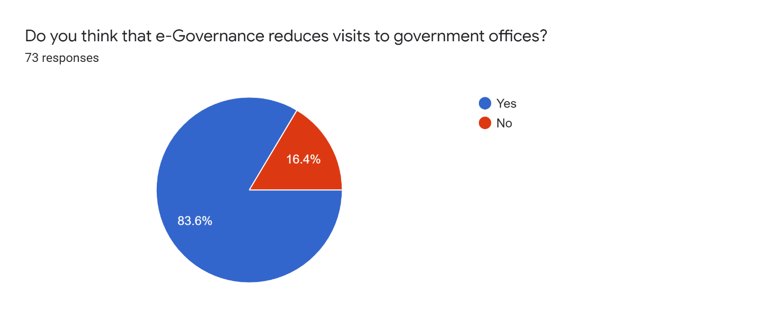
Figure 9 e-Governance and Physical Visits to Offices
About 70%sample population agreed, or strongly agreed, that e-Governance can help improve effective administration and service delivery. Similarly, nearly 72% of the surveyed population agreed that e-Governance reduced the cost of public service delivery, and 68%agreed, or strongly agreed, that e-Governance empowers the citizens more as compared to conventional governance.
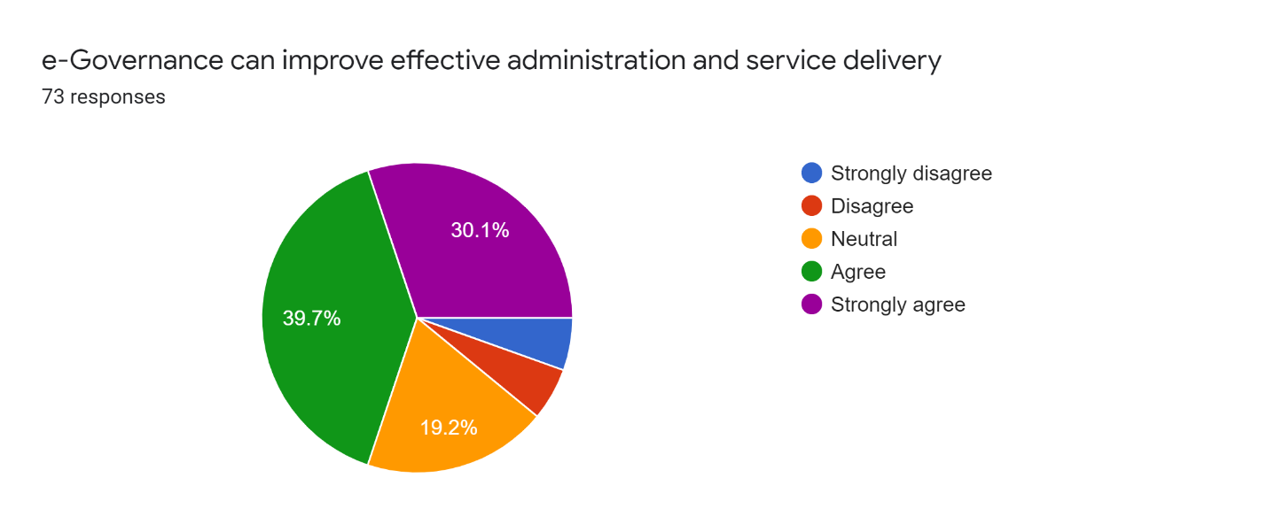
Figure 10 e-Governance and Effective Administration

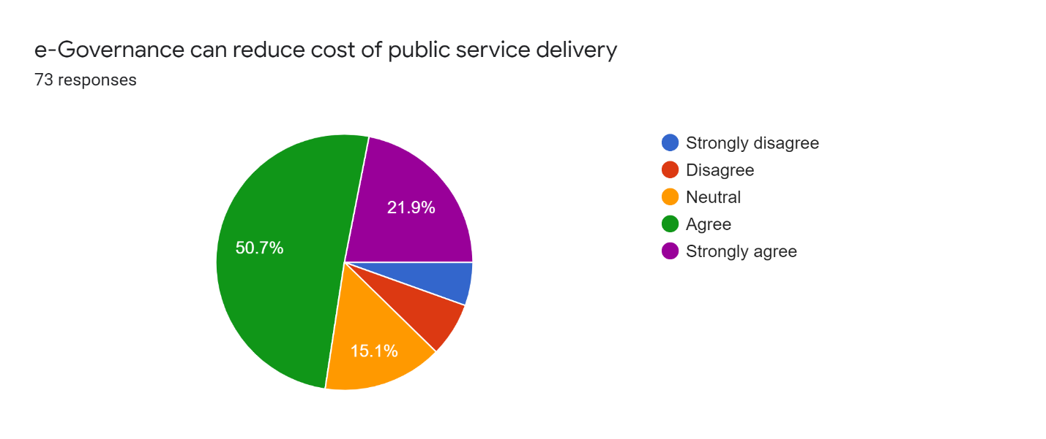
Figure 11 e-Governance and Cost of Public Service Delivery
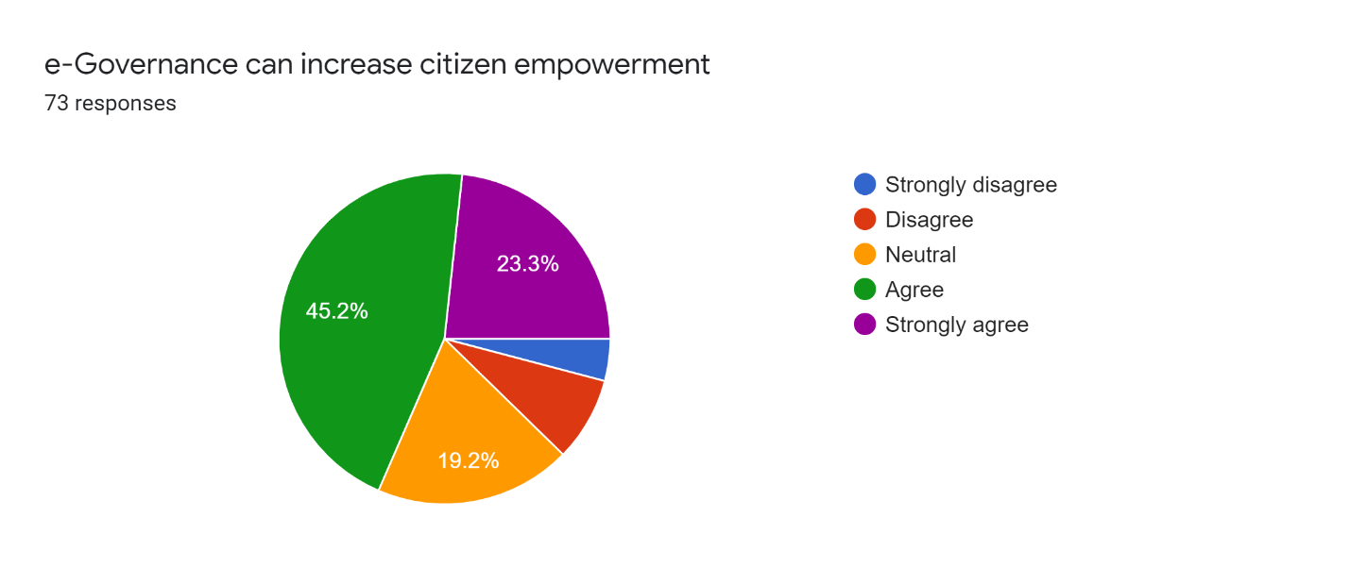
Figure 12 e-Governance and Citizen Empowerment
Majority population (52%) disagreed that e-Governance can be very costly and it would benefit only rich people, but most of them (44%) agreed that e-Governance can put the poor people at disadvantage due to existing digital divide between the rich and the poor. Similarly, almost 40% agreed that e-Governance would benefit only urban people as compared to rural people.
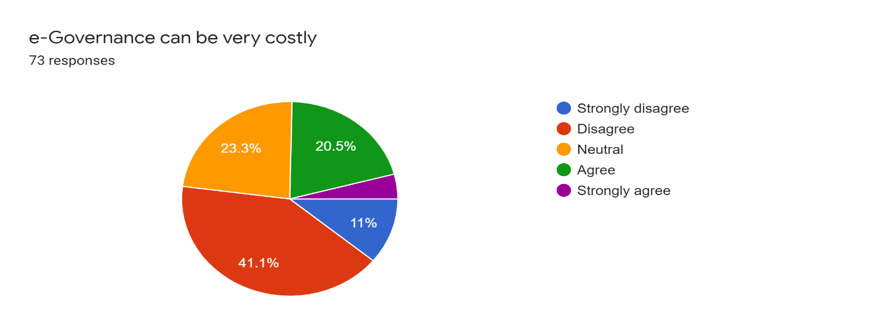
Figure 13 Is e-Governance costly?
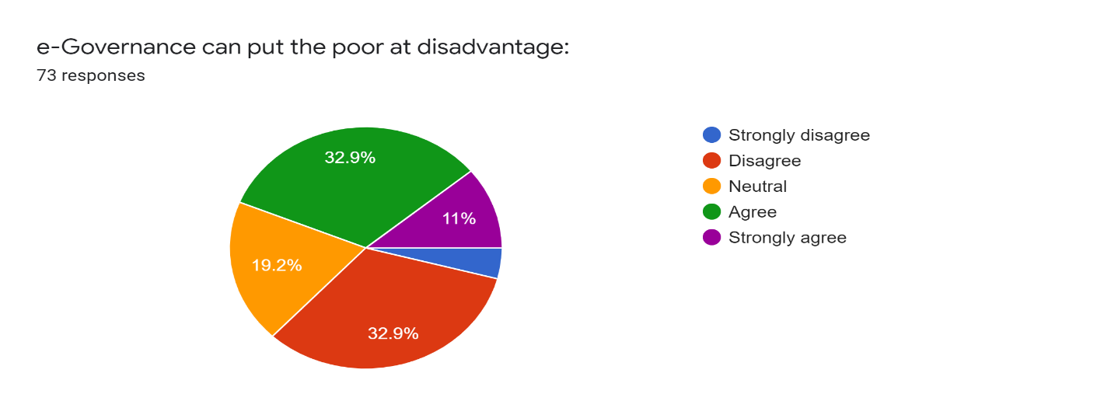
Figure 14 e-Governance and the poor
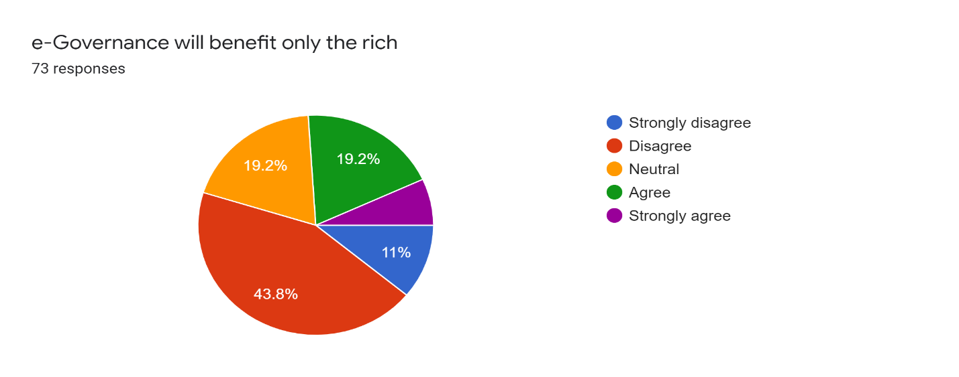
Figure 15 e-Governance and the rich
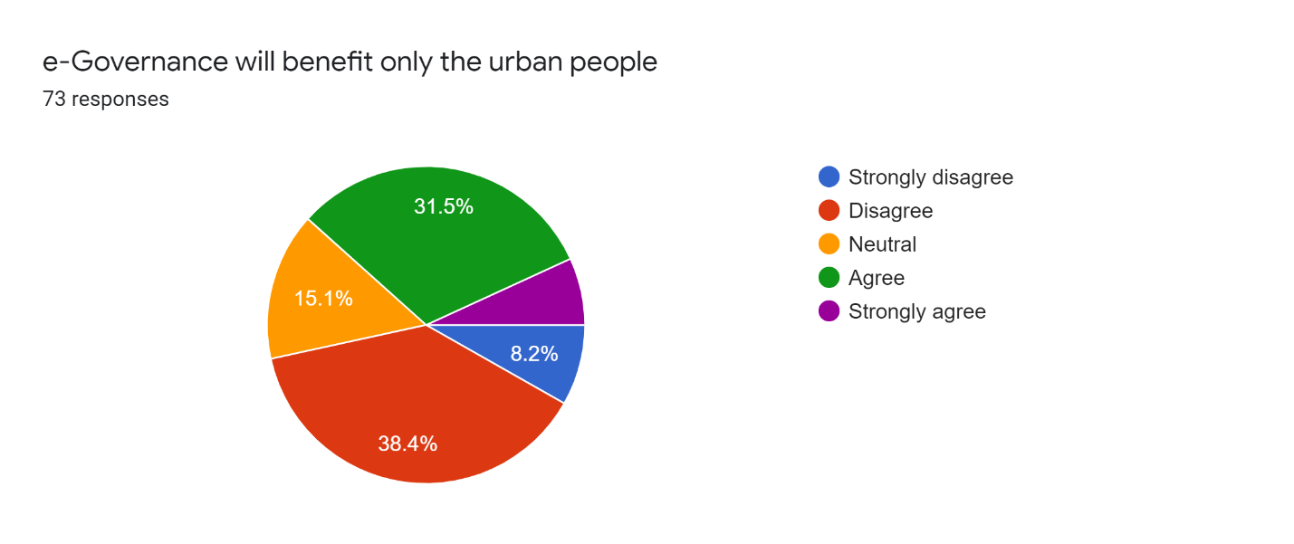
Figure 16 e-Governance and the rural-urban divide

4.7.4Public Usage of Major e-Governance Initiatives – Citizens Portal, e-FIR and IRIS
Even though bulk of the population had heard about the three major e-Governance initiatives – Citizens Portal, e-FIR, and e-Filing of taxes through IRIS, majority (54%) have never used any one of them in their life.
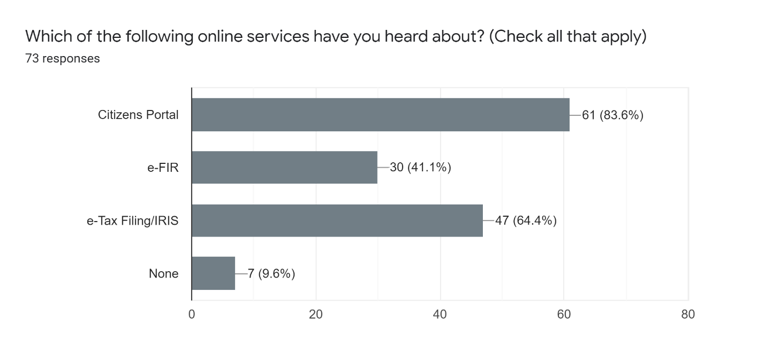
Figure 17 Public Knowledge of major online services

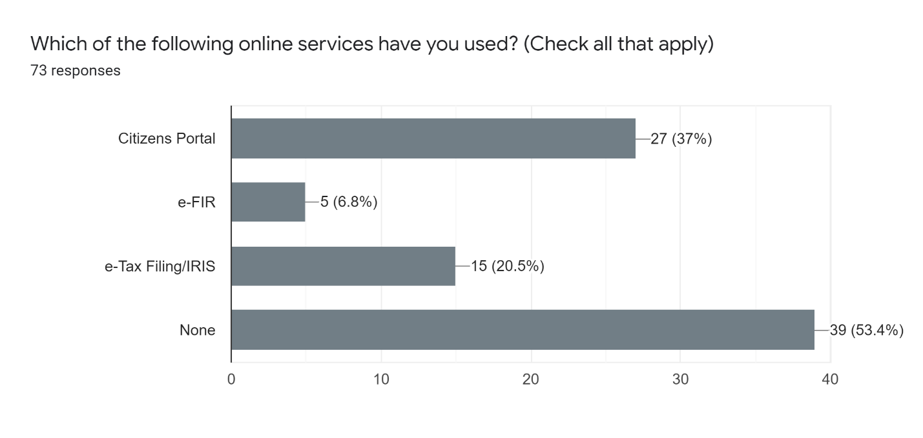
Figure 18 Public Usage of Major Online Services
People rated Citizens Portal as the most useful service, followed by electronic filing of taxes. 85% of the sample population had never used e-FIR, which is probably more indicative of our sample population than public in general. Overall, those people who had used these online services were satisfied with their experience.
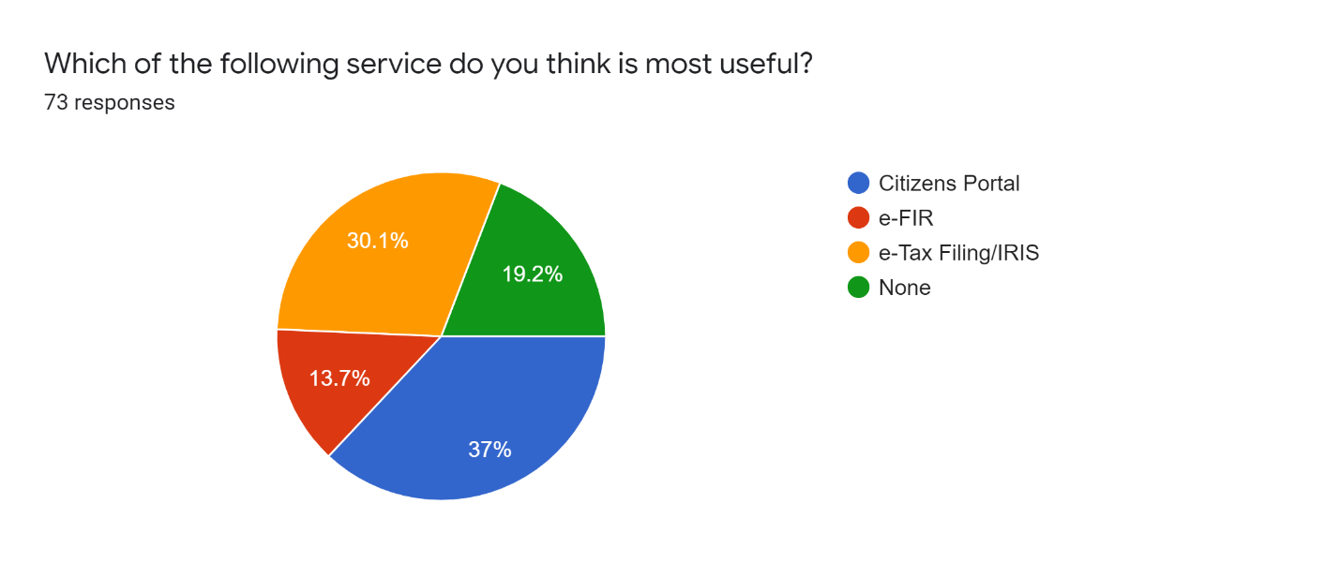
Figure 19 Most useful Online Service
Finally, most people commented that Police, Tax Department and Education would benefit most from the introduction of e-Governance, and would make administration and public service delivery much more effective in these departments.

Conclusion and Recommendations

5.1 Discussion in light of Literature Review
In view of the literature review, it can safely be concluded that E-Governance is the phenomenon that has enhanced the mechanism of service delivery both in public and private sector. The cases of developed countries testify to the fact that e-governance, though a lengthy process to begin with, once established, can bear considerable fruits for both the implementers and the end-users. When it comes to service delivery, the process becomes much more efficient and streamlined in the wake of the utilization of Information and Communication Technology. Furthermore, it has also been established that in developing countries like Pakistan, the process of implementing e-governance tools is not a smooth sail as there are certain constraints which need to be taken into account when introducing new initiatives. The e-Government Development Index (EGDI)of Pakistan is 148 out of 193, and Pakistan is weakest in Telecom Infrastructure Index, and Human Capital Index. These results corroborate the findings deduced in light of interviews of administrators that capacity of our workforce need to enhanced to reap full benefits of e-Governance. To conclude, the most substantial constraints in proper implementation of e-Governance in Pakistan are lack of IT ridden infrastructure coupled with the dearth of professional workforce. However, these constraints are not at all unsurmountable, and once overcome, they are likely to unveil all the benefits associated with e-governance.

5.2 Answers to Research Questions
Detailed answers to each research questions have already been provided in chapter 4. To summarize the answers to each question, e-Governance has improved the administration in Pakistan by reducing the human element, streamlining the processes, increasing the efficiency, reducing corrupt practices, and shortening the timelines for service delivery. There are still substantial challenges in the complete transition towards e-Governance, which include lack of trained IT personnel, resistance of current government staff to new digital initiatives, lack of awareness in public regarding e-Governance and their digital illiteracy, non-integrated existing systems, high cost of complicated automation systems, and security of citizens’ data. However, these challenges can be overcome by training the human resource, developing integrated ICT infrastructure, formulating a comprehensive e-Governance plan and dedicating fiscal resources towards the achievement of that plan.
To conclude, e-Governance has turned out to be a benediction for both policymakers and end-users alike. It has improved efficiency, minimized human related errors and increased transparency. When it comes to service delivery in the public sector, e-governance has transformed the entire mechanism for service delivery. A lot of ease has been provided to the public by making the erstwhile convoluted official processes easy and streamlined. However, this transformation is not devoid of issues. Data security, lack of IT skilled labor and inadequate IT infrastructure are some of the substantial factors that continue to hamper the process of pursuing 100 percent digitization. Nevertheless, the benefits of digitization are much more concrete and substantial to eclipse all the glitches. All that needs to be done at this point is providing correct direction and planning.The policymakers need to be extremely meticulous in planning the process of going automated. If they fail to plan at this stage, they will plan to fail.

5.3 Contribution to Theory and Practice
The research may contribute little to theory, but the findings would be quite useful for the practitioners of public administration – the civil servants – in making the administration more effective and efficient. E-Governance is going to be the modus operandi of governance in the coming future, and the earlier we transition towards e-Governance, the better it would be for both the administrators and the public.

5.4 Limitations of the Research Study
The research was conducted in the limited time available. The interviewees were all serving in the province of Punjab, and most of the secondary data wasalso taken from provincial departments. Hence, the research cannot be called a comprehensive discourse on the situation of e-Governance all over Pakistan. Rather the views of interviewees are more indicative of the prevailing situation in Punjab. Nevertheless, as Punjab is the most developed province of the country, it could be argued that situation in Punjab is a reasonable reflection of the best possible scenario in Pakistan. Moreover, the public survey conducted was only filled by literate strata of the society, so their views cannot be generalized to the entire population. Again, an argument could be made that it is the digitally literate segment of the society which is first to benefit from e-Governance, and their views are at least indicative of early adopters of e-Governance.

5.5 Recommendations
There are two sets of recommendations – one, to suggest some improvements in the existing e-Governance structures in the country, and second, to introduce some of the most relevant best global practices of e-Governance in Pakistan. Both are discussed in detail in the following sections.

5.5.1 Recommendations for improving e-Governance in Pakistan
Following set of recommendations discuss the improvementsin existing e-Governance structure of Pakistan:
- Build capacity of Public Administrators:Before any more e-Governance initiatives are introduced, it is imperative that public officials and staff at all levels of governance are trained in the skills of Information Technology. Our Human Capital Index (HCI) in EGDI is only 0.3682 as compared to 0.9 and 1.0 for highly e-developed countries.IT has become an essential skill for a modern civil servant, and it must be taught to existing staff through trainings and courses. Digitally illiterate staff are slow to adapt existing e-Governance initiatives, and provide much resistance to new initiatives and practices. Thus, it becomes paramount that all government machinery must be made abreast with the modern usage of technology, and IT skills should form an integral part of Performance Evaluation Reports (PERs) of officials.
- Raise Awareness in Public regarding existing online services:The public survey conducted highlighted a significant concern of e-Governance – public unawareness regarding existing online services. Even though our sample population was aware of some of the key online service provided by government like e-FIR and e-Tax filing, most were unaware that many more services are available online, and they never bothered to check department websites before visiting the department offices. Moreover, usage and adaptation of existing online services is also very low, and people still do not use the readily available online services due to fear of complexity of the new systems. In that regard, people must be made aware of all the existing automated and online services, and must also be provided with simple and easy-to-learn tutorials on how to use these services. Only then, full benefits of e-Governance could be reaped.
- Bridge Digital Divide – Move towards single service delivery mechanism:Since a bulk of our population is not digitally literate, and the penetration of Internet is not that much (only 36.8%), there exists a significant digital divide in our population. For that reason, government has to maintain two parallel governance structures whenever e-Governance is introduced in any department. For the majority segment of the society, automation and online services are useless as either they are inaccessible to them, or they do not know how to use them effectively. Hence, it is essential that this digital divide in our country be bridged by providing everyone the same opportunity to use the online services.
- More focus on installation of ICT infrastructure:As mentioned earlier, the penetration of Internet in Pakistan is only 36.18%, and that of 3G/4G subscribers is only 35%. Hence, there is a great need for the installation of new ICT infrastructure all over Pakistan, so that whole population can come online, and benefit from e-Governance. The rank of Pakistan in E-Governance Development Index is 148, which is quite poor, and the major reason behind that is our poor Telecommunication Infrastructure Index (TII), which is merely 0.1529. Compared to that, our Online Services Index (OSI) is 0.5486, which is almost thrice the value of TII. This indicates that we need to invest more on the development of our infrastructure than developing new online services.
- Integrate existing e-Governance projects: Integration of existing e-Governance structures is necessary if full benefits from e-Governance are to be enjoyed. Current e-Governance structures exist in isolation as discussed in the analysis section before, and must be integrated together in a well-knit centralized system. An example could be cited from the Inland Revenue Service department. In the words of Commissioner IRS, “Tax structure is such that no matter how much we simplify, it remains a complex matter”. Hence, a single-pronged reformation would not serve the purpose. Every single department that possesses data related to potential taxpayers should be integrated and embark upon efficient intelligence sharing mechanism. For example, Mr. A has bought a plot in DHA so now the system should automatically tell whether this is reflected in his wealth statement or not. In another example, if a person has claimed tax exemption from Donation, system should automatically detect all of his previous transactions and show which organization has received the donation. Thus, an integrated and centralized system should be designed which could make the process of obtaining information much smoother for administrators as well as the general public.
- Early stress on data security and privacy:Data security and data privacy are two of the key issues which developed countries are facing, and scandals like Cambridge Analytica shed a light on the need for security of citizens’data. Since Pakistan is still an evolving country with regards to e-Governance, it has been observed that proper care is not taken when maintaining databases of citizens data. All interviewees claimed that proper security mechanisms were in place for their department’s data. Nevertheless, we do observe that advertising agencies and spam callers do have access to sensitive information about the citizens, which is a cause of concern. The government of Pakistan must put proper stress on the security and the privacy of citizens’ data, and prevent any misuse of that data. Tackling this problem heads-on at the early stages of e-Governance should be a priority of the government. Otherwise, if the same casual approach is continued with regards to data security, it might pose a major threat to national progress and national security at the later stages of e-Governance.
- Adapt mobile service delivery over online service delivery:There are currently 164 million cellphone subscribers in Pakistan, which amount to 77.69% of the total population. So, the penetration of cellphones is about twice as much as the Internet in Pakistan. Thus, focus of the government should be more on mobile based services, rather than on Internet based services alone. Even Internet based services should be made available both through websites, and through mobile (Android and iOS) applications. Mobile service delivery has the advantage of reaching the populace which has access to mobile phones but not to Internet. In that way, maximum number of people could benefit from e-Governance services.
- Harness fast evolving technologies:21st century is a century of new fast evolving technologies like Artificial Intelligence, Edge Computing, Virtual and Augmented Reality, Cloud Computing, Blockchain, and Distributed Ledger technologies. The government should harness these technologies at the early stages of e-Governance to get a comparative advantage over other developing countries. For instance, block chain and distributed ledgers should be used for digitizing records, like land registries, to avoid tempering of records. Similarly, Artificial Intelligence or AI could be used to mine patterns in the data, and deduce trends like crime patterns, or tax evasion patterns. Such state-of-the-art initiatives could really boost up the working of existing e-Governance structures in the country.

5.5.2 Global Best Practices in e-Governance – Some recommendations for Pakistan
Following set of recommendations pertain to some of the best global practices in e-Governance which are most suited to Pakistan:
- Digital Centers in Rural Areas:Bangladesh’s Central Bank started the Digital Financial Services Lab to provide financial support to the poor in the remote pockets of Bangladesh. More than 1900 Digital Centers were established in remote rural areas in order to provide access to Internet and e-Government services. It aimed to increase payment digitization, assisted e-commerce and financial literacy among the poor families in the villages. Such digital centers would be extremely helpful for our rural population as well which is not well-versed in use of technology but could benefit a lot from new and existing e-Governance projects. For instance, farmers could get information regarding their land record registries; they could remotely order seeds and fertilizers, and make payments through microfinance services.
- South Korea e-Government Masterplan 2020:South Korea has been ranked as number one country in UN E-Governments Survey, consecutively for the last three years. Surely, there are lessons to be learned for Pakistan. Their latest e-Government Masterplan 2020 uses the slogan “ENJOY” for gearing the future progress of the e-Governance in the country. The masterplan included roadmap for enhancing digital services in the country, building a hyper-connected e-Government platform which integrates government departments with industries, and develop new security infrastructure which can perceive future risks, and adapt accordingly. Pakistan’s Digital Policy 2018 was a step in the right direction with twelve policy objectives to enhance e-Governance in the country. However, the policy is ambitious in nature with lots of commitments on moving towards e-Governance, but contains hardly any roadmap on how to achieve these objectives. There is a need to create a roadmap that enlists each step that needs to be taken to achieve those policy objectives, and an objective creation should also exist to evaluate the completion of these objectives on periodic intervals.
- Hong Kong’s One-Stop Online Portal:Hong Kong is a major Asian business hub, and a major chunk of their e-Governance initiatives are geared towards facilitating existing businesses, and attracting new ones. They currently provide 80% of their public services online. The local and foreign businesses can access Hong Kong’s one-stop online portal to register their companies and perform other auxiliary administrative tasks. Such a system would dramatically increase the rank of Pakistan in ease-of-doing business. In fact, last year Pakistan rose by 28 places in global ease of Doing Business to the rank of 108 due to six reforms, one of which was enhancing the functionalities of one-stop shop. Through WeBOC (Web Based One Customs) and NSW (National Single Window), Pakistan Customs is already facilitating external trade by integrating different government departments. Now is the right time to move towards an internal one-stop shop as well which will facilitate local and foreign businesspersons to register and start their businesses in a hassle-free manner.
- Real-time Digital Disclosure of Taxes:South Korean government also uses real-time digital disclosure of taxes to keep its citizens informed about the spending of taxpayers’ money. Some interviewees were highly appreciative of that idea as it would keep the citizens informed regarding the spending of their tax money, and motivate them to keep paying their taxes.

References
- UNESCAP (2010). What is good governance? Available at: https://www.unescap.org/sites/default/files/good-governance.pdf
- Prof. Alpana Upadhyay, Dr. C. K. Kumbharana, “Perceptual Study of Behavioral Implications of Usage of ICT for Sustainable e-Governance in Rural India”, International Journal of Scientific and Research Publications, Volume 2, Number 4, April 2012 1, ISSN 2250-3153,www.ijsrp.org, pp2. 9
- Monga, A “E-government in India: Opportunities and challenges”, JOAAG, Vol. 3. No. 2, 2008, pp55. 10
- Alvydas Baležentis, Gintarė Paražinskaitė, Mykolas Romeris University, Lithuania, “The Benchmarking of the Government to Employee (G2E) Technology Development: Theoretical Aspects of the Model Construction for Social Technologies”, Volume 2, Number 1, 2012, p. 58 www.doaj.org
- Peter Shackleton, Julie Fisher Monash University, Australia, “Evolution of Local Government E-Services: the applicability of e-business Maturity models”, Proceedings of the 37th Hawaii International Conference on System Sciences, 2004, pp 4.
- Shareef M. Shareef, Hamid Jahankhani University of East London, “e-Government Stage Model: Based On Citizen-Centric Approach In Regional Government In Developing Countries”, International Journal of Electronic Commerce Studies, Volume 3, Number 1, 2012, pp.153.
- Ministry of IT & Telecom (2018). Digital Pakistan Policy. Available at: http://moib.gov.pk/Downloads/Policy/DIGITAL_PAKISTAN_POLICY(22-05-2018).pdf
- Arfeen, M., Iqbal, J., && Mushtaq, M. (2017). Model for e-Government Implementation in Pakistan.
- Chandio, A. R. (2019). E-GOVERNMENT IN PAKISTAN: FRAMEWORK OF OPPORTUNITIES AND CHALLENGES. Global Scientific Journal.
- Haider, Z., Chuwen, C., && Burdey, M. (2016). E-Government Project Obstacles in Pakistan.
- Ilyas, M. (2016). E-GOVERNANCE PRACTICES AND MODELS; OPTIONS FOR PAKISTAN. Institute for Strategic Studies, Research and Analysis (ISSRA).
- UNDESA (2018). UN e-Government Survey 2018: Gearing E-Government to Support Transformation towards sustainable and resilient societies. [online] Available at: https://publicadministration.un.org/egovkb/Portals/egovkb/Documents/un/2018-Survey/E-Government%20Survey%202018_FINAL%20for%20web.pdf
- UNDESA (2016). UN e-Government Survey 2016: E-Government in Support of sustainable development. [online] Available at:https://publicadministration.un.org/egovkb/Portals/egovkb/Documents/un/2016-Survey/Executive%20Summary.pdf
- United Nations (2015). Transforming our World: the 2030 Agenda for Sustainable Development. [online] Available at: https://sustainabledevelopment.un.org/content/documents/21252030%20Agenda%20for%20Sustainable%20Development%20web.pdf
- The World Bank (2016). World Development Report 2016: Digital Dividends. [online]. Available at:http://www.worldbank.org/en/publication/wdr2016
- Alhomod, S. M., Shafi, M. M., Kousarrizi, M. N., Seiti, F., Teshnehlab, M., Susanto, H., & Batawi, Y. A. (2012). Best practices in E government: A review of some Innovative models proposed in different countries. International Journal of Electrical & Computer Sciences, 12(1), 1-6.
- Fath-Allah, A., Cheikhi, L., Al-Qutaish, R. E., & Idri, A. (2014). E-government maturity models: A comparative study. International Journal of Software Engineering & Applications, 5(3), 71.
- Piaggesi, D. (Ed.). (2011). Global Strategy and Practice of E-Governance: Examples from Around the World: Examples from Around the World. IGI global.
- Cisco, I. B. S. G. (2007). E-Government Best Practices learning from success, avoiding the pitfalls. Cisco IBSG.
- Shaikh, A. Z., Shah, U. L., & Wijekuruppu, C. (2016). Public service delivery and e-governance: The case of Pakistan. International Journal for Infonomics, 9(2), 1161-1170.
- Kazmi, S. N. A. (2010, July). Factors influencing e-Governance implementation: Issues and challenges in Pakistan. In 2010 Fifth International Conference on Digital Information Management (ICDIM) (pp. 326-331). IEEE.
- Sarfaraz, H. (2007, Jan. 19). E-governance: a case for good governance in Pakistan. Communication Policy Research for Improving ICT Governance in the Asia-Pacific (pp. 1-18). Manila: Asian Institute of Management. Retrieved Dec. 15, 2019, from http://dx.doi.org/10.2139/ssrn.1415689
- Ali, M., & Mujahid, N. (2015). Electronic government re-inventing governance: a case study of Pakistan. Public Policy and Administration Research, 5(2), 1-9. Retrieved Dec. 15, 2019, from https://www.iiste.org/Journals/index.php/PPAR/article/view/19742
- Dadashzadeh, M. (2010). Social Media In Government: From e-Government to e-Governance. Journal Of Business & Economics Research (JBER), 8(11). doi: 10.19030/jber.v8i11.51
- Haque, S., & Pathrannarakul, P. (2013, Jan.). The role of technology in enhancing transparency and accountability in public sector organizations of Pakistan. International Journal of Economics Business and Management Studies - IJEBMS, 2(1), 20-24. Retrieved Dec. 15, 2019, from http://ssrn.com/abstract=2196811
- E-governance and Citizenship Participation in Africa: Challenges and Opportunities. (2017). The Panos InstituteWest Africa & The United Nations Development Programme. Retrieved from https://www.undp.org/content/dam/undp/library/Democratic%20Governance/IParticipation/e-Governance%20and%20Citizen%20Paticipation%20in%20West%20Africa%20(UNDP-IPAO%20Report%20English).pdf
- Jain, V. (2018). Design of Secure E-Governance Model for India. Journal Of Engineering And Technology, 4(2). Retrieved from https://www.gyanvihar.org/journals/index.php/2018/11/21/design-of-secure-e-governance-model-for-india/
- Madon, S. (2014). E-governance for Development. Palgrave Macmillan.
- Papadopoulos, T., & Kanellis, P. (2014). Public Sector Reform Using Information Technologies. Hershey: IGI Global.
- Waema, T., & Adera, E. (2014). Local Governance and ICTs in Africa. Ottawa: International Development Research Centre.
- United Nations Department of Economic and Social Affairs. (2013). Compendium of Innovative e-Government Practices.
- Digital Pakistan. Accelerate to the digital state: d-health. Retrieved from http://digitalpakistan.pk/pdf/d-health.pdf
- Well, D. N. (2007). Accounting for the effect of health on economic growth. The Quarterly Journal of Economics, 122, 1265–1306.10.1162/qjec.122.3.1265
- Lorentzen, P., McMillan, J., & Wacziarg, R. (2008). Death and development. Journal of Economic Growth, 13, 81–124.10.1007/s10887-008-9029-3
- Din, Izhar Ud et al., (2017). Role of information & communication technology (ICT) and e-governance in health sector of Pakistan: A case study of Peshawar. Cogent Social Sciences, 3:1, DOI: 10.1080/23311886.2017.1308051
- Government of Pakistan. (2016). Ministry of finance government of Pakistan. Retrieved from http://www.finance.gov.pk/
- Muqeet, Adeel, & Durrani, Hammad. Towards a national e-health/telehealth strategy for Pakistan: Experiences, Challenges, and Opportunities. LEAD Pakistan.
- Qureshi et al., (2014). E-Health in Pakistan: Issues and Prospects. Journal of Biology, Agriculture and Healthcare. 4(17), 106-115.
- Rehman, M., Esichaikul, V., & Kamal, M. (2012). Factors influencing e-Government adoption in Pakistan. Transforming Government: People, Process and Policy, 6, 258–282. 10.1108/17506161211251263
- Roser, Max, Ortiz-Ospina, Esteban, & Ritchie, Hannah (2019, Oct.) Life Expectancy. Our World in Data. Retrieved from: https://ourworldindata.org/life-expectancy
- https://www.worldbank.org/en/news/press-release/2019/10/24/doing-business-2020-accelerated-business-climate-reform-agenda-puts-pakistan-among-top-10-improvers

Appendices

Appendix I

(Interview Protocol 1- Generic e-Governance Questions)

- What are the key advantages of e-Governance over conventional governance?
- What according to you are the necessary pre-requisites for implementing e-governance? (a) Infrastructure (network) (b) Human Resources (c) Budget
- Please cite a few reasons why you think e-governance will lead to good governance?
- Can you identify an area in your department which needs implementation of e-governance the most?
- How do you think can effective and efficient service be provided to the public such as one-stop shops or websites and portals?
- Have you noticed any change in the streamlining of the procedure after implementation of e-governance?
- How do you think resistance to change to initiating new e-services can be countered?
- How can transparency and acceptance of the e-services be measured?
- What in your opinion are the resources required (human and capital) that can help implement e-governance throughout the country?

Appendix II

(Interview Protocol 2 – Validation of Global Best Practices)

- Singapore’s eGov 2015 e-Governance masterplan focused on collaborative government. It provided 1600 online services, and 300 mobile services. The focus now is on providing more mobile based public services, through the mGov programme which focuses on feature-rich and innovative mobile services.
  - In the context of Pakistan, do you think that mobile-based public services would be a better fit for our population as compared to web-based services?

- Fiscal transparency and fiscal monitoring enhances the trust of citizens on government functionaries. South Korean government uses a real-time digital disclosure of tax usage on public projects.
  - Do you think such an initiative could help improve our tax-base? Why, or why not?

- South Korea’s “smart governance” initiative uses an mVoting system, in which public policies are shared on the platform, and citizen vote against, or in favor of such policies.
  - Do you think such a system would benefit citizen-government relationship, and help in effective administration? Why, or why not?

- Hong Kong is a major Asian business hub, and a major chunk of their e-Governance initiatives is geared towards facilitating existing businesses, and attracting new ones. They currently provide 80% of their public services online. The local and foreign businesses can access Hong Kong’s one-stop online portal to register their companies and perform other auxiliary administrative tasks.
  - Do you think such a portal is needed for improving ease-of-business in Pakistan?
    - Why, or why not?
  - Taking into account the usage of Pakistan’s Web Based One Customs (WeBOC), how beneficial or non-beneficial a new portal would be for businesses? [For Customs only]

- India launched its “Land Registry Digitization” initiative in 2008, aimed at surveying lands, upgrading records and establishing ownership. It was to be completed in 2016 with an allocated budget of $841 million, but in 2016, date was extended to 2021 with a 100% increase in budget. Land Registry Record in Pakistan in also undergoing digitization for quite some time, but the process remains incomplete.
  - What do you think are the impediments in the completion of project?
  - How do you explain the parallels between India and Pakistan in this regard?

- Bangladesh’s Central Bank started the Digital Financial Services Lab to provide financial support to the poor in the remote pockets of Bangladesh. More than 1900 Digital Centers were established in remote rural areas in order to provide access to Internet and e-Government services. It aims to increase payment digitization, assisted e-commerce and financial literacy among the poor families in the village.
  - Do you think establishment of such Digital Centers could help in better administration of remote areas? Why, or why not?

Appendix III

(Research Survey on e-Governance)
This survey is designed to gauge the response of general public regarding e-governanceservices provided by the government. The survey is for research purpose only. Your name andemail is not required for completion of this survey.
* Required
1. Age in years: *
Mark only one oval.
- 18 - 30
- 31 - 45
- 46 - 60
- 61 and above
2. Gender: *
Mark only one oval.
- Female
- Male
- Prefer not to say
3. You are staying in the region: *
Mark only one oval.
- Rural
- Urban
- Semi-Urban
4. Education (Highest Level): *
Mark only one oval.
- Less than Primary
- Primary
- Secondary
- Higher Secondary
- Graduate
- Professional
- Post Graduate and Above
5. Occupation: *
Mark only one oval.
- Student
- Government Servant
- Private Service
- Business Owner
- Unemployed or Housewife or Retired
- Other:
6. Monthly Income: *
Mark only one oval.
- Less than 20000
- 20000 - 50000
- 50000 - 100000
- 100000 and above
  - General Usage
This section asks about your experiences and opinions regarding e-Governance.
7. You mostly access Internet through (Check all that apply): *
Check all that apply.
- Mobile
- Laptop
- Desktop Computer
- Tablet
8. How frequently you access Internet? *
Mark only one oval.
- Daily
- Twice a week
- Fortnightly
- Monthly
9. E governance means online government. Are you aware that Government of Pakistan is also offering many e-governance services? *
Mark only one oval.
- Yes
- No
10. Do you know that most government departments have websites? *
Mark only one oval.
- Yes
- No
11. Before obtaining any government service, do you check website of concerned department? *
Mark only one oval.
- No
- Yes
12. How often do you find online services you need? *
Mark only one oval.
- Never
- Very Seldom
- Seldom
- Often
- Quite Often
- Always
13. Do you prefer online services over manual services? *
Mark only one oval.
- Yes
- No
14. Do you trust government online services? *
Mark only one oval.
- Yes
- No
15. How often do you think are e-Governance processes prone to error? *
Mark only one oval.
- Never
- Very Seldom
- Often
- Quite Often
- Always
16. Do you think that e-Governance would reduce corruption? *
Mark only one oval.
- Yes
- No
17. Do you think that e-Governance reduces visits to government offices? *
Mark only one oval.
- Yes
- No
18. e-Governance can improve effective administration and service delivery *
Mark only one oval.
- Strongly disagree
- Disagree
- Neutral
- Agree
- Strongly agree
19. e-Governance can reduce cost of public service delivery *
Mark only one oval.
- Strongly disagree
- Disagree
- Neutral
- Agree
- Strongly agree

20. e-Governance can increase citizen empowerment *
Mark only one oval.
- Strongly disagree
- Disagree
- Neutral
- Agree
- Strongly agree
21. e-Governance can be very costly *
Mark only one oval.
- Strongly disagree
- Disagree
- Neutral
- Agree
- Strongly agree
22. e-Governance can put the poor at disadvantage: *
Mark only one oval.
- Strongly disagree
- Disagree
- Neutral
- Agree
- Strongly agree
23. e-Governance will benefit only the rich *
- Strongly disagree
- Disagree
- Neutral
- Agree
- Strongly agree
24. e-Governance will benefit only the urban people *
Mark only one oval.
- Strongly disagree
- Disagree
- Neutral
- Agree
- Strongly agree
  - Specific Services
This section asks some questions about three well-known e-Governance projects in Pakistan -Citizens Portal, e-FIR, and e-Tax Filing.
25. Which of the following online services have you heard about? (Check all that apply) *
Check all that apply.
- Citizens Portal
- e-FIR
- e-Tax Filing/IRIS
- None
26. Which of the following online services have you used? (Check all that apply) *
Check all that apply.
- Citizens Portal
- e-FIR
- e-Tax Filing/IRIS
- None
27. Which of the following service do you think is most useful? *
Mark only one oval.
- Citizens Portal
- e-FIR
- e-Tax Filing/IRIS
- None
28. How satisfied were you with your experience with Citizens Portal? *
Mark only one oval.
- Not Satisfied at all
- Somewhat satisfied
- Satisfied
- Very Satisfied
- Never used Citizens Portal
29. How satisfied were you with your experience with e-FIR? *
Mark only one oval.
- Not Satisfied at all
- Somewhat satisfied
- Satisfied
- Very Satisfied
- Never used e-FIR
30. How satisfied were you with your experience with e-Tax Filing? *
Mark only one oval.
- Not Satisfied at all
- Somewhat satisfied
- Satisfied
- Very Satisfied
- Never used e-Tax Filing
31. Name one department, which you think,would benefit most from the introductionof e-Governance.

https://businessjargons.com/e-governance.html
https://www.psca.gop.pk/AboutUs/Index
http://www.euro.who.int/en/health-topics/Health-systems/e-health
https://data.worldbank.org/indicator/SH.XPD.CHEX.GD.ZS?locations=PK
https://www.pta.gov.pk/en/telecom-indicators
https://www.pta.gov.pk/en/telecom-indicators/2
https://www.nia.or.kr/common/board/Download.do?bcIdx=19053&cbIdx=37989&fileNo=1
https://www.worldbank.org/en/news/press-release/2019/10/24/doing-business-2020-accelerated-business-climate-reform-agenda-puts-pakistan-among-top-10-improvers

