Population of Pakistan: Challenges, Problems and Prospects


Syndicate Group – 12

Syndicate Advisor: Dr. Nizamuddin
Research Coordinator: Madam Sidra Irfan
Faculty Member: Mr. Maqsood Ahmed
In-Charge Coordination Syndicate Activity: Syed Shabbir Akbar Zaidi

________________________________________________________________

47TH COMMON TRAINING PROGRAMME
CIVIL SERVICES ACADEMY, WALTON, LAHORE
SYNDICATE GROUP NO. 12 MEMBERS
S # | NAME OF PROBATIONARY OFFICER | CSID # | POSITION
 | Faizan Taimoor Saqib | 120 | President
 | Muhammad Majid Altaf | 138 | Secretary
 | Amar Shakir Jajja | 113 | Member
 | Anam Tajjamul | 175 | Member
 | Awais Afzal | 272 | Member
 | Danial Khan | 119 | Member
 | Saifullah | 254 | Member
 | Syeda Sidra Majid | 159 | Member

PLAGIARISM UNDERTAKING

A paper submitted to the Faculty of the Civil Services Academy Walton, Lahore, in fulfilment of the requirements of the 47th Common Training Programme.
We solemnly declared that research work presented in the report titled “Population of Pakistan:Challenges, Problems and Prospects” is solely our research work. Small contribution / help, wherever taken, has been duly acknowledged and referenced and the complete report has been written by us.
We understand the zero-tolerance policy of the Civil Services Academy Lahore towards plagiarism and its implications. Therefore, we, as Authors of the report, declare that no portion of our report has been plagiarized and any material used as reference is properly referred / cited. The paper reflects our own views and is not necessarily endorsed by the Academy.

Syndicate President Signature: _______________________
Syndicate Secretary Signature: _______________________

Dated: ____________________

CERTIFICATE OF APPROVAL
This is to certify that the research work presented in this report, entitled “Population of Pakistan: Challenges, Problems and Prospects” was conducted by Syndicate Group No. 12, under our supervision.

Signature: ______________________
Name of Syndicate Advisor: Dr. Nizamuddin
Dated: __________________________

Signature: ______________________
Name of Research Coordinator: Madam Sidra Irfan
Dated: __________________________

Signature: ______________________
Name of Faculty Member: Mr. Maqsood Ahmed
Dated: __________________________

Acknowledgements
All praises to Almighty Allah - the creator of resources, skills and opportunities who guided us and provided us the strength to accomplish this work.
We want to use this opportunity to express oursincere gratitude to Dr. Nizamuddin, syndicate advisor, for agreeing to be our supervisor. We are immensely grateful for his support, calmness, guidance, motivation, encouragement, and immense knowledge, which he made available to us throughout the course of the project. We feel great honor in expressing ourdeep gratitude to Mr. Zulfiqar, Director Common Training Program, Civil Services Academy (CSA), Lahore, for his efforts in keeping an environment conducive to research and study at the academy. A special thanks befits to Mr. Amir Sohail, Director General, Civil Services Academy, Lahore, for promoting his vision of creating various research opportunities during common training at CSA.
We would also like to acknowledge our research and faculty advisors Mr. Masood Ahmed, without whom it would not have been possible to carry out this research project. Our sincerest thanks go to Ms. Sidra Irfan and Mr. Shabir Akbar Zaidi. We have come to value them for their consistent help, cheerful company, and support, as well as motivation at every single step.
Thank you,
Syndicate 12

EXECUTIVE SUMMARY
High population growth in Pakistan has been a persistent problem which is harming the country for the past three decades. The literature which exists about population of Pakistan, the problems associated with population growth and the prospects for this population, needed contributions, especially in the context of execution and implementation of population policies. The purpose of this study was to understand the problems/challenges and prospects of the population of Pakistan and the effects of high population growth on maternal and infant health, environment and poverty. Data of population was taken from primary as well as secondary sources. Interviews of experts and senior executives were carried out to gather primary data about the challenges related to the implementation of the population policy, and documentary sources were also used.
Three major themes emerged from the data. (1) Factors affecting modern contraceptive service uptake / family planning at consumer end which includedfamily’s decision-making dynamics and socio-cultural barriers. (2)Factors related to supply side / health sector, which includeduniversal access of contraceptives,inter - sectoral coordination and federal - provincial coordination. (3) Consequences of unsustainable population growth on health, environment, and economy.
The analysis showed that barriers to family planning existed in both supply as well as the consumer end. Recommendations which were derived from the analysis were divided along these two lines. The recommendations for the consumer / demand side involved advocacy & awareness and legal interventions. The recommendations for the supply side involved interdepartmental coordination and ensuring nation-wide access to contraceptive security.
TABLE OF CONTENTS
Chapter 1: Introduction 1
1.1 Purpose Statement 3
Chapter 2: Literature Review 4
2.1 The Challenges Population in Pakistan 4
2.2 Prospects of Population in Pakistan 7
2.3 Case Study of Bangladesh and South East Asian Countries 8
2.4 State of Health Care in Pakistan 9
2.5 Pakistan’s Population Policies and its International Commitments 11
2.6 Population and its impact on Environment, Health and Economy 12
2.7 Research Questions 15
Chapter 3: Research Methodology 17
3.1 Research approach 17
3.2 Philosophical Worldview 17
3.3 Research Area 17
3.4 Data Collection & Analysis 18
3.5 Ethical considerations 18
3.6 Sources of Data 19
3.7 Limitations 19
Chapter 4: Research Findings 20
4.1 Research Themes 20
4.2 Factors affecting modern contraceptive services uptake/ family planning 20
4.2.1 Family’s Decision-Making Dynamics 20
4.2.2 Socio Cultural Barriers 27
4.3 Factors related to supply side 29
4.3.1 Universal Access of Contraceptives 29
4.3.2 Federal and Provincial Coordination 36
4.4 Inter departmental Coordination 38
4.5 Population Prospects of Pakistan-Demographic Window 45
4.6 Consequences of unsustainable Population growth 49
4.6.1 Population and health 50
4.6.2 Population and Economy 51
4.6.3 Population and environment 52
Chapter 5: Discussion and Recommendations 55
5.1 Discussion 55
5.2 Recommendations 57
5.2.1 Demand Side: 57
5.2.2 Supply Side: 58
5.2.3 Social Interventions to Improve Population Prospects 59
Bibliography 61

LIST OF TABLES
Table 1: Population Growth trends and prospects of Pakistan (1951-2050) 1
Table 2: Pakistan’s Population and Social Indicators 2
Table 3: Access to Education in 2030 according to Trends and Goals 48
Table 4: Maternal and reproductive health indicators – India, Iran, Pakistan & Afghanistan 51
LIST OF FIGURES
Figure 1: Hierarchy of Public Sector Facility at Provincial Level in Punjab 10
Figure 2: Percentage of contraception use by women’s empowerment (Source: PDHS 2017-18) 22
Figure 3: Average Number of Children by women’s empowerment (Source: PDHS 2017-18) 22
Figure 4: Unmet need for family planning vs women empowerment (Source: PDHS 2017-18) 23
Figure 5: Median Age at First Childbirth and First Marriage wrt Education Level (Source: PDHS 2017-18) 23
Figure 6: TFR by Woman Education (Source: PDHS) 24
Figure 7: Modern Contraceptive Prevalence Rate wrt house hold income (Source: PDHS 2017-18) 25
Figure 8: Poverty Trends by Province and Rural/Urban Divide (Source: PDHS 2017-18) 25
Figure 9: Province wise Total Fertility Rate (Source: PDHS 2017-18) 26
Figure 10: Modern contraceptive use by region (Source: PDHS 2017-18) 26
Figure 11: Ownership of assets (Source: PDHS 2017-18) 27
Figure 12: Decisions making dynamics in household about RH care-seeking? (Syed Khurram Azmat, 2015) 28
Figure 13: Demand & Need of Family Planning among married women of Reproductive Age (Source: PDHS) 30
Figure 14: Knowledge of Contraceptives among married women of reproductive age (Source: PDHS) 30
Figure 15: Trends in contraceptive use among married women of reproductive age (Source: PDHS) 31
Figure 16: Trends in Wanted and Actual fertility (Source: PDHS) 32
Figure 17: Fertility Planning Status (Source: PDHS) 33
Figure 18: Regional Comparison of Contraceptive Prevalence Rate (Sources: PDHS 2017-18, SLDHS 2016, BDHS 2014-15 and NFHS 2015-16) 34
Figure 19: Regional Comparison of Percentage of Women using Modern Methods (Sources: PDHS 2017-18, SLDHS 2016, BDHS 2014-15 and NFHS 2015-16) 34
Figure 20: Crude birth rate in South Asia (births per 1,000 population) (Bank W. , 2020) 35
Figure 21: Total Fertility rate in South Asia (births per woman) (Bank W. , 2020) 35
Figure 22: Trend for Total Fertility Rate and Population Growth for Regional Countries (Dr. Dur-e-Nayab, 2019) 36
Figure 23: Population and Interdepartmental Coordination 38
Figure 24: Informed choice 39
Figure 25: Trends in fertility by Residence (Rural vs Urban) (Source: PDHS 2017-18) 40
Figure 26: Urban Rural Gap in access to Basic Services 2013/14 40
Figure 27: Sources of Supply of Modern Contraceptives (Donna Clifton, 2013) 41
Figure 28: Increased sources of modern contraception (Source: PDHS) 42
Figure 29: Current contraceptive use reported by MWRA - Any Method 44
Figure 30: Current contraceptive use reported by MWRA -Any Modern Method 44
Figure 31: Population Pyramid of Pakistan with Education Level in 2010 (Source: UN 2011) 46
Figure 32: Various Projections of TFR in Pakistan (Source: Population Council 2011, NIPS 2010, UN 2008 &2010) 46
Figure 33: Population Projection for Three Age Groups (Source: Population Council) 47
Figure 34: Trends of Total Fertility Rate under Two Educational Scenarios (Zeba Sathar R. R., Capturing the demographic dividend in Pakistan, 2013) 48
Figure 35: Trends of Working Age to Non-Working Age Population in Pakistan (Source: Population Council, 2011, UN 2011) 49
Figure 36: Total Working Age Population Employed and Women Population Employed in Workforce (Source: Labour Force Surveys) 49
Figure 37: Sectoral Air Pollution Share in Punjab (2008-17) (Source: UN FAO) 53
Figure 38: Number of Patients with Asthma Presenting to Pediatric Pulmonary Department 53

ABBREVIATIONS AND KEY TERMS
ANC Antenatal care
BHU Basic Health Unit
CMW Community Mid Wife
CPR Contraceptive Prevalence Rate
DHQ District Headquarter
FAO Food and Agriculture Organization
FP2020 Family Planning 2020
GIS Geographic Information System
IUD Intrauterine Device
LHW Lady Health Worker
MNCH Maternal, Newborn, and Child Health
NGO Non-Governmental Organization
PBS Pakistan Bureau of Statistics
PDHS Pakistan Demographic and Health Survey
RHC Rural Health Centre
SDG Sustainable Development Goal
TFR Total Fertility Rate
THQ Tehsil Headquarter
UNESCO United Nations Educational, Scientific and Cultural Organization
WHO World Health Organization
WWF World Wide Fund

Chapter 1: Introduction
The last seventy-three years has seen the population of Pakistan growing at an alarming rate which suggests that the government could have done more to contain the rapid population growth; the population of the country has grown from 33.74 million in 1951 to 208 million in 2017 (PBS, 2020). Population has been growing at an alarming rate even now.Figures show a 57% increase in population from 1998 to 2017 – a period of just 19 years – signifying an annual growth rate of 2.4% which is the highest in the South & Central Asian region(PBS, 2020). Almost two third of the country’s population resides in rural areas while remaining one third is living in urban areas. Of the total population of Pakistan, more than one third is below the poverty line, which directly hampers their access to quality healthcare.
Table 1: Population Growth trends and prospects of Pakistan (1951-2050)
Year | Population (Million) | % of World Share | Global Ranking
1951 | 33.74 | 1.46% | 14
2020 | 220.892 | 2.83% | 5
2050 | 338.013 | 3.47% | 5
The table 1 shows that Pakistan population share as a percent of world share has increased from 1.46% in 1951 to 2.83% in 2020, and at the same rate it would reach to 3.47% in 2050. During 1998-2017 tenure, Pakistan’s population increased from 132 million to 207 million, an increase of 57% and an annual increase of 2.4%. This increase in the population at an alarming rate of 2.4% is an indicator of low to no improvement in the health sector, specifically in infant and maternal health. In Pakistan, low usage of modern contraceptives has played its role in the high maternal mortality ratio of 184 deaths per 100,000 live births; in the high infant mortality ratio of 67 deaths per 1,000 births; and, in the high total fertility rate of 3.8%. Due to low access to quality health care services, 10,000 women die, per annum, either due to pregnancy or from reasons related to the pregnancy and/or its management(PDHS, 2013). The table 2 shows few social indicators of the country which aptly represent the state of affairs in Pakistan.

Table 2:Pakistan’s Population and Social Indicators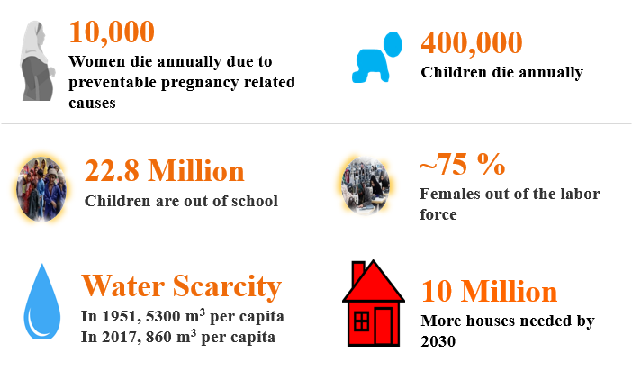
The data of the preceding paragraphs shows that population growth in Pakistan has been high since its inception, which naturally means that governments have been facing some challenges and problems in tackling the issue of rapid population growth. The current economic situation of the country does not reflect bright prospects for the population, especially the youth. Such a high population growth has effects on the environment, health and the economy too.
Previous studies carried out in this field suggest that population growth control policies have been unsuccessful in achieving their objectives and that this issue should be seen from a multi-dimensional and cross-sectoral aspect, and not just from the perspective of fertility reduction (Zeba Sathar R. B., 2013). The studies suggest that further understanding is required to know whether the problem is of contraceptive access or that of socio-cultural barriers (Asim, 2014). Stephenson suggests that lack of provision of resources to reduce fertility rate and a social environment which is unwelcome towards the adoption of contraceptives is the main issue. The role of government-NGO partnerships to increase awareness about the issue of reproductive health and population growth control has been seen as very important (Zeba Sathar R. B., 2013). Autonomy of women to take decisions and their empowerment, both financially and in family decision making is a major factor in the determination of family size and fertility rates (Saleem, 2005)
Other studies suggest that the prospects of such a large population, especially of youth, can be improved through education and skill training. Increasing the prospects includes investing in human capital at its core (Nayab, 2007). In order to reap this dividend, focus should be towards inculcating skills in the youth, industrialization and tapping of natural resources, provision of education, involvement of NGOs, greater employment opportunities, utilization of youth bulge and poverty reduction(Kugelman, 2011; Nayab, 2007; Zeba Sathar R. B., 2013).
However, the studies carried out by Nayab, Kugelman, Zeba Sathar, Bobak and Aqeela Tabassum shed some light on the matter of why Pakistan has been unsuccessful in reducing its population growth rate as well as the prospects for the bulging youth population and the effects of high population growth on the environment, economy and health. It was felt that further studies should be carried out to get more information on the matter.
The results and findings of this research can be particularly helpful to the executive and legislative bodies of Pakistan. The findings can help devise a better population policy as well as the problems in execution of said policies. This study sheds light on the prospects of the bulging youth population of Pakistan as well as the effects of high population growth on maternal and infant health in Pakistan, effects of high population growth on poverty in Pakistan and the effects of high population growth on the environment in Pakistan.

Purpose Statement
The purpose of this study was to understand the problems, challenges and prospects of the population of Pakistan vis-à-vis the inability of the government to control the high population growth and the prospects for the bulging youth population and the correlation of high growth rate with poverty, health and environment. This study derives from in depth interviews of senior executives who have experience and knowledge of the population sector, as well as from documentary analysis.

Chapter 2: Literature Review
The population of Pakistan (currently 207.8 million) is growing at a faster rate than most regional and Muslim countries. Between the two last censuses of 1998 and 2017, the population of Pakistan grew at 2.4% per year. Bearing this trend of population growth rate in mind, the population of Pakistan is projected to rise up to 285 million by 2030, and to double in the next 30 years. In comparison to Pakistan, the average doubling time for other regional countries is estimated to be 60 years.Such a high rate of population growth is unsustainable. It is eating into our modest socio-economic development gains, making it increasingly harder to ensure basic investments in human development such as health, nutrition, education, and productive skills.
This rapidly growing population would strain country’s natural resources, especially water and government services. Moreover, the increasing population would create many problems including health, energy crisis, poor quality life, poverty, unemployment, inflation and urbanization. It is obvious that Pakistan is facing issues of water and food security because there are simply too many people, resulting in too much demand for water and agriculture. Moreover, rapidly rising population poses a serious threat to human existence, causing serious problems such as management challenges and efficient resource allocation, educating the masses regarding family planning and late marriage.

The Challenges Population in Pakistan
Pakistan devised a population program to counter this challenge starting in 1965; it was a national family planning program that was devised for the first time after the creation of Pakistan. The population control programs aimed at reducing rate of increase in population primarily by reducing fertility. However, Population control programs have been futile in getting the desired result.Zeba Sathar suggested that fertility reduction should not be the only goal in the population control policy of Pakistan. It should look at this issue and solve the challenges from multi dimensions(Zeba Sathar R. R., 2013).
It is projected that Pakistan’s population will rise to 229.6 million by the year 2025 and it will reach 314.3 million by the year 2050. However, 42.3 per cent females and 37.5 per cent males in Pakistan do not want to give birth to more children. According to an estimate, 890,000 abortions are done in Pakistan every year which means that one of six pregnancy ends up aborted. Thus, the real problem whether it is access to contraception or socio-cultural barriers needs to be understood (Aqeela Tabassum, 2014).
The fertility rate in Pakistan is more than the desired fertility rate due to two reasons: inadequate provision of resources to curb fertility rate and a social environment which is unacceptable towards the adoption of contraceptives. The usage of contraceptive measures increased more than two times between 1990-1991 and 2000-2001; furthermore, it is noted that in excess of 96%, married women were cognizant of at least one method of means to avoid fertility but still the rate of population growth is increasing which serves an evidence that there are other factors which act as an impediment to slow down the population growth in the country (Stephenson, 2006).
Fertility reduction policy is essential to counter the problems and challenges that the growing population poses. Looking at the success of Bangladesh, not only political commitment but also the government and NGO partnership played a role in reduction of population (Zeba Sathar R. R., 2013). Another factor which can lead to population control is the cumulative “Information, Education and Communication Strategy”. The foremost thing that needs to be done is to create awareness on the issue. The Ministry of Population and Welfare can play its due role in creating awareness. Different sections of the society including the NGOs, welfare organizations, local leaders and other associations can play a role to counter these population problems and challenges(Zeba Sathar R. R., 2013).
In a study involving 600 married women in the district Chakwal, the limited effectiveness of family planning programs adopted by Pakistan due to socio-cultural barriers was studied. The results of the research revealed that the women on average wanted three children but had given birth to four children. Low education, lack of permission to women to go outside and stubborn attitude of husbands and in laws significantly influenced the low usage of contraception (Zeba Sathar R. R., 2013).
The cultural aspects also play a huge role in the usage of the family planning services. In Pakistan, Islam as a religion influences the behavior of the citizens. Women are considered as ‘izzat’ of the family and they are subjugated and confined to their homes to remain in ‘purdah’. There is separation of the two genders and women are restricted from joining the workforce. They are forbidden from going out of their homes and seeking medical service of family planning especially if the service is provided by males. In Punjab, the two major reasons identified which leads to high fertility include the belief among women that usage of contraceptive methods is culturally inappropriate and that its usage is in conflict with the husband’s sexual gratification (Aqeela Tabassum, 2014).
Autonomy of women to take decisions has a positive correlation with the use of contraception but there is no significant relationship between a woman’s education and adoption of contraceptive methods. For this purpose, the “Pakistan Reproductive Health and Family Planning Survey 2000” was reviewed. This survey gathered data by interviewing 6,579 married women between the 15 and 49 years. The nine relevant questions related to decision autonomy of women and six questions related to mobility of women with or without permission from their homes were picked up from the survey. The scrutiny of interview results showed that the women who had autonomy to take decisions were able to use contraception. In Pakistan, the use of contraceptives is minimal where there is a social and religious restriction on women to take decisions autonomously and independently. This study complemented this positive correlation between the decision autonomy of women and their usage of contraception and this social restriction is one of the reasons why population growth rate is increasing in Pakistan (Stephenson, 2006).
Due to the less availability of access to health services, very few women in the country will visit a completely functional health facility. This information is available from the Pakistan demographic and health survey 2012–13. It showed that significantly, 48 percent of women delivered at a health facility, very few 16 percent in Baluchistan followed by 41 percent in KP, and 49 percent in Punjab, and very high 59 percent in Sindh(Bobak, 2005).
According to Jones, provinces need to be assisted in order to ensure effective population control policies are formulated. After the devolution, the provinces are responsible for population planning. It has been noted that some steps have been taken in the provinces of Sindh, KP and Punjab, but their policies are yet to be aligned with the economic development and human development plans. There needs to be capacity building at the provincial level and greater coordination along with technical support to ensure greater alignment of policies between the health and population departments at the provincial level. Similarly, the planning at the district level is also a challenge in Pakistan. The projection of migration at the district level needs to be carried out through assistance of the Pakistan Bureau of Statistics and NIPS(Jones, 2017).
In terms of curtailing of population growth, the Government of Pakistan has taken this initiative and drafted Implementation Plans for all the provinces. Various planning task forces comprised of public and private sector stakeholders in each of the provinces by using currently available national resources to procure contraceptives and to increase its use in their respective areas. Additionally, the government wants to ensure provision of availability of contraceptives throughout the country and has trained mid-level service providers both in the public and private sectors to provide IUDs and implants. Moreover, the Government of Pakistan has also made substantial efforts by increasing cooperation with significant religious leaders in order to promote the acceptability of family planning by mobilizing social efforts. In this regard, various health centers have been established in Punjab, Sindh, and KPK specifically for adolescents(FP2020, 2019).

Prospects of Population in Pakistan
Demographic Dividend is defined as a window of opportunity spanning over 40-50 Years, during which the ratio of dependent children is reduced as a result of low fertility rate and proportion of population labour force is increases. This provides an opportunity for accelerated economic growth. According to Durr-e-Nayab,youth bulge in a country can act as a ‘double-edged sword’. If the growing working age population is not included in the labor force, there will be no demographic dividend. There is a dire need for the greater involvement of youth through education and skill training. Robust economic policies are needed to create employment opportunities. The priority areas for Pakistan in this situation comprise of education, health, low fertility rates, incentives for increase in savings and provision of employment opportunities (Nayab, 2007). Pakistan needs to follow the example of East Asian countries. They reaped the demographic dividend. Their policy included investment in human capabilities and labor force productivity. In these countries, the tax payers and the working age population increased. The school going children in these countries lessened and as a result the spending per student increased in the schools. Extensive agricultural research was carried out as well as industrial base was widened. The trade had also increased in these countries and they focused on increasing the exports. The employment opportunities were created and more skilled labor force participated in the economic activity which led to the demographic dividend (Nayab, 2007).
The ‘demographic dividend’ is a situation where the population consists of more working age labor force, this can result in economic development. This happens because of the higher proportion of youth or working age population which can participate in labor force. This is ‘once in a lifetime opportunity’(Kugelman, 2011). Kugelman posits that the second largest salt mine of the world, seventh largest copper mine, and fifth highest reserves of coal exist in the country which means that there is enormous potential. The economy can dramatically grow if these untapped resources are tapped. If demographic dividend is reaped then this can bring prosperity in Pakistan. The most important means to achieving this demographic dividend is through inculcation of relevant skills in the youth. The more the skilled the youth in Pakistan, the greater economic development can result (Kugelman, 2011).
According to Kugelman, if a situation arises where the infant birth rates drastically drop and the young population in Pakistan is provided education and also assimilated into the workforce, the nation can benefit from a “demographic dividend” resulting in improvement in economic and social welfare. The median age will be thirty years in Pakistan by the year 2050. The demographics in Pakistan reveal that it is very different from the pattern observed all over the world as it has the highest percentage of youth (Kugelman, 2011).
There is a silver lining and provision of education, involvement of NGOs, greater employment opportunities, utilization of youth bulge, poverty reduction and a policy not only aimed at fertility reduction can lead to addressing the challenges and problems of population in the country. According to Sathar, there is a need for skills training amongst the youth. It is quite unfortunate that it is still not clear amongst the policy makers that what skills are needed. There is a large proportion of youth but it is largely untrained. It is noted that the youth primarily learns those skills which are demanded by the job opportunities in the market. There are some private institutes which impart these skills but there is a need for the government institutions to teach skills to the youth so that demographic dividend could be reaped by skills enhancement by those segments of youth which do not have the financial capabilities. Some of these skills include designing, computing and other such skills. There is an urgent need for planning to create greater job opportunities in both the private and public sector. It is imperative that economy grows for that to materialize. There is a crisis of employment in the country particularly women whose participation rate in the labor force stands at only twenty percent. Nearly fifty percent of the employment in Pakistan is in the agriculture sector. There needs to be greater employment opportunities in the industry and services sector(Zeba Sathar R. R., 2013).

Case Study of Bangladesh and South East Asian Countries
The report, “Population Stabilization in Bangladesh: Problems, Prospects and Policy Issues”, described a new policy that was formulated with a purpose to achieve replacement level by 2015. In contrast to previously effective policies on “Two children are enough”, the new “Bangladesh Population Policy 2011”, proposed to promote family sizes lower than two, with a new slogan, “Not more than two, it is better to have one”. In Bangladesh, conventional family planning methods were delivered by full-time lady health field workers followed by a social marketing program especially focused on providing contraceptives in retail outlines(Atiqur Rahman Khan, 2010).
It is expected that by 2030, the population of Pakistan is projected to escalate to huge 268 million. This will have a grave impact on natural resources and other relating to crises in agriculture and food production, health, poverty, Ironically, increasing urbanization resulted into further pressure on agricultural land; urban sprawl and the need to provide housing and commercial space to even faster growing urban populations is leading to the usage of agricultural land even for nonagricultural purposes, contributing to mismanagement of allocation of even basic necessities like food for Pakistan to feed its own population. The effects are already evident in the form of water shortages and food shortages even in the major cities of the country. Malaysia and Indonesia have managed to craft a careful policy equating between population growth and national resources which has greatly helped these countries. Moreover, China too, a large country, made a concerted plan to reduce population growth in order to preserve its available natural resources and to maximize its human and economic resources to eradicate poverty, and eventually become a superpower.Pakistan, however, has not been able to develop any such framework(Dr. Dur-e-Nayab, 2019).

State of Health Care in Pakistan
Health care system in Pakistan consists of two ministries/departments. Ministry of health and Ministry of population welfare. After the 18th amendment, the department of health and population welfare was devolved to respective provinces. A bifurcation of health department was done in to tertiary and primary (and secondary) healthcare systems. There is a system for the primary and secondary system which is controlled separately than the tertiary system. The hierarchy of public healthcare facility is explained in Figure 1. On the other hand, objective of the population welfare department is to promote healthy, prosperous, educated and knowledge-based society. The focus of the department is to control population and for this they consider family planning to be an effective way to maneuver the plans and execute them accordingly. The liaison of the population welfare department and health department can help control population and thus the service delivery at all levels of the healthcare can be improved specially at the tertiary level because the number of tertiary healthcare facilities is low as compared to primary and secondary levels.
There is another parallel structure consisting ofPrivate (profit/noon profit) clinics and hospitals that is providing health care facilities. In developing countries like Pakistan, Private health care system is providing high quality and substantial portion of primary health care facilities. They perform better when it comes to supply of drugs, responsiveness and effort. These private setups have better performance when compared to public sector health institution under same resources(Sima Berendes, 2011).
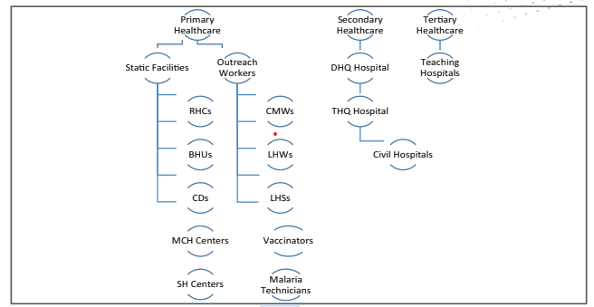
Figure 1: Hierarchy of Public Sector Facility at Provincial Level in Punjab
Health Care system in Pakistan is underfunded and hence been underperforming and underserving the needs of the population. As a result, 78% of the population pays out of pocket health expenditure, three quarters of health services are provided by private sector.The issues of the publics sector include dual practice, charging informal fees, and staff absenteeism. Mal-governance in this sector can also be gauged by the fact that there are two times the doctors and physicians in the country than number of midwives and nurses(Nishtar S, 2013).This reflects the failure of the public sector to provide reproductive health care services to the population. 92% (73,650 private health care facilities, 5941 public sector health care facilities)of the primary health care facilities are provided by private sector. Similarly, 93% (40,000) Pharmacies and 60% (2,400) diagnostic facilities are also owned by private health care sector. 71% of the physicians work in the private sector and most of the public sector physicians also have contract with these private health care facilities(Organization, 2014).22% of the population in the country is covered under social safety nets and rest of the population has to face the shocks of exorbitant health expenditures(Nishtar S, 2013).

Pakistan’s Population Policies and its International Commitments
Pakistan’s first explicit policy on population was approved in 2002 with an aim to check the unsustainable growth of population. The objective was to create a balance between the utilization of resources and population, increase awareness about adverse impact of rapid population growth. This policy cited the objective to achieve universal access to contraceptives by 2010 and reduce population growth rate to 1.9% by 2004 and achieve population stabilization by 2020 via reducing population growth rate to 1.3% per annum. However, policy failed miserably to achieve its targets and indicators like CPR and TFR has shown only marginal improvement when policy was implemented. Another policy draft was chalked out in 2010, with an aim to reinvigorate the zeal into the family planning project, however the subject of population and health was devolved to provinces amid 18th constitutional amendment(Khattak, What Hampers Population Policy in Pakistan? The Crossroads of Women’s Empowerment and Development Agendas, 2013). The aims and objectives of this new policy included achieving replacement level fertility, minimizing the unmet need of family planning to 10% and achieving the CRP of 70% by the year 2025.
After devolution and establishment of provincial population departments, threeprovinces have come out with their own population policies. According to population policy of Punjab 2017, family planning is declared as a human right. Sind announced its population policy in 2016, with the aim to increase CRP from 30% in 2015 to 45% in 2020, achieving replacement level fertility rate by 2035 and universal access to family planning services by 2020. KPK population policy 2015 also targeted CRP of 42% in 2020, achieving replacement level fertility rate by 2032 and universal access to family planning by 2020.
Pakistan is the signatory of Sustainable Development Goals, a set of 17 goals to improve the quality of life globally. Its target 3.7 deals with ensuring universal access to family health care service including awareness and integrating the reproductive health into the national policies and programmes. Under this target, the satisfactory access of modern contraceptive methods to reproductive age women is to be increased to 70% by 2030. Similarly, a target has been set to reduce the adolescent birth rate by half of the value of 44% in 2014-15 till 2030.
Family Planning 2020 (FP2020) is the outcome of London Summit on family planning held in 2012. The aim of this project was to empower women so that they can freely decide about their reproductive health. Pakistan is also partner of this initiative since 2012. Pakistan committed to increase CPR to 50% and reach 6.7 million additional users till 2020 by devolving and increasing the collaboration between the regions. However, the data tells the other story. CRP has been stagnant over the past few years and modern contraceptive prevalence rate in 2019 has been meager 27.1%. Similarly, women with unmet need of contraception has been 27.1% and only 50% women has been satisfied with the use of modern methods of contraception(FP2020, 2019).

Population and its impact on Environment, Health and Economy
Infant mortality rate in Pakistan has been one of the highest in the World today. In order todecrease maternal and infant mortality rates, improvements in infrastructure and skill such as ease of access to skilled birth attendantsare needed. Health system of Pakistan has largely failed to meet the needs of the population which can be gauged by indicators like fertility and mortality rates along with thehigh malnutrition among children and women of reproductive age; and insufficient antenatal care and health care facilities at birth. Many policies and programs have been implemented to improve the situation, some of them are mentioned below.
A maternal and neo-natal child health program was initiated in 2005. This strategic framework clearly established a vision and guiding principles to formulate maternal, neonatal and child health (MNCH) interventions.In pursuance of the above-mentioned strategic framework, the government initiated National Maternal Neonatal Child Health Program to expedite work on infant and maternal health and well-being. This program had aimed at two things: Provision of emergency health care services and community-based midwives, Spearheading the task of promoting institutional deliveries carried out through properly trained and skilled birth attendants (Technical Resource Facility 2013).
Unwanted pregnancies also result in abortions which is a significant cause of deaths in the developing world.Family planning also provides women with the time to invest their energies on upbringing of their children and contribute to the labor force of the country. This increases the resilience of the society and reduces risks from many natural disasters and unforeseen circumstances(Singh, 2010; Joshi, 2007).
Primary health-care was also made a part and parcel of the MNCH Program and these services were rendered through Lady Health works (LHWs) who provided service delivery at the very door step through home visits in the rural areas. The duties of these LHWs included improvement of the hygienic practices, expanding the use of contraceptives, provision of ante-natal health care services, fortifying the diet with iron and folic acid during pregnancy, assessment of the physical growth of the children through anthropometric measurements and educating the mothers regarding the pressing need of immunization of their children.
Integrated Reproductive Maternal Newborn, Child Health & Nutrition Program was initiated by the Government of Punjab with an aim to expedite the services that were already being rendered towards the goal of achieving 'Universal Coverage' for health services as well as address the health and nutrition related goals put forward in the Planning Commission’s 'Economic Growth Framework'. The aims included bringing about a reduction in maternal, newborn and child morbidity and mortality, promotion of family planning services and bringing about an improvement in nutritional status of women and children. A variety of initiatives were proposed to tackle the problem of malnutrition and to expand the availability of MNCH services. The strategy that was devised for this very task was ensure ng the availability of service delivery at selected primary and secondary health care units (BHUS, all RHCs, THQs and DHQs) around the clock. BHUs were to be selected by a designated Provincial Management Committee keeping in mind the criteria for selection which was geographical distribution of and the community's accessibility to individual facilities. In spite of these endeavors, the mammoth task of maternal and infant health and well-being has been a distant dream till date.
Severity of air population related illnesses can be gauged from World Health Organization (WHO) report according to which over 4 million people around the world succumb to air pollution related diseases annually, owing to highly toxic air quality in especially in urban areas. Population and environment are having close association with each other. Environment is the umbrella that protects and provides basic needs for survival on this planet. Increasing human population may put more pressure on environment. More population means more demand for resources and energy. Several parameters are used to understand population and air quality trends including carbon emissions (CO₂ etc), energy consumption, deposition of nitrogen, or land area deforestation(Cole, 2004). Almost 34% of population is urban, suffering from swerve air quality issues like smoke, acid rain and water quality. Currently two cities (Lahore and Karachi) from Pakistan ranked among top 5 most polluted cities in the world with US-AQI 210 and 199 for Lahore and Karachi respectively beside this they are among the most populated cities of Pakistan.even today, more than two billion people rely on the biomass and other conventional sources of energy to meet their energy needs. Pakistan is a developing country struggling to meet energy demand and tackle environmental issues. From last few years Pakistan is facing sever air quality issues in major cities (Sherbinin, 2007).
Julia C. Allen analyzed the relationship between land-use/cover change and factors including population growth, wood use, and change in arable land. The results suggested a significant link between population growth and deforestation. The study concluded that “deforestation is associated in the short term with rising population and expansion of agriculture and in the long term with wood harvesting for fuel and export. Deforestation through extensive wood use does not occur as quickly as it does through population growth and expansion of arable land” (Allen, 1985).A more recent study by Ruth S. DeFries used “satellite-based estimates of forest loss for 2000 to 2005 to assess economic, agricultural, and demographic correlates across 41 countries in the humid tropics”. The study found a significant correlation between urban population growth and landmass of forests; however, the study claims that rural population is not associated with the forest loss(DeFries, 2010).
Khalid Ahmed explored the “validation of the Environmental Kuznets Curve (EKC) hypothesis for Pakistan using time series data from 1980–2013 with deforestation as an indicator (dependent variable) for environmental degradation, and four independent variables (economic growth, energy consumption, trade openness, and population)”. The study concluded that economic growth along with the energy consumption, and population density negatively affect the forest area. However, the study found no relationship between trade openness and deforestation. The study further adds that “the increasing population ratio is a fueling factor to worsening environmental conditions due to economic growth and energy use”(Ahmed, 2015).
The growing number of populations has put immense pressure on the accessibilitytofresh water sources. The sources of fresh water have been decreasing with time. Among the different reservoirs in which water is stored, fresh water forms only few percent of the total land water(Prigent, 2012), is a vital resource for human life and industrial and recreational activities. The rural to urban population trend has also played its role in the shortage of water. The urban areas have been the hub of economic activities and attract most of the population. Studies shows urban areasuse additional sources of water supply (like from the ground water) to meet the demand of the quality of urban life.
Pakistan being an agriculture country largely relay on fresh water, which has been depleting due to population growth and global warming. The mismanagement of rivers, canals and absence of small dams have aggravated the situation. Water scarcity not only puts a pressure on food security but also poses a threat to national security.Generally, regions with the highest amount of surface water decline (e.g., India, Pakistan and China) represent areas where riskof water security is high(Vörösmarty, 2018).
There is no empirical evidence that establishes the relation of population growth and poverty and consequently on the overall economic development of a country however, an indirect relationship based upon observations and theories has been concluded. Indirect link suggests that rapid population growth reduces the per capita income growth as well as well-being, which increases poverty. In addition to this, in densely populated developing countries there is a high incidence of poverty due to landlessness caused by pressure on land, deteriorating education system and worsening of health facilities.
Moreover, population growth has increased the dependency ratio of unemployed population to employed population. The calculated labor force in Pakistan is calculated to be 54.92 million, whereas the remaining population depends upon them(Pakistan - Our World in Data, 2020). Therefore, a direct and close relationship exists between population growth and poverty in Pakistan. In future, there would be an increase in relative and absolute poverty due to stagnant or deteriorating employment opportunities as there is a persistent increase in population. It has ultimately negatively affected the health, education and housing conditions in Pakistan. High incidence of poverty in Pakistan also has a relation with the significance for sustainable economic development. Long-term economic development will remain a distant dream without protecting the marginalized groups and the inclusion of the whole population in the process of economic development.

Research Questions
- Why Pakistan has failed to control its population growth?
- What measures can be suggested for improving the prospects of population in Pakistan?
- How does high population growth affect poverty, environment, maternal and infant health in Pakistan?

Chapter 3: Research Methodology

Research approach
Qualitative approach was used in this syndicate project. As initially team has explored different theoretical and practical factors contributing to particular research questions. The research aimed to derive subjective meaning from people’s experiences in the execution, therefore interviews were held. The executives’ perspective was taken. This is done in qualitative approach. This was because the research questions were of the nature which could be answered through qualitative analysis. However, the research question number 3 and its analysis and data will be taken from the RAGs. For research question number 1 and 2, “why” and “what” was used it means the research questions are of a qualitative nature.
The first criterion for selection of a research approach is the research problem and the research questions. The problem being researched in this paper was about the population conundrum in Pakistan, which is multifaceted and includes many sub-issues attached to it. Hence a qualitative method was chosen to understand in greater detail the dynamics of the problem. Moreover, not a lot of research has been undertaken in this area before even though the issue is pertinent to the welfare of the country.
Another criterion was the audience for the paper. This paper was meant to shed light on the problems and prospects of population and come up with recommendations for the policy makers. In this light, a qualitative method was chosen to make sure that the issue is explored in all its varied aspects.

Philosophical Worldview
Pragmatic worldview was the worldview of the team. Research question number 2 investigates “what” which is answered through a pragmatic worldview. More focus is towards the research problem and knowledge about the problem is derived through all approaches. The lens used is problem-centric, pluralistic and real-worldpractice-oriented worldview was kept.

Research Area
For syndicate project, the data of population of provinces as well as whole of Pakistan was considered. Policy analysis which was done by documentary analysis included policies of provinces as well as federal policies. They were chosen to ensure holistic picture of the problems, challenges and prospects of the population of Pakistan.

Data Collection & Analysis
Both primary and secondary data collection methods were adopted for this project. Primary data was taken from interviews of executives and experts. Documentary data was also analysed and used; such as different institutional reports, policies, articles, and official website pages. As far as primary data is concerned, interviews were taken which was open ended and flexible, keeping in mind the qualitative approach. Secondary data was also taken from documents such as reports, policies and census data. The executives/experts point of view was taken. Thematic analysis was carried out as is the practice in qualitative analysis.
Participants (executives/experts) were purposefully (purposive sampling) chosen because that is the proper way to choose participants in a qualitative research. The executives chosen were those who had ample experience in the fields of population. They had either served in the population welfare department or at other national level bodies related to population. Qualitative documents were analysed, purposive sampling was chosen in the documentary analysis too.

Ethical considerations
Codes of ethics set forth by American Sociological Association (ASA) were considered while doing research, as while doing research ethical considerations are so important (Munhall P. L., 1988). Ethical consideration is being taken care of during whole project; proper permission was sort from various institutes for data gathering. Following ethical considerations were observed in the study. First and foremost, informed consent was taken before collecting data. For ensuring principle of professional competence suitable scientific, professional, technical, and administrative resources were utilized, along with consulting professionals. High integrity was maintained during research to inspire trust and confidence. Respect towards people’s rights, worth, and dignity was observed. Elimination of all sort of biasness and forms of discrimination were kept into consideration during research activities.

Sources of Data
Research Question | Topic | Data type | Source of Data
(1) | Population growth | Primary & Secondary | Interview & Documents
(1) | Population growth | Primary & Secondary | Interview & Documents
(2) | Improving Prospects | Primary & Secondary | Interview & Documents
(3) | Effect on Poverty | Secondary | RAG data
(3) | Effect on environment | Secondary | RAG data
(3) | Effect on Maternal and infant health | Secondary | RAG data

Limitations
The limitations of this study are as follows:
- Hectic routine during CTP led to time constraints.
- More interviews could have been done if there was more time.
- Due to paucity of time, most of secondary data was used for analysis.

Chapter 4: Research Findings
Based on the interaction with society, environment, expert opinion, analysis of the past and existing policy documents and research literature six inductive themes were derived as mentioned below:

Research Themes
Over the span of past seventy years of the country, population of the country has grown by six times from 33.78 Million in 1951 to 207.7 million in 2017. Despite having the oldest population program in the region, it has highest population growth rate in the region today. According to the census of 2017, population growth rate in Pakistan has remained 2.40 during 1998-2017(Dr. Dur-e-Nayab, 2019). During thematic analysis, following few themes were identified for research topic after analysis of the collected data.
- Factorsaffecting modern contraceptive services uptake/family planning at consumer end
  - Family’sDecision-making Dynamics
  - Socio-Cultural Barriers
- Factors related to supply side / health sector
  - Universal Access of Contraceptives
  - Intersectoral coordination
  - Federal Provincial coordination
- Consequences of unsustainable Population growth
  - Population and Health
  - Population and Environment
  - Population and Economy

Factors affecting modern contraceptive services uptake/family planning
Following are the factors that are present at the consumer end that act as barrier to uptake of family planning services and access to reproductive health care.

Family’s Decision-Making Dynamics
Family’s decision-making dynamics to use reproductive health and contraceptive facilities are dependent on the many factors including education level of both partners, women’s say in domestic household and overall economic wellbeing of the domestic household. Women empowerment is an important aspect that effects population growth in this country. It is not only the gateway to economic development and their involvement in the decision making but also plays a majorpart in determining the population trajectory of any country. This issue of women empowerment is linked with socio-cultural and interpersonal domains(Choudhry, 2019). It has several facets including educational and economic empowerment.
Pakistan Demographic and Health survey 2017-18 measured the impact of women participation in decision making by asking questions about their say in decision making in three domains (1) their own health care, (2) major household purchases, and (3) visits to their family or relatives. The result showed that 39% of the women have no say or participation in any of the three decisions. Report also suggested that higher the inclusion of womenin the decision making, higher the ratio of using modern methods of contraception.
The women who participate in none of the decision-making process has 27% Contraceptive use rate while women who had the participate in all three decisions has a 41% Contraceptive use rate as shown in Figure 2. Graph also depicts that use of modern contraceptive method is higher in women who participate in all three decisions than women with no participation in any of the decision by 10.2%. Ideal children among women also vary with the inclusion of women in decision making process in the home setting. Women who do not participate in the decision making have higher average of children than women who have participation in the decision-making process as depicted in Figure 3. Unmet need for family planning also decreases with rising women participation in household decision making as displayed in Figure 4.
Women education is another aspect of women empowerments which has an impact on population variables like TFR, CPR, median age at first marriage and first child for women. Average age at first marriage increase from 18.7 to 24.9 years when we move from no education to higher education as depicted in Figure 5. Similarly, there is a gap of 1.6 children between the TFR of illiterate women and women who have higher education as depicted in Figure 6.

Figure 2: Percentage of contraception use by women’s empowerment (Source: PDHS 2017-18)

Figure 3: Average Number of Children by women’s empowerment (Source: PDHS 2017-18)

Figure 4: Unmet need for family planning vs women empowerment (Source: PDHS 2017-18)

Figure 5: Median Age at First Childbirth and First Marriage wrt Education Level (Source: PDHS 2017-18)

Figure 6: TFR by Woman Education (Source: PDHS)
Survey also suggests that domestic household’s economic wall being also has a bearing on TFR. Higher the poverty, lower is the chance of access to modern contraceptives, so access to contraceptives also varies with respect to region and wealth class(PDHS-2018, 2019). Modern use of contraceptive increases from 17% in first quintile to 30% in fifth quintile as depicted in Figure 7. Similarly, the modern contraceptive use varies province wise according to poverty. According to 2017-18 Survey, Punjab has lowest percentage of the people i.e. 25.3% living below the poverty line and Balochistan has highest percentage of the people i.e. 56.8% as shown in Figure 8. Figure 9 and 10 also represent that Punjab has lowest TFR and highest CPR while Balochistan has the opposite.

Figure 7: Modern Contraceptive Prevalence Rate wrt household income (Source: PDHS 2017-18)

Figure 8: Poverty Trends by Province and Rural/Urban Divide (Source: PDHS 2017-18)
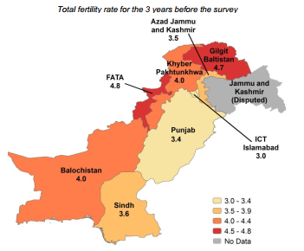
Figure 9: Province wise Total Fertility Rate (Source: PDHS 2017-18)
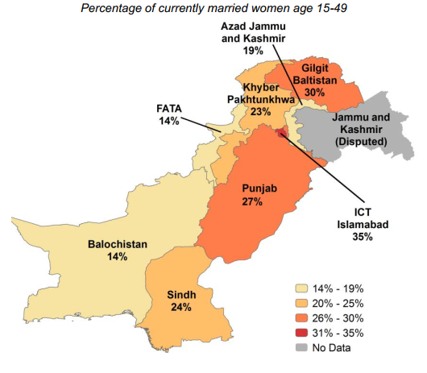
Figure 10: Modern contraceptive use by region (Source: PDHS 2017-18)
Women in Pakistan has low empowerment level and this disparity is also reflected in decision making for contraceptive use and having intercourse as discussed above. Gender gap report 2018 depicts that Pakistan is 148th in the world and lowest in the region with an overall score of 0.55. Figure 11 shows the distribution of different assets based on gender. Economic empowerment can be gauged from the fact that in 2018, 98% of the newly married men were employed while only 19% of the women were employed in Pakistan(PDHS-2018, 2019). Similarly, educational empowerment can be gauged from the fact that women also have low literacy rate when compared with men. According to economic survey of Pakistan, in 2017-18 women literacy rate was just 51.8% as compared to men who had 72.5% literacy rate.

Figure 11: Ownership of assets (Source: PDHS 2017-18)

Socio Cultural Barriers
Socio-cultural and religious constraints have also restricted the ability of the state to successfully control the population explosion. A cross sectoral study was carried out in three underserved districts in Punjab in May 2012 to see the impact of socioeconomic factors on seeking the reproductive health facility. Most women in survey included those from low socio-economic setting and younger than 30 years(SK Azmat, 2015). District wise data is shown in the Chart12. The study found that husbands were the key decision makers in receiving reproductive health care facilities by the women.

Figure 12: Decisions making dynamics in household about RH care-seeking?(Syed Khurram Azmat, 2015)
Raza et al. studied the impact of religious perception on use of contraceptives among the women in Pakistan.The data from National Institute of population studies was used to conduct the study with a population size of 2398 sample (Raza, 2012). The study found that in communities were religious ulema were conducive to the use of contraceptives, women had 1.7 times more probability to adopt contraceptive practices than communities where ulema were against use of contraceptives (Odds Ratio [OR]=1.704, 95% confidence interval [CI]=1.11–2.6; P=0.014). An interviewee also expressed his concerns on the topic in following words:
“…. Religious factor has been a problem to some extent, we have agreement with them (Ulema) when it comes to mother and child health care. However, they are against few surgical and medical procedures adopted in this process.”
The demographic and health survey1990-91suggested that 67% of the women between the age 18-25 were married before there 18th Birthday. Although, this ratio has declined to 18%, but still it is a significant value. To overcome the issue of early marriage a legislation is in pipeline in Punjab Province.
“Draft of the first legislation has been made (in Punjab). To restrain early marriage, family act is being amended and minimum age of marriage will be increased from 16 years to 18 years.”

Factors related to supply side
Following are few factors that are related to the supply side of the contraceptive and reproductive health care facility.

Universal Access of Contraceptives
In Pakistan, there has been a vast divide between the demand of contraceptives and their availability. Unmet need of the contraceptives is one important parameter for measuring the accomplishment of the family planning policies and programs in any country. Over the years unmet need of family planning services has declined as shown in the Figure 13, but still the gap between contraceptive demand and demand met is considerable. Pakistan Demographic and Health survey 2017-18 suggest that out of 51.5% married women who want to have access to contraceptives, 17.3% women remain devoid of such services.
This statistic of unmet demand is important because the knowledge of contraceptive methods has improved rapidly in past few decades and has almost reached the level of universality i.e. 98.3% as per demographic and health survey of 2017-18. Figure 14shows that knowledge about the contraceptive use has become universal in this country but there is a failure to match the demand which results in unwanted pregnancies and abortions.

Figure 13: Demand&Need of Family Planning among married women of Reproductive Age (Source: PDHS)

Figure 14: Knowledge of Contraceptives among married women of reproductive age (Source: PDHS)
According to Pakistan Demographic and Health Survey 2012-13, only 26% married women of reproductive age (15-49 years) used contraceptives. It remains stagnant at 25% according to the Demographic and Health Survey 2017-18. Practice of traditional contraceptive methods remains stagnant at 9% over the period of 2012-18 as per Demographic and health survey. The high prevalence of traditional methods of contraception also indicates the failure to meet the requirement of the population for modern contraceptive services, as a result of which couples’ resort to traditional methods for birth control. The trend of contraceptive use over the years has been shown in the Figure 15.

Figure 15: Trends in contraceptive use among married women of reproductive age (Source: PDHS)
The unmet demand contraceptives, results in Total Fertility Rate (TFR) to be higher than the total wanted children in families. The demographic health surveys suggest that the difference between the total wanted children and actual fertility rate has declined from 2006-07 to 2018-19, but there is a wide gap of 0.7 between the total fertility rate and wanted fertility in the country as shown in Figure 16. It means that for a woman with four children, one child is unwanted. So, lack of access of contraceptives is also a hurdle in achieving the target of TFR target of 2.1 in the country. Similarly, contraceptive prevalence rate remained stagnant during the period of 2012-13 to 2017-18, demographic and health survey suggest that Total Fertility Rate declined only marginally from 3.8 to 3.6 during the period thus showing little change in the overall population growth trend.

Figure 16: Trends in Wanted and Actual fertility (Source: PDHS)
Pakistan demographic health survey, 2018 which suggests that almost 12% of the pregnancies over the period of past 5 years were either mistimed or unwanted. Although, there is a decrease in unwanted pregnancies by 4% from the survey of 2012-13 but the ratio still remains significant as depicted in Figure 17. A report of National Population Council of Pakistan stated that almost 9 million pregnancies were reported in Pakistan in 2012 of which 4.2 million pregnancies were unwanted. This meant 93 unintended pregnancies per 1000 women of the age 15-49. 54% (2.25 million) of these unintended pregnancies ended in abortion. This makes 50 abortions per 1000 women per annum in Pakistan and almost all of these abortions were illegal.Since, abortions are allowed in Pakistan only in certain condition, practices of safe abortion are not easily available. Approximately 40% abortion are hence carried out by unskilled people(Sathar, 2014).

Figure 17: Fertility Planning Status (Source: PDHS)
When we compare the access to contraceptives in Pakistan with regional countries, we find that Pakistan lags far behind the regional countries as depicted in Figure 18 and 19. The data from Bangladesh demographic and health survey 2014-15 shows that it has 62.2% of contraceptive access rate for women between the age of 15 to 49 and 87.2% of the population uses modern methods of contraception(Islam, 2017). Similarly, 2015-16 National Family Health Survey of India states the contraceptive prevalence rate to be 53.50%, out of which 89.15% use modern methods of contraception. According to National Demographic and Health Survey, 2016 in Nepal, contraceptive prevalence rate in Nepal is 52%. Contraceptive Prevalence rate in Sri Lanka according to Sri Lanka Demographic and Health Survey in 2016 was 61.7% of which 83.14% used modern methods of contraception. However, Pakistan Demographic and health survey 2017-18 shown the contraceptive prevalence rate to be 34.2% of which 73.1% use modern methods of contraception. Pakistan not only has the lowest contraceptive prevalence rate in the region but also has the lowest percentage of the population using the modern contraceptive methods.

Figure 18: Regional Comparison of Contraceptive Prevalence Rate (Sources: PDHS 2017-18, SLDHS 2016, BDHS 2014-15 and NFHS 2015-16)

Figure 19: Regional Comparison of Percentage of Women using Modern Methods (Sources: PDHS 2017-18, SLDHS 2016, BDHS 2014-15 and NFHS 2015-16)
This difference in the Contraceptive prevalence rate is also reflected in the regional comparison of the crude birth rate and total fertility rate as shown in the Figure 20 and 21. The data from World Bank shows that in both indicators Pakistan performs worse than its neighbors and other regional countries. A drastic reduction has been observed in the fertility rates of the regional countries over past 30 years, however, this decrease has been small in case of Pakistan.

Figure 20: Crude birth rate in South Asia (births per 1,000 population)(Bank W. , 2020)

Figure 21: Total Fertility rate in South Asia (births per woman) (Bank W. , 2020)
Bangladesh Demographic and health survey states average age at first marriage among the women of age 20-49 to be 16.1 years in 2014 while in Pakistan the age at first marriage is 20.7 years as per demographic survey of 2017-18. Although, the span of fertile age in Bangladesh is larger as compared to Pakistan, but they have a population growth rate of 1.05 in 2018 as compared to Pakistan’s 2.056 in 2018 according to World Bank as shown in Figure 22.
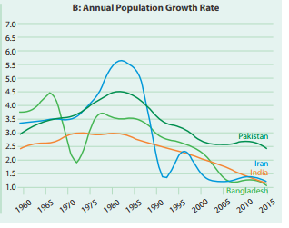
Figure 22: Trend for Total Fertility Rate and Population Growth for Regional Countries (Dr. Dur-e-Nayab, 2019)

Federal and Provincial Coordination
The continuous shifting of responsibilities between federation and provinces is one of the major issues identified in our research. The issue of shifting federal control over population program to the provinces is hugely politicized(Khan, 1996). This point has been unequivocally raised in the interviews that were conducted:
“Before 18th amendment, administrative powers relating to population kept shuttling between federation and provinces. When one government settled with responsibility of the subject of population, government was transferred to another political party which used to start all this exercise from the scratch.”
Federal and provincial governments have a history of managing population control programs intermittently and interchangeably. In 1965 first national program on family planning was initiated along with constitution of National Board of Family Planning which worked at federal level. The efforts for population control have faced various setbacks, more so since 1976 when the it was fully federalized(Khan, 1996). In 1983, there was a sudden change in policy when Attya Inayatullah set out to initiate the process of provincializing the population program, because federalized efforts were not yielding desired results and different problem were being faced in its implementation. At that time, ground situation was being managed under a Presidential Ordinance which shiftedthe field activities to provincial tier, while finances and policymaking were controlled by the federation, as required by the constitution. Provincial councils were introduced for population welfare and planning, implementation being done at district level. However, funding for these population programs and activities continued to be a part of the Annual Development Plan of Federal budget's (Khan, 1996). Another problem which was faced by the staff of provincial population program was their dependence on the federal government to release funds for even the smallest expenditure at the local level. Moreover, the federal government decreased the staff in population departments in 1983 from 16,000 to 8,300. As said by the interviewee: -
“In the era of President Zia, when the project was sailing smoothly, this program was capped because it was against the islamization project of that government.”
Due to these issues first policy came in 2002, 50 years after the start of the family planning work and in 2010, the subject was devolved to provinces in the after math of 18th constitutional amendment. In the words of interviewee: -
“First, population policy was launched in 2002. A draft of the national population policy was prepared in 2010, but then subject of population devolved in the aftermath of 18th amendment.”
18th amendment suddenly turned the tables in the favor of provinces and subject of population welfare and control activities was devolved to provinces. However, the process of devolution has been lackadaisical as many elements of population planning continued to be managed at federal level. Provincial population welfare departments just rephrase and reproduce the policies made at the center. One such case in point is recent recommendations by national task force which were more or less as it is adopted by provincial departments without having much say in initial policy formulation.
However, despite the welcome development of devolution, few problems persist which have been identified by World Health Organization(WHO, 2010). Some problems which remain unaddressed even after devolution are:
- Redesigning of human resource for health at both federal and provincial level
- Updating regulatory framework and revamping coordination mechanism between provinces and the federal government
- Administering responsibilities falling upon provinces as a result of recent devolution remain largely unaddressed (WHO, 2012).

Inter departmental Coordination
Population control or management is such a program that needs collaborative effort of different departments and organizations. As clearly mentioned by one of the interviewees in population welfare department that:
“Menace of population explosion cannot be controlled by any one department very less population welfare department. It needs combined effort by all departments”

Figure 23: Population and Interdepartmental Coordination
When it comes to supply side, mutual working mechanism of health and population departments comes to question. There is still 20% unmet need of contraceptives usage. It can only be met by proper supply mechanism which include not only governmental departments but also private sector which is lacking. When it comes to interaction between health and population welfare departments, they face a number of issues. On policy level, they often have cross-directional targets. On ground, they have separate infrastructure as former has around 5000 basic health facilities whereas the latter has around 3000 facilities for offering a range of family planning services. But their efficacy has serious doubts(Shaikh B. T., 2010). There is absence of proper liaison between different facilities and collaboration of any sort.
On what count does departments have to collaborate. PDHS 2012-13 gives us insight into similar interesting facts that currently 96% of married men and women have heard of some kind of contraception method but despite that only 35% adopt them. One reasons for that appear to be fear of side effects, various concerns associated with contraception methods, non-approval by family decision-makers i.e. husbands (Gilda Sedgh, 2007; Shaikh B. T., 2010). In such a situation, non-addressal of these demand side issue become crucial in diluting governmental efforts for promoting contraceptive prevalence ratio. Absence of proper counselling and awareness regarding potential concerns associated with contraception methods especially modern ones have played their detrimental part in this regard.

Figure 24: Informed choice
Population growth rate has been higher in rural areas ofthe country. Demographic and Health Surveys in Pakistan has constantly indicated the fact that Total Fertility Rate has been greater in rural areas than urban areas. The difference in Total Fertility Rate between rural and urban areas was 1.0 in 2018 as shown in Figure 25(PDHS-2018, 2019). This difference is due to gap in access to services and amenities in rural areas as compared to urban areas. World Bank in 2018 reported this gap by stating the gap in urban and rural access to mother and child care facilities as shown in Figure 26(Bank W. , 2018).

Figure 25: Trends in fertility by Residence (Rural vs Urban) (Source: PDHS 2017-18)

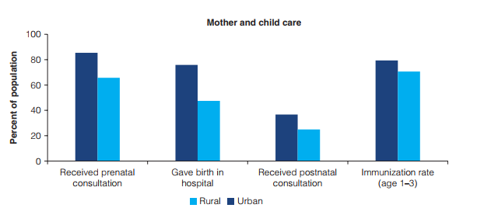
Figure 26: Urban Rural Gap in access to Basic Services 2013/14
Heavy reliance on less effective contraceptive methods in combination with the lack of quality information has resulted in high consumer dissatisfaction and high 12-month discontinuation rate. Contraceptive discontinuation rates are higher for sources like pills (47.2%), injectables (46.8%), male condom (33.2%). Side effects and health reasons have been the major reason for discontinuation of majority of the modern contraceptives with 26.6% of the 46.8% people discontinuing use of injectables and pills and 17.8% of the 47.2% population discontinuing the use of pills citing this reason (PDHS-2018, 2019).
In South Asia, the share of Public sector in provision of modern contraceptives is almost twice the share of Private Sector, however, Pakistan represents a unique case. Its Public Sector’s share in providing contraceptive related services has been lowest in the region at present as shown in Figure 27. According to Demographic and Health Surveys, share of public sector has declined over the years and now private sector has been taking over to provide these facilities as depicted by Figure 28.

Figure 27: Sources of Supply of Modern Contraceptives(Donna Clifton, 2013)

Figure 28: Increased sources of modern contraception (Source: PDHS)
This is due tomismanagement and disconnect between the population and health department was also explained in the following words of the expert.
“In Punjab we have 45,000 LHW (Lady Health Workers), whose main focus is on primary health care and polio vaccination, but family planning is not the priority of the program. Population welfare department cannot control this menace on its own. A combined effort from other institutions like health, education and religious sector is also required.”
Private health sector forms a large network of health care service provider, it is being taken into the loop to utilize its potential to provide family health care facilities as explained by interviewee: -
“Private health care providers also form a large network. Punjab Health care Commission has registered private practitioners and hospitals but we need law for making them to provide family planning services. We have drafted and tabled a bill named “Family Planning and Reproductive Health Right Bill” in Punjab since it has also been made human right by UN. Sindh has already approved this bill. When this law will be passed, it will be mandatory for all health institutions to provide services related to family planning and reproductive health.”
This loophole of poor coordination between public and private sector is being filled in Punjab by Population welfare department by developing a logistic and coordination system. Similarly, population welfare department is developing a pre martial counseling module on the model of Iran.
“On supply side, we have developed a contraceptive management system to forecast the requirement of contraceptives. We are also developing a supply change management system.”
“Pre martial counseling modules have been developed by provinces in Pakistan and there testing is to be done yet. A column will be introduced in the Nikah form regarding pre-counseling.”
Community based public private partnership model has been implemented as a pilot project in one of the studies.An intervention was carried out by Marie Stopes Society (MSS) of Pakistan in the name of “Evidence for innovating to save the lives” to explore the feasibility and impact of family planning interventions in underserved areas of Sind, Punjab, and KPK an resulting improvement in spacing of pregnancies(Syed Khurram Azmat, 2015). Two interventions were carried out with the name of SurajModel which provided free vouchers and a community midwife model was implemented for promoting modern contraceptive methods in the control areas. Baseline and end line cross-sectional household surveys were conducted with a gap of 24 months.
In suraj model, 10 suraj service providers were constituted in each intervention district. This model was a partnership between MSS and private health providers to provide reproductive health facilities. In community midwife intervention model, a link was created between the MSS and CWMs to provide quality contraceptive facility to the community. In this model also, 10 CMWs were selected in each district and trained to provide services.
The result of the study found that current contraceptive use increased by 14% in Surj intervention model and 8% in CWM model as compared to 8% increase in CPR in control group. Similarly, modern contraceptive use increased by 8% in Suraj model, 6% in CWM model and 4% in control group.
Suraj intervention modelshows the effectiveness of embedding subsidized family planning services within the societies of the beneficiaries. CMW intervention also shows the improved outcomes in the use of long-term contraceptives. These findings show the importance of designing and implementing family planning initiatives by including local mid-level service providers to increase the coverage of contraceptives in under-served areas.

Figure 29: Current contraceptive use reported by MWRA - Any Method

Figure 30: Current contraceptive use reported by MWRA -Any Modern Method
Education and media are the other two important stake holders in this problem. The importance of education and role that education departments can play in curbing this menace was put down in following words by the interviewee: -
“I would like to break down it into three levels. It was decided that Primary (Class 1-4) students should be familiarized with health and hygiene. At second level, students of Class 5-10 should be familiarized with life skill education, like good touch bad touch. It is also our responsibility to tell our children about the physical and mental changes that take place in them with age. We should mentally prepare them about the situations that they would face in the future. At the third level, students at college and university level, we should aware them about the benefits of small family and population.”
The role of media has been put in the following words by the expert.
“We have a supply side and a demand side. Demand is generated through advocacy like print, social, interpersonal and electronic media. We are penetrating far lung rural areas using theater in collaboration with Rafi Peer. We were facing the issue that slogans like “do bachy khushhal gharana”. We have now decided to use narrative of “Balance between resource and family” after consultation with religious scholars. We have asked PEMRA to tell electronic media to air free ads.”

Population Prospects of Pakistan-Demographic Window
The study of population growth in Pakistan will be incomplete without taking into study the demographic transition in this country. According to UN’s Pakistan Human National Development Report published in 2018, 64% of the population in this country is younger than 30 years and 29% of the population is between the age of 15 to 29 years, a group which is defined as youth. The population pyramid of Pakistan with levels of Education in 2010 is shown in the Figure 31. As depicted in Figure 32, the fertility rate in Pakistan is declining gradually, this trend of having more people under the age of 30 is likely to continue till 2050. It is important to unleash this potential of youth as this can work as engine to economic development (Ahmad, 2018).
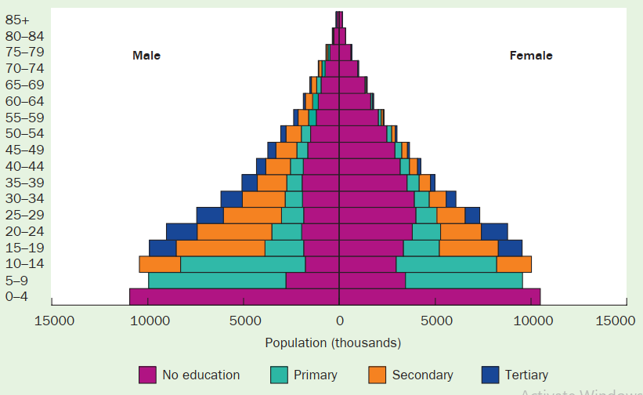
Figure 31: Population Pyramid of Pakistan with Education Level in 2010 (Source: UN 2011)
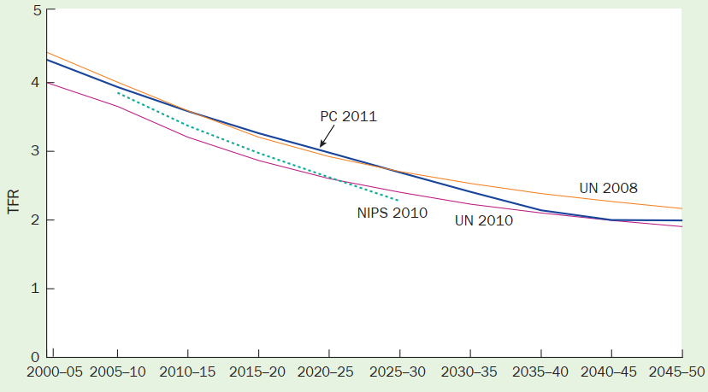
Figure 32: Various Projections of TFR in Pakistan (Source: Population Council 2011, NIPS 2010, UN 2008 &2010)
The complete transition of the population demographics consists of following steps. Countries may have high fertility and mortality rates. However, with improvement in public service delivery and health facilities, mortality rate may decline and will be likely to have less children because of declining mortality trend among infants. As a result, proportion of youth may increase in a country. If this youth is properly trained and women are empowered, the population may be utilized to achieve accelerated economic growth(Zeba Sathar R. R., 2013).
Figure 33 shows the population projections for three different age groups the less than 15 years age group, working age group (15-64 years) and old age population. The graph suggests that population of children (<15 years age group) would decline with the decreasing fertility rates and working age population would also start stabilizing by the near 2050. However, the grey age population would start rising rapidly.
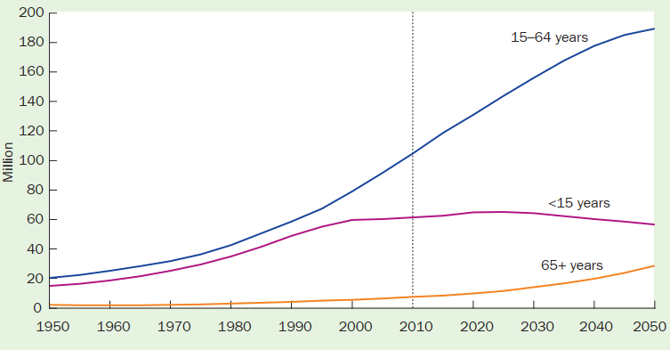
Figure 33: Population Projection for Three Age Groups (Source: Population Council)
Demographictransition alone is not the only component required to achieve the economic growth. It requires skillful youth so that it can play productive role in the development of the country. To get maximum yield of this window of opportunity, Pakistanneed to invest in education.According to UNESCO report 2018, Pakistan has 2nd highest out of school children of age 5-16 in the world i.e. 22.8 million. Progress in education is closely linked with the economic development in the country. The dichotomy between the political discourse and implementation has been causing troubles regarding provision of quality education. The government has set target to achieve universal primary education under SDG till 2030. However, present trends suggest that target is difficult to be achieved by 2030. Table 1 below shows the predicted changes according to trends in access to education by 2030 and the goals of government.

Table 3: Access to Education in 2030 according to Trends and Goals (Source: Population Council 2011)
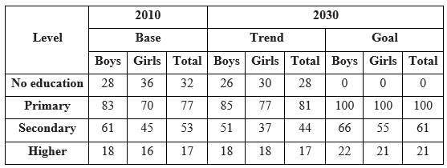
Increased education would have two-sided impact, on one hand it would improve the skill of the youth so that they can take an active role in economic development, on the other hand it would reduce the population growth. The Figure 34 shows the TFR trends in both cases. The population in 2050 would be 293 million if Pakistan is able to meet educational targets, 70 million less than what it would be if current trends continue.
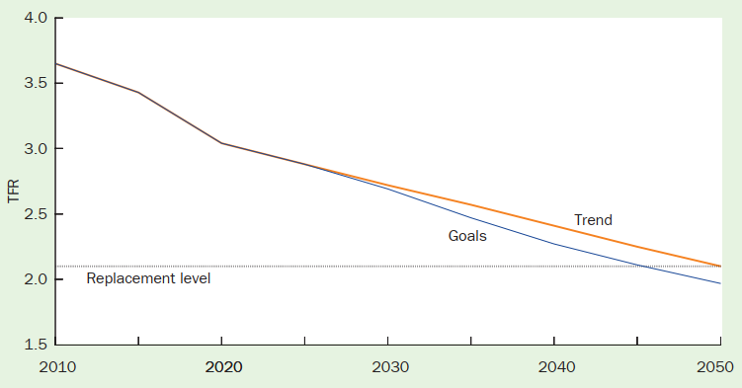
Figure 34: Trends of Total Fertility Rate under Two Educational Scenarios (Zeba Sathar R. R., Capturing the demographic dividend in Pakistan, 2013)
Women empowerment is also necessary to accelerate the economic growth in the country. Figure 35 shows the ratio of working age population to non-working age population. Since, the ratio has been constantly increasing after 2000, suggesting that Pakistan has a window of opportunity knocking at its doors. However, Figure 36 also suggests that around 50% of the working age population is employed but women participation is less than 25%. Thus, to achieve sustainable economic growth, it is mandatory for harness the potential of woman labor force to achieve a sustainable economic growth.
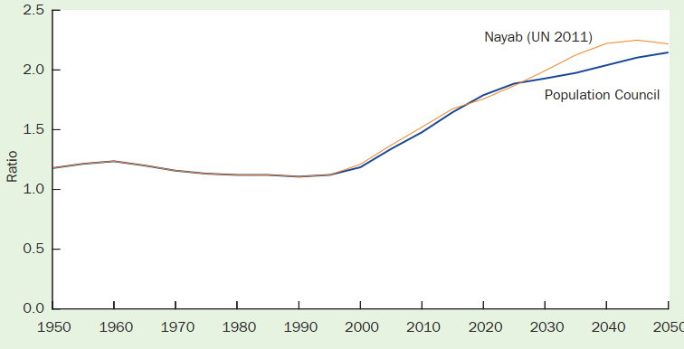
Figure 35: Trends of Working Age to Non-Working Age Population in Pakistan (Source: Population Council, 2011, UN 2011)
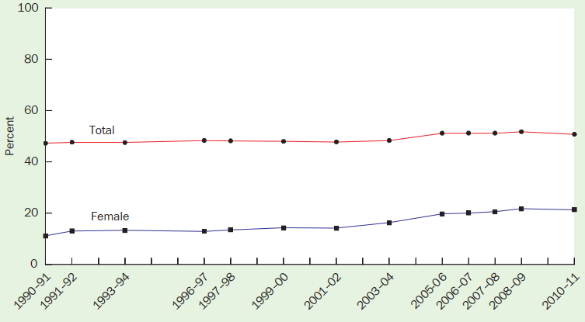
Figure 36: Total Working Age Population Employed and Women Population Employed in Workforce (Source: Labour Force Surveys)

Consequences of unsustainable Population growth
Population growth also has a deep linkage with factors like health, environment and poverty as discussed below.

Population and health
High fertility rate has a close relation with both the maternal and infant health. A major hurdle in the maternal and infant health and well-being is lack of access to health care facilities. At high fertility rate, provision of proportionate health care facilities for prenatal, postnatal and antenatal health care also becomes a challenge for developing countries like Pakistan.To increase access to family planning services, primary health care service was provided to population through the lady health workers (LHWs). The share of populationgetting Antenatalcare from skilled health-care provider has graduallyimproved from 26% in 1990-91 to 86% in 2017-18. However, women residing in Urban areas had greater access to ANC from a skilled health provider than rural women. Similarly, women who fall in the highest wealth quintile and have highest education status are expected to avail more ANC related services from a skilled health serviceprovider than their counterparts.
Delivery process when carried out by a skilled birth attendant is another important factor for reducing the maternal and neonatal mortality. 69% of deliveries in Pakistan are carried out by skilled health service providers. Major chunk of births isdealt by doctors (60%), and another 9% by skilled health care providers. Still a substantialamount of births arecarried out by a traditional birth attendant (Dai)which is close to (24%). Institutional deliveries have a direct correlation with various factors including the antenatal visits, educational status of the mothers, residence of the mothers in urban areas as well as the socioeconomic status of the mothers.
Studies reveal that postnatal period is also vital for mothers, as there are more chances of mothers to develop birth related problemslike postpartum hemorrhage during this period. Visits for Postnatal care help toavert or treat many of these complications. In this regard, percentage of women with a postnatal visit within 2 days of delivery has kept almost stagnant between 2012-13 to 2017-18 at 61-62%. Appropriatemedical care of newborns is vital to lessen neonatal complications and deaths. Since many of the neonatal deaths occur with 48 hours of birth, WHO has suggested that postnatal care services for newborns should begin as soon as possible after birth (WHO 2015). The studies revealed that in Pakistan almost 35% of newborns did not obtain any postnatal care during the first 48 hoursof their life.
In the 5-year period preceding the Pakistan Demographic and Health Survey 2017-2018, neonatal mortality rateremained 42 deaths per 1,000 live births, while infant mortality rate was 62 deaths per 1,000 live births, and under-5 mortality rate was 74 deaths per 1,000 live births. The study also shows that likelihoodof newborns dying in infancy is higher among children that are born to mothers who are younger than 18 or older than the age of 34.Similarly, children which are born after a short birth interval of less than 24 months after previous birth, and children born to mothers of high parity of more than 3 children are also at greater risk. The risk also getsincreased when a womanwho has more than one of the above-stated risk factors gives birth to children.
Table2 shows that maternal life risk is one of the highest in South Asia. It shows that 1 woman out of 140 dies due to pregnancy related issues. Every year 10,000 women die in Pakistan due to causes related to pregnancy, which is second largest in region after India. These deaths can be averted by proper provision and utilization of health care facilities(Bank T. W., 16; UNICEF, 16).
Table 2: Maternal and reproductive health indicators – India, Iran, Pakistan and Afghanistan (Source: PDHS 2017-18, Azmat, 2017)
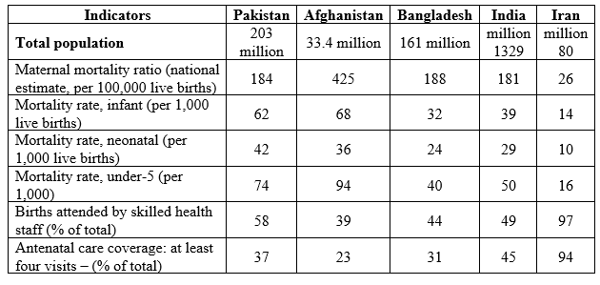

Population and Economy
The researchers agree that there is strong relationship between population growth and poverty. When population changes then economic development also changes and vice versa. An Indian economist, Thirwal said that,
“Population growth and poverty is a complex one. It is difficult to identify what is ‘cause’ and ‘effect’ in this relationship”
When we look at global patterns, it is observed that poor people live in Africa and Asia and richest countries are in North America and Europe where population is small. Demographics shows that those tend to be in richer countries have low fertility, low morality rate and lowest population growth rate.Neo-Malthusian analysis is of the view that poverty is a product of high population growth. Population growth puts pressure over natural resources and deflection of resources constrains economic development. This has led to inflation, poverty and unemployment. They ask for moral restraint on population and they advocate harsher means to control population.
According to Economic survey 2018-209, 29.5% of population lives below poverty line in Pakistan. Pakistan’s human development index standing has also fallen from 151st position to 152ndposition. In Neo-Malthusian view, poverty in Pakistan is present due to high population. There is a linkage between infant mortality rate, fertility rate, population and GDP.

Population and environment
Population has a direct bearing on the environment. The study was restricted to the Lahore region to bring out solid facts to support the argument. According to 2017 census, Lahore has a population of over eleven million people while it was just 6.32 million according to 1998 census. This shows that there has been a rapid increase in the population of the city. More population means more usage of transportation. FAO report for Sectoral Emission Inventory for Punjab shows that air pollutant share in Punjab is highest from transport sector than industries, followed by power and agriculture sector as depicted in Figure37. In 2018, Lahore was ranked at number 10 as the most polluted city in world AQI ranking report. Such poor air quality has a direct impact on the health of people. The number of children presenting with hyperactive airway disease to Pediatric Pulmonology OPD has grossly increased over the last ten year as shown in Figure 38. As per a verbal information taken from a popular pharmacy chain of Lahore, the sale of domestic nebulizers has increased 5-7 folds over the last 5 years.

Figure 37: Sectoral Air Pollution Share in Punjab (2008-17) (Source: UN FAO)
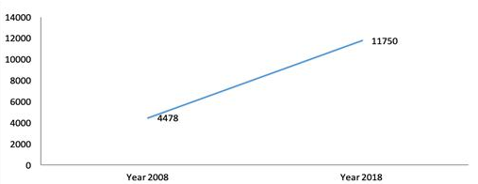
Figure 38: Number of Patients with Asthma Presenting to Pediatric Pulmonary Department

World Wide Fund (WWF) Pakistan in collaboration with Kinnaird College conducted a study about Lahore canal system and the trees surrounding them. According to the study, over 36 percent of the trees in the region were slashed reducing the number of trees to 14,873, due to the Canal Widening Project. Moreover, another study, published in the Pakistan Journal of Meteorology in 2015, used GIS imaging to assess the impact of land use/land cover on land surface temperature. The main focus area of the study was Lahore district. The study concluded that there was an unprecedented rise in urban population in Lahore; therefore, the constructed area that replaced the forest cover in the city had increased by 25% from 2000 to 2011.
Furthermore, population growth puts pressure on the agriculture as farmers need to produce more agricultural products to feed the population.Newland that is acquired for increasing agricultural output mostly contains forest area which is cut down by the farmers to harvest crops.
The World Wildlife Fund (WWF) study from 2014 estimated domestic water consumed at about 3,79 million meters per day in the Lahore region (MCM / day), almost all of that from a single aquifer from Lahore. It is not therefore surprising that there is a decline in the water table by 2,5-3 meters per year because hundreds of water pumps operated by the WASA or private housing systems have become operational in the last few years. Actually 160 million liters of soil water are pumped every day by various methods such as hand pumps, power pumps, and tube wells and supplied to residents of Lahore via water supply schemes, water filters, and tankers. Uncontrolled water extraction and a poor recharge of the aquifer make it possible for the city to run out of the water if preventive measures cannot be introduced in an emergency manner.

Chapter 5: Discussion and Recommendations

Discussion
Barriers in family planning services are present both at the supply and the consumer end. Data from Demographic and health surveys suggested that at the consumer side, major determinants for uptake of the reproductive health related services was the economic conditions of the household, women empowerment, place of residence (rural/urban) and socio-cultural barriers. Due to low level of inclusion of women in household decision making, education and economic independence, husbands are the primary decision makers in the process. Since, the social structures are erected in such a way that promote mail dominance, it can be argued that patriarchal societal dynamics is one of themajor reasons for slow uptake of family planning services by the women. Economic factor was considered to be the other reason for low CPR and health care quality in the country.To mitigate this issue world bank has coined the term “result based financing”. Under this idea cash payments or non-monetary transfers are made to the consumers after they have attained desired predefinedresults. Vouchers and conditional cash transfers are few examples of result-basedfinancing. In this regard we also studied SurajModel and CWM model of public private partnership and their positive impact on the availability ofreproductive health care facilities and their uptake.
Barriers related to supply side of family planning and reproductive health survives included low access to contraceptives, competence of the staff and staff absenteeism, perception of risk and fear of having side effects due to use of contraceptives. It was found that the knowledge of the contraceptives has become universal over the years.However, there exists a clear gap between the population needs of reproductive health care resources that are available to tackle the needs of the population regarding birth spacing and limiting the childbirth as evident by the large unmet demand of contraceptives in this county, use of conventional contraceptive methods and alarming rate of abortions that are carried out to prevent unwanted pregnancies. One reason for this issue was the shifting of business between the centre and federating units every now and then.The responsibility was spread between the tiers. No single entity was responsible for the population program and it is rightly said that “every body’s business is nobody’s business”. This can be attributed to lack of will on the part of political elite because population control was considered to be a controversial topic and no political party was ready to assume a leadership role on it. Similarly, population policy of Pakistan came in 2002 when the population of the country has already multiplied by five times and the damaged has already been done.
The health and population departments have been working in isolation with each other. Health policy enacted in 2001 and population policy enacted in 2002 were not integrated with each other and functioned in isolation to achieve the targets. The lack of commitment to policy implementation can be gauged from the fact that the indicators like CPR only improved marginally at a rate 1% between 2006-07 to 2012-13 and remained stagnant at 35% after 2012-13, after implementation of these policies. Pakistan has largely failed to meet its international commitments like MDG and FP2020 targets and trends suggest that Pakistan will also fail to fulfill its commitment of universal access to contraceptive by 2030 under SDG. The government also failed to remove the rural-urban disparity in access and use of reproductive health facilities. As a result, rural population which forms almost two-third of the country’s population has a TFR of 3.9 as compared to urban TFR of 2.9.
The government’s family planning program also enjoyed a large support from international donors and NGOs, but that support could not be translated into reality on the ground. This is due to certain procedural loopholes in the population department including service delivery, record keep and supply chain management. All in all, the population departments could not take the leadership role required to make the family planning program dynamic or tailored to the needs of the customers.
Due to these supply side issues; Pakistan has one of the lowest contraceptive prevalence rates in the region and highest percentage of people use conventional methods of contraception to avoid pregnancies. Study also found that Bangladesh had lower fertility rate despite lower first marriage age thanks to high availability of contraceptives in Bangladesh.
We also studied the prospects of the population in the country. Pakistan has been blessed with a window of opportunity to use this population potential its benefit and achieve a sustainable economic growth. We found that at present Pakistan till now has not been able to capitalize on this opportunity. The youth presents a bleak picture when it comes to quality of skill and education. If Pakistan is not able to use this window, the youth today will turn non productive grey age population in future and would become a burden on this country. We also found that women labor force is not participating to the full of its capacity. It is therefore necessary to impart education to youth and involve women in economic activity. Similarly, reallocation of labour force is also required to high valued sectors for increased productivity.
Lastly, we studied the consequences of high population growth on several areas. Since high population growth means that more services are required for maternal and child health care. Since, Pakistan’s health budget is very low, it becomes difficult to provide quality health care facilities of mother and child health care. Therefore, Pakistan has highest maternal and infant mortality rates in the region and more than 10,000 women die due to pregnancy related issues each year. Population growth also has a direct bearing on the economy of the country. High population growth means that country requires more infrastructure including schools, hospitals, employment opportunities and civic services. For a developing country like Pakistan with an average economic growth of 4% per annuum, it becomes difficult to support the such high population growth. Similarly, high growth rate keeps most of the population dependent, which is evident in the case of Pakistan, where 56 million labor force has been supporting 210 million population. A link between population and environment was also studied and found that high population growth puts up a large pressure on natural resources and contributes to degradation of the environment. In this regard impact of the population growth of Lahore on Air, Land and Water pollution was studied and found that over the years, pollution has increased in Lahore.

Recommendations
The recommendations have been divided into demand side and Supply side recommendations and discussed below.

Demand Side:
Advocacy and Awareness:
- Although, Pakistan has lately made a tremendous progress when it comes to the advocacy and awareness front but still there is a lot of room for improvement which can be done in following manner:
- Proper and workable communication strategy should be developed for the dissemination of population policies and strategies
- Communication exercise to be overseen by a dedicated section within population welfare department or health ministry.
- Visibility of service centers and mechanisms for service provision should be improved at ground level.
- Allied areas of advocacy and awareness to be covered as well for example life skills to be imparted in students at school, college and university level. In this regard whole specialized regime of Life Skills Based Education (LSBE) to be promoted in educational institutes.
- Male mobilizers at community level to be activated and encouraged.
Legal Interventions:
- Legislation has a bearing upon how people make choices. One of the choices that affect population dynamics in Pakistan is when people marry. In Pakistan, early child marriages are a grave issue which needs serious governmental intervention. In this regard, some efforts have been made to promulgate Early Child Marriage Restraint Act but so far it has not been successful. There is an urgent need for such act to restrict early marriages so that productive age of mothers can be curtailed hence, contributing to decrease in total fertility ratio.
- Cash transfers from social safety programs like BISP to be made conditional to the utilization of family planning services.
- Moreover, population census should be conducted after every decade so that real picture of population is available to policymakers of the country.

Supply Side:
It can be safely inferred from the data collected and interviews conducted that when it comes to Pakistan's population management, supply side requires the main intervention. A considerable population has a demand for contraceptives which remain unmet due to supply related lapses. These lapses can be removed by adopting some of the following measures:
Interdepartmental Coordination:
- All departments especially health and population welfare department need collaborative effort on multiple levels: starting from local level which can be union council level, sub-division level or district level and ranging to provincial and federal level.
- NGOs and International donor agencies should be encouraged to participate in collaborative mechanism under one umbrella so that public-private efforts are combined.
- All remnant areas relating to population department to be devolved to provinces for effective implementation by provinces as population is primarily a provincial subject after the 18th amendment.
- Role of Lady Health Workers LHWs to be revamped in which family planning is needed to be given central importance. Even though LHWs are performing well but still they lack proper service structure and integration into health framework which hampers their performance to a large extent. Provision of incentives and proper service structure to LHWs will increase their efficacy and efficiency.
- Increased collaboration is needed between Family health clinics, Gynae departments and maternal care units within hospitals so that all demand and supply chain is adequately integrated.
- Final aim has to be the merging of population welfare department and health ministry under one program or umbrella so that duplication of effort, reinvention of wheel and leg-pulling can be avoided. Although, population welfare department can continue to exist but this entity must come under the ambit of Ministry of primary health as family welfare related resources both human and material are dependent upon health ministry. -District planning and monitoring mechanism to be devised for localized patronage of population management and contraceptive supply efforts.
Ensuring Universal Access and Contraceptive Security:
- Procurement, transportation and monitoring of contraceptives should be delegated to local level preferably at sub-divisional level.
- Digitization of records with remote monitoring of stocks and their transportation through whole supply chain.
- Storage facilities to be equipped with all necessary equipment to keep contraceptives safe and under optimum conditions.
- Commodity distribution and penetration across an area to be improved by management of inventory and demand spikes.
- Contraceptive security can only be ensured if their localized production is promoted, subsidized and encouraged. This will not only make them competitive with respect to price but also ensure steady supply. However, following of WHO,FDA standards cannot be compromised while encouraging local production.
- All levels of healthcare facilities right from BHUs and RHCs to Teaching hospitals, provision of family planning services to be made essential part of whole-some health service package.

Social Interventions to Improve Population Prospects
Since, population of Pakistan has already snow balled to a huge amount, it is therefore desired that social interventions should be done by the state to improve the prospects of the population and the country. Following are few suggestions that should be undertaken by the state.
- Government Role in Institution Building– Fullbenefits offered by the demographic dividend cannotbe realized unless the Government clearly accepts itsrole and that of the markets. Without Government’sfacilitation (and freedom) in developing institutionsthat aid economic growth and social development –improvements in education, economic activity andpublic health cannot really take place.
- Productivity of Labor Force - Labor forceparticipation rates need to be improved. Thisrequires integrating quality education and vocationaltrainings with the existing market demands and generating employment through expansion of newerindustries in manufacturing and services andcapitalizing on worldwide agricultural advances thatcan readily absorb the large number of workersentering the labor force.
- Inclusion of Girls and Women - Strategies toengage girls and women to avail the economicopportunities as means of improving their lives andthat of their families is critical to reap the full benefitof the demographic dividend. This would require
influencing social and structural constraints thatdiscriminate against women.
- Education and Training – are vital to developingand improving the productivity of human resources.This cannot be gained by merely increasing schoolenrollment. Interventions are needed to revisit theeducational priorities, develop skills to meet
demands of global and local markets, and measuringquality.
- Savings Matter – local savings increases innovationand local growth by providing liquidity to thedomestic banking system that further helps attractbigger investments/foreign investors and pushesproductivity growth. In Pakistan, the flight of capitaland informal savings, mainly in real estate, are notconducive to growth.

Bibliography
Ahmad, S. (2018). Unleashing the potential of a young Pakistan. Islamabad: UNDP Pakistan.
Ahmed, K. e. (2015). The linkages between deforestation, energy and growth for environmental degradation in Pakistan. Ecological Indicators 49, 95-103.
Allen, J. C. (1985). The causes of deforestation in developing countries. Annals of the association of American Geographers 75.2, 163-184.
Asim, M. N. (2014). Perception and Practices of Mothers about Feeding Practices of Newborn Babies in Faisalabad, Pakistan. Mediterranean Journal of Social Sciences 5.4, 662.
Atiqur Rahman Khan, a. M. (2010). Population programs in Bangladesh: Problems, prospects and policy issues.
Azmat, S. K. (2017). Models to accelerate modern family planning/contraceptive services access and uptake among married women in rural Pakistan. Ghent: Ghent University.
Bank, T. W. (16, 02 2020). Health Nutrition And Population Statistics. Retrieved from Health Nutrition And Population Statistics: https://datacatalog.worldbank.org/dataset/health-nutrition-and-population-statistics
Bank, W. (2018). When Water Becomes a Hazard. Washington DC: World Bank Group.
Bank, W. (2020, February 20). Crude Child Birth Rate (births per 1,000 population). Retrieved from World Bank Data: https://data.worldbank.org/indicator/SP.DYN.CBRT.IN
Bank, W. (2020, February 20). Total Fertility rate (births per woman). Retrieved from World Bank Data: https://data.worldbank.org/indicator/SP.DYN.TFRT.IN
Choudhry, A. N. (2019). Socio-cultural factors affecting women economic empowerment in Pakistan: A situation analysis. International Journal of Academic Research in Business and Social Sciences 9.5, 90-102.
Cole, M. A. (2004). Examining the impact of demographic factors on air pollution. Population and Environment 26.1, 5-21.
DeFries, R. S. (2010). Deforestation driven by urban population growth and agricultural trade in the twenty-first century. Nature Geoscience 3.3 , 178-181.
Donna Clifton, T. K. (2013). Family Planning Worldwide, 2013 Data Sheet. Population Reference Bureau.
Dr. Dur-e-Nayab, D. R.-u.-H. (2019). The Dynamics of Population in Pakistan. UNDP, Pakistan.
FP2020. (2019). FP2020 Core Indicator Summary Sheet: 2018-2019 Annual Progress Report. Family Planning 2020.
Gilda Sedgh, R. H. (2007). Women with an Unmet Need for Contraception in Developing Countries and Their Reasons for Not Using a Method. New York: Guttmacher Institute.
Islam, M. K. (2017). Contraceptive use, method choice and discontinuation of contraception in South Asia. Am. J. Sociol. Res 7, 109-116.
Jones, G. W. (2017). Changing marriage patterns in Asia. Routledge handbook of Asian demography, 351-69.
Joshi, S. a. (2007). Family planning as an investment in development: evaluation of a program's consequences in Matlab, Bangladesh. Yale University Economic Growth Center Discussion Paper 951.
Khan, A. (1996). Policy-making in Pakistan's population programme. Health Policy and Planning, 30-51.
Khattak, S. G. (2010). The Challenges of population policy and planning in pakistan. Reaping the DiviDenD, 2-5.
Khattak, S. G. (2013). What Hampers Population Policy in Pakistan? The Crossroads of Women’s Empowerment and Development Agendas. In Population Council Book Series. 81-83.
Kugelman, M. a. (2011). Pakistan’s demographics: Possibilities, perils, and prescriptions. Reaping the Dividend: Overcoming Pakistan’s Demographic Challenges (Wilson Center, 2011), 10.
Nayab, D. E. (2007). Demographic dividend or demographic threat in Pakistan. Pakistan Institute of Development Economics Working Paper Series, 20.
Nishtar S, B. T. (2013). Pakistan's health system: performance and prospects after the 18th Constitutional Amendment. The Lancet, 2193-2206.
Organization, W. H. (2014). Analysis of the private health sector in countries of the Eastern Mediterranean: exploring unfamiliar territory. EMRO Publications.
Pakistan - Our World in Data. (2020, 02 15). Retrieved from Our World in Data: https://ourworldindata.org/country/pakistan
PBS. (2020, February 20). Population Census. Retrieved from Pakistan Bureau of Statistics: http://www.pbs.gov.pk/content/population-census
PDHS. (2013). Pakistan Demographic and Health Survey 2012-13. Islamabad: National Institute of Population Studies, Macro International.
PDHS-2018. (2019). Ppakistan Demographic and Health Survey, 2018. Islamabad: National Institute of Population Studies.
Prigent, C. e. (2012). Changes in land surface water dynamics since the 1990s and relation to population pressure. Geophysical Research Letters 39.8.
Raza, H. S. (2012). Effect of Islamic perception on family planning practices. OIDA International Journal of Sustainable Development, 85-96.
Saleem, S. a. (2005). Women's autonomy, education and contraception use in Pakistan: a national study. Reproductive health 2.1 , 8.
Sathar, D. Z. (2014). Induced Abortions and Unintended Pregnancies in Pakistan, 2012. Islamabad: National Council of Pakistan.
Shaikh, B. T. (2010). Health care system in Pakistan. HS R, editor, New Dehli.
Shaikh, B. T. (2010). Unmet need for family planning in Pakistan–PDHS 2006–2007: it’s time to re-examine déjà vu. Open Access J Contracept, 113-118.
Sherbinin, A. d. (2007). Population and environment. Annu. Rev. Environ Resour. 32, 345-373.
Sima Berendes, P. H. (2011). Quality of Private and Public Ambulatory Health Care in Low and Middle Income Countries: Systematic Review of Comparative Studies. PLoS medicine .
Singh, S. (2010). Global consequences of unsafe abortion. Womens Health (Lond)., 849-60.
SK Azmat, M. A. (2015). Assessing predictors of contraceptive use and demand for family planning services in underserved areas of Punjab province in Pakistan: results of a cross-sectional baseline survey. Reproductive health, 25.
Syed Khurram Azmat, W. H. (2015). Engaging with community-based public and private mid-level providers for promoting the use of modern contraceptive methods in rural Pakistan: results from two innovative birth spacing interventions. Reproductive health, 25.
UNICEF. (16, 02 2020). Deliver Care - UNICEF Data. Retrieved from UNICEF Data: https://data.unicef.org/topic/maternal-health/delivery-care/
Vörösmarty, C. J. (2018). Ecosystem-based water security and the Sustainable Development Goals (SDGs). Ecohydrology & Hydrobiology 18.4, 317-333.
WC Robinson, M. S. (1981). The family planning program in Pakistan: What went wrong? International Family Planning Perspectives, 85-92.
WHO. (2010). Pakistan Human Resources for Health: Establishing the Country Coordination and Facilitation Process in Pakistan with a Decentralized System. WHO.
WHO. (2012). Annual Progress Report Pakistan: Submitted by the Health Services Academy to the Alliance. WHO.
Zeba Sathar, R. B. (2013). Capturing the demogrpahic dividend in Pakistan. Population Council.
Zeba Sathar, R. R. (2013). Capturing the demographic dividend in Pakistan.
Zeba Sathar, R. R. (2013). Capturing the demographic dividend in Pakistan. Population Council.

